Press release

French Minister Delegate for Transport visits Liebherr

⸺

Jean-Baptiste Djebbari, the French Minister Delegate for Transport at the Ministry of Ecological Transition visited the Toulouse site of Liebherr-Aerospace Toulouse SAS on 8 July 2021 as part of a ministerial visit to the Occitanie region. An opportunity for Liebherr-Aerospace to present its product development strategy, which aims to prepare for the technological future of the company, meet environmental challenges such as the zero-carbon aircraft, and continue to pursue the diversification strategy it has been committed to for several years.

Toulouse (France) 8 July 2021 – Jean-Baptiste Djebbari, Minister Delegate for Transport at the Ministry of Ecological Transition visited the Toulouse site of Liebherr-Aerospace Toulouse on 8 July 2021 as part of his visit to the Occitanie region. Liebherr-Aerospace’s management presented the company’s product strategy, which is based on three axis: strengthening of key aerospace products and technologies, development of new aviation products based on breakthrough technologies, and diversification into new markets.

The visit took place at the test center of Liebherr-Aerospace, which provided the perfect platform to give a detailed presentation of the testing facilities and key strategic products that will allow the company to prepare for the future.

**Preparing for the zero-carbon aircraft, a major challenge for Liebherr-Aerospace**

Developing a green aircraft is an objective shared by the entire aviation industry. In order to meet this challenge, Liebherr-Aerospace is conducting research and development projects that aim to design more economical air systems, electrical systems and air-bearing compressors - capable of powering high-powered fuel cells without contaminating the cell membranes - for the propulsion of future aircraft using fuel cells.

With the support of the Directorate General for Civil Aviation (DGAC), Liebherr-Aerospace is also conducting research regarding hydrogen as an energy source to power all non-propulsion systems on board future aircraft. With the support from the Occitanie Region, the company has installed a hydrogen cell that will enable Liebherr to carry out tests in a real-life configuration, powering all of the key, non-propulsive systems of a single-aisle aircraft.

**Continuing to increase diversification into new markets in order to generate a share of growth for Liebherr-Aerospace**

In order to prepare for its future, the company is pursuing its diversification strategy based on its key technologies. This is a strategy that involves increasing Liebherr’s presence in the automotive, railway and space sectors in particular.

In these markets, Liebherr-Aerospace is developing greener technologies, particularly for the railway sector, with a range of air conditioning systems based on air cycle technology, using air as a coolant, which is significantly more environmentally friendly since it does not harm the ozone layer. In the automotive sector, the company is developing high-speed air compressors with air bearings that can be used to power fuel cells for light vehicles, as well as for zero-carbon heavy vehicles (lorries, buses, etc.), for which the energy transition is accelerating.

“We have to accelerate the development of our products and technologies that meet the challenges of decarbonization. Some technologies are already available and their deployment must be accelerated. This transformation is essential for our planet and for future generations. We will be ready,” explains Nathalie Duquesne, R&T Director at Liebherr-Aerospace Toulouse.

**About Liebherr-Aerospace Toulouse SAS**

Liebherr-Aerospace Toulouse SAS develops, manufactures, distributes and services air management systems for aircraft. The number 1 systems provider among the world’s leading providers, Liebherr-Aerospace Toulouse supports its customers, which include aircraft and helicopter manufacturers, as well as airlines, with their projects. The company employs 1,500 people at its two sites in Toulouse and Campsas (Tarn-et-Garonne), and achieved a turnover of € 402 million in 2020. Liebherr-Aerospace Toulouse SAS is a subsidiary of the aerospace and transportation systems divisional control company of the Liebherr Group.

**About the Liebherr Group**

The Liebherr Group is a family-run technology company with a highly diversified product portfolio. The company is one of the largest construction equipment manufacturers in the world. It also provides high quality and user-oriented products and services in a wide range of other areas. The Liebherr Group includes over 140 companies across all continents. In 2020, it employed around 48,000 staff and achieved combined revenues of over 10.3 billion euros. Liebherr was founded in Kirchdorf an der Iller in Southern Germany in 1949. Since then, the employees have been pursuing the goal of achieving continuous technological innovation, and bringing industry-leading solutions to its customers.

Photos

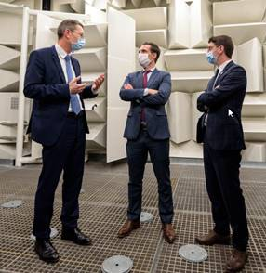

liebherr-djebarri-8juil2021-11.jpg  
From left to right: François Lehmann, Managing Director and Chief Financial Officer, Liebherr-Aerospace & Transportation SAS, Minister Delegate Jean-Baptiste Djebbari, and Mickaël Nogal, Member of the French Parliament, in the anechoic chamber in the test center of Liebherr-Aerospace Toulouse - © Liebherr

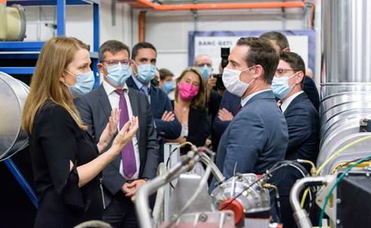

liebherr-djebarri-8juil2021-6.jpg  
Nathalie Duquesne, Director R&T, Liebherr-Aerospace Toulouse SAS (left), explains Minister Delegate Jean-Baptiste Djebbari (right) Liebherr’s R&T activities regarding green mobility. - © Liebherr

Contact person

Ute Braam  
Corporate Communication  
Telephone : +49 8381 46 4403  
E-mail : ute.braam@liebherr.com

Published by

Liebherr-Aerospace & Transportation SAS   
Toulouse / France  
www.liebherr.com