Press release

50th Liebherr machine delivered for Mainka

⸺

Mainka Bau GmbH & Co. KG extends its fleet

Long-term and trusting partnership with Liebherr

Focus on high quality standards, sustainable innovations and safety

Mainka Bau GmbH & Co. KG, a leading specialist company for industrial construction projects from Lingen, is extending its fleet. This year the company is investing in 17 new Liebherr earthmoving machines, which are to be delivered in 2021. A long-term and trusting partnership links Liebherr and Mainka. The delivery of the 50th Liebherr machine was celebrated recently in the new head office of Mainka Bau GmbH & Co. KG.

Kirchdorf an der Iller (Germany), 28 July 2021 – The official machine handover took place at the headquarters of Mainka in Lingen (Lower Saxony). The building was moved into for the 125-year anniversary of the company last year. Rudolf Arnold, Sales Director of Liebherr-Hydraulikbagger GmbH, took the delivery of the 50th Liebherr machine and the 125-year anniversary as an opportunity to present a Liebherr beverage refrigerator in a customized design to Mainka: The illustration on the refrigerator shows the 50th Liebherr machine of the company, an A 916 Litronic wheeled excavator, in front of the new Mainka headquarters in Lingen.

The Liebherr A 916 Litronic wheeled excavator is a popular all-rounder, which impresses with excellent performance and stability. Whether in road construction, on a large construction site or for applications with confined spaces – with an operating weight of 17 tonnes, a powerful, fuel-saving four-cylinder motor with 115 kW / 156 hp, as well as the superior combination of uppercarriage and undercarriage, the machine is always reliable and powerful.

**Long-term and trusting partnership**

Mainka Bau GmbH & Co. KG successfully implements industrial construction projects in Germany, the Netherlands, Belgium and Luxembourg. The projects include production buildings, power plants, warehouses, as well as laboratory and administration buildings. Mainka also offers infrastructure measures, from earthworks and pipeline construction to road construction through to the realisation of traffic areas. Mainka already uses 42 Liebherr machines with maintenance contracts for the efficient and smooth execution of these projects. "We have been working predominantly with Liebherr machines in the earthmoving area for many years now. We greatly appreciate the versatile, high-quality and powerful machines, as well as the reliable service and the competent advice of Liebherr-Baumaschinen Vertriebs- und Service GmbH in Dortmund-Lingen", says Werner Molde, Technical Director at Mainka. Now the company has ordered another package of Liebherr machines. This includes 17 earthmoving machines, including 12 Liebherr L 506 Compact loaders, four A 916 Litronic wheeled excavators and an R 914 Compact Litronic crawler excavator.

**Mainka focuses on sustainability and innovation**

Apart from a high quality standard, Liebherr has been impressing with sustainable innovations and creative solutions for generations. This aspect is important to Mainka: "For over 125 years our company has stood for reliability in the construction sector. We have a particular responsibility not only to our customers and staff, but also to our environment", highlights Werner Molde. The 17 new Liebherr earthmoving machines correspond to the latest developments. Ingo Schubert, Sales Manager at Liebherr-Baumaschinen Vertriebs- und Service GmbH in Dortmund-Lingen, adds: "The earthmoving machines are equipped with the latest technologies for maximum efficiency with high productivity at the same time. The diesel engines in the machines are efficient and robust and impress with low fuel consumption. In addition, they comply with the current guidelines of exhaust emissions standard Stage V, with innovative exhaust gas aftertreatment systems for the effective reduction of pollutant emissions."

**Focus on safety**

Mainka specialises in complex construction projects, for which high safety requirements must be fulfilled. Dr. Andreas Mainka, Managing Partner at Mainka, explains: "We also successfully implement construction projects under the toughest conditions because occupational safety lies at the heart of our corporate activity. We build safely - or not at all." The figures prove Mainka right. For years the company has been one of the pioneers in occupational safety and in 2019 won the German Occupational Safety Award for its commitment "Occupational safety as a corporate philosophy". The organisers of the award are the Federal Ministry of Labour and Social Affairs (BMAS), the Commission for Occupational Safety and Safety Engineering of the Federal States (LASI) and the German Social Accident Insurance (DGUV).

Mainka has been placing its trust in the reliable Liebherr machines, which are designed for maximum safety, for day-to-day site work for around 25 years. For example, the Liebherr operator's cabs are equipped with large glass panes, which give the machine operator an optimal panoramic view. Lateral and rear-view cameras are also available as standard for the monitoring of the side and rear danger zone. Furthermore, Liebherr machines impress with maximum stability and safety against tilting because they provide stability, with comfortable and stable driving performance at the same time thanks to their robust design.

**About Mainka Bau GmbH & Co. KG**

Mainka Bau GmbH & Co. KG is a family-run construction company with its head office in Lingen (Lower Saxony), which was set up in 1895. Apart from the headquarters in Lingen, the company also has eight other locations in Germany. Mainka employs around 600 employees altogether. The company achieves over 90 percent of sales in the chemicals industry, the energy sector and special logistics. The consolidated total revenue of the Mainka Group was around € 180 million in 2020.

About the Liebherr Group

The Liebherr Group is a family-run technology company with a highly diversified product portfolio. The company is one of the largest construction equipment manufacturers in the world. It also provides high-quality and user-oriented products and services in a wide range of other areas. The Liebherr Group includes over 140 companies across all continents. In 2020, it employed around 48,000 staff and achieved combined revenues of over 10.3 billion euros. Liebherr was founded in Kirchdorf an der Iller in Southern Germany in 1949. Since then, the employees have been pursuing the goal of achieving continuous technological innovation, and bringing industry-leading solutions to its customers.

Images

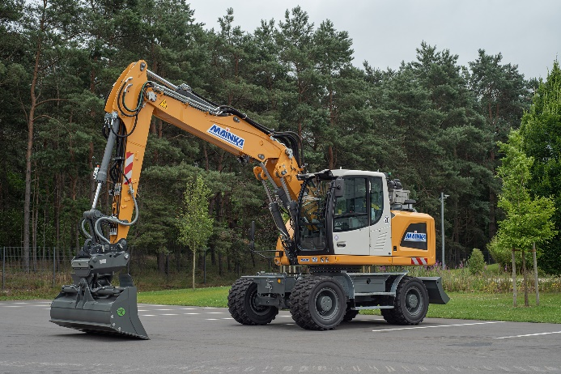

liebherr-mainka-1.jpg  
Mainka Bau GmbH & Co. KG extends its fleet and invests in 17 new Liebherr earthmoving machines. The delivery of the 50th Liebherr machine, an A 916 Litronic wheeled excavator, was recently celebrated in the new headquarters of Mainka.

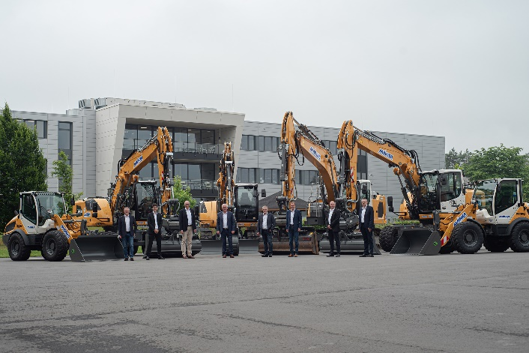

liebherr-mainka-2.jpg  
Representatives from Mainka and Liebherr at the official handover of the machines. From left to right: Werner Molde (Technical Director at Mainka Bau GmbH & Co. KG), Andreas Leiprecht (Branch Manager of Liebherr-Baumaschinen Vertriebs- und Service GmbH in Dortmund-Lingen), Dr. Andreas Mainka (Managing Partner at Mainka Bau GmbH & Co. KG), Rudolf Arnold (Sales Manager of Liebherr-Hydraulikbagger GmbH), Ingo Sperber (Technical Director at Mainka Bau GmbH & Co. KG), Andreas Schmidt (Commercial Manager at Mainka Bau GmbH & Co. KG), Ingo Schubert (Sales Manager of Liebherr-Baumaschinen Vertriebs- und Service GmbH in Dortmund-Lingen), as well as Frank Boyer (Engineering Department at Mainka Bau GmbH & Co. KG).

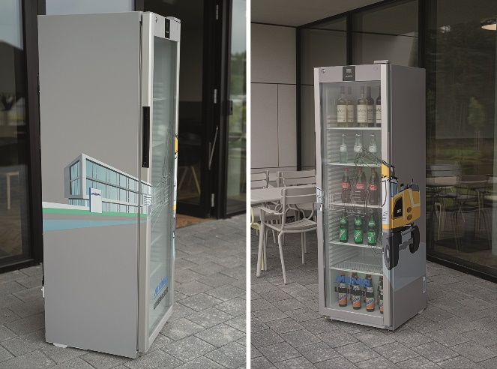

liebherr-mainka-3.jpg  
Liebherr congratulated Mainka Bau GmbH & Co. KG with a Liebherr beverage refrigerator in a customized design. The illustration shows the 50th Liebherr machine of the company in front of the new Mainka headquarters in Lingen.

Contact person

Nadine Willburger  
Marketing  
Phone: +49 7354 / 80 - 7332  
E-mail: Nadine.willburger@liebherr.com

Published by

Liebherr-Hydraulikbagger GmbH   
Kirchdorf an der Iller / Germany  
www.liebherr.com