Press release

Number two: Paradiso takes delivery of Liebherr LG 1750 lattice boom mobile crane

⸺

High demand in Italy and good experience with LG 1750 are the deciding factors

LG 1750 offers optimised boom systems for different wind turbines

Paradiso focuses activities on renewable energy market

The crane rental company Fratelli Paradiso S.r.l. has taken delivery of a Liebherr LG 1750 lattice boom mobile crane. It is already the second crane of this type in the fleet of the company from the Apulia region in the south of Italy. It will be used mainly for the assembly of wind turbines. The high demand in this area in Italy and the good experience with this type of crane were the reasons for the decision to purchase another LG 1750.

Ehingen (Germany), 10 August 2021 - In recent years, Fratelli Paradiso S.r.l. has focused its activities on the growing renewable energy market, especially wind energy. Michele Paradiso, owner and CEO of the company, explains, "We recognize a higher demand for high performance cranes in Italy and we want to grow further by focusing on large cranes and investing in Liebherr products and the Liebherr brand."

He describes the 8-axle LG 1750 as the "queen" of cranes for the wind energy industry in the 750-tonne class. For several years, Paradiso has successfully operated the world's strongest lattice boom mobile crane, which led to the decision to purchase another crane of this type.

The LG 1750 lattice boom mobile crane offers the flexibility of a 750 tonne crawler crane combined with the mobility of a high-speed truck crane. It thus combines the advantages of both crane types in one concept. For the LG 1750, Liebherr uses the crane slewing platform and boom system of the LR 1750 crawler crane as well as an eight-axle chassis of the latest design with speed-dependent rear-axle steering. The lattice boom mobile crane is therefore ideal for fast assembly operations in wind power, industrial construction or infrastructure. The chassis travels to the construction site with all four outriggers at a total weight of 96 tonnes. If required, the outriggers of the LG 1750 can be removed, thus reducing the weight to 48 tonnes.

Liebherr offers a wide range of special wind power boom systems for the LG 1750, which are optimized for smaller and medium-sized turbines as well as for the latest generation of wind turbines with tower heights of up to more than 160 meters. "We have chosen the SL8HS configuration with 119 meters, which is ideal for small to medium-sized turbines. We don't have to set up a derrick system for this. That saves time and money. But we can easily extend the crane later, up to the new powerful SX3 system with 165 meters", says Paradiso.

Fratelli Paradiso S.r.l. was founded in 1967 by Vito Paradiso. The family business is run by the second generation, Michele, Francesca and Silvia Paradiso. It operates an extensive fleet of medium to large cranes, including ten Liebherr cranes over 230 tonnes. The company is a recognised reference for crane work in Italy, but also throughout Europe and North Africa, especially for wind power applications.

**About Liebherr-Werk Ehingen GmbH**

Liebherr-Werk Ehingen GmbH is a leading manufacturer of mobile and crawler cranes. Its range of mobile cranes extends from 2-axle 35 tonne cranes to heavy duty cranes with a lifting capacity of 1200 tonnes and a 9-axle chassis. Its lattice boom cranes on mobile or crawler crane chassis deliver lifting capacities of up to 3000 tonnes. With universal boom systems and extensive additional equipment, they can be seen in action on construction sites throughout the world. The Ehingen site has a workforce of 3,600. Extensive, global service guarantees the high availability of Liebherr mobile and crawler cranes. In 2020, the Liebherr plant in Ehingen recorded a turnover of 2 billion euros.

**About the Liebherr Group**

The Liebherr Group is a family-run technology company with a widely diversified product range. The company is one of the largest manufacturers of construction machines in the world, but also supplies technically advanced, user-focused products and services in many other sectors. The group currently comprises more than 140 companies based in every continent of the world, has a workforce of around 48,000 and recorded a consolidated total turnover of more than 10.3 billion euros in 2020. Since it was founded in 1949 in Kirchdorf an der Iller in southern Germany, Liebherr’s aim has been to win customers by supplying high quality solutions and to contribute to technological progress.

**Picture:**

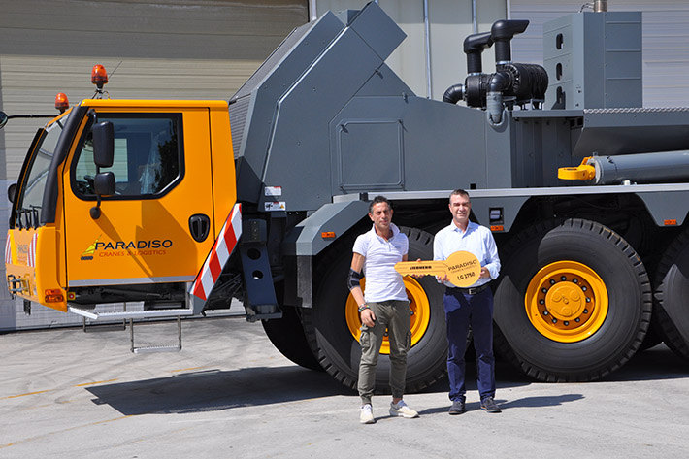

liebherr-lg1750-paradiso.jpg  
The key to „Paradiso“: Fabio Fenzi of Liebherr Italia S.p.A. (right) hands over the LG 1750 to Michele Paradiso.

**Contact person:**

Wolfgang Beringer  
Marketing and Communication  
Phone: +49 7391/502-3663  
Email: wolfgang.beringer@liebherr.com

**Published by**

Liebherr-Werk Ehingen GmbH  
Ehingen (Donau) / Germany  
[www.liebherr.com](http://www.liebherr.com)