Press release

Liebherr HVAC units on-board maglev train in China

⸺

**Liebherr-Transportation Systems (China) will provide on-board, ultra-light air-conditioning systems for Chengdu Xinzhu Road & Bridge Machinery Co., Ltd., for its new maglev train project. First delivery is expected for the third quarter of 2021.**

Pinghu (China), August 2021 – Liebherr China has officially signed an agreement with Chengdu Xinzhu Road & Bridge Machinery Co., Ltd., to provide air-conditioning systems for its newly developed maglev urban transportation system.

Each passenger compartment will be equipped with three ultra-lightweight air-conditioning systems named MACS 10.0 by Liebherr. MACS stands for modular air-conditioning systems. The new and improved MACS 10.0 product design by Liebherr offers a high degree of flexibility, integration and modularization while also maintaining a low height. The integration of MACS 10.0 in the weight-optimized vehicles is much easier, as there is no need for a specific duct system anymore. The air conditioning system meets the customer’s needs regarding passenger transport according to Chinese requirements.

The newly developed MACS 10.0 is based on Liebherr’s existing MACS 8.0 — already familiar to Chengdu Xinzhu Road & Bridge Machinery. Back in 2020, Liebherr provided MACS 8.0 to a German-based construction company that had been collaborating with Chengdu Xinzhu Road & Bridge Machinery in the successful development of one of the world’s first new-generation, medium-to-low-speed maglev rail system with a maximum speed of 160 kilometers per hour.

MACS 10.0 with its innovative cooling technology will be put into serial production after ambitious development and testing, and it will be engineered and produced at Liebherr-Transportation Systems' newest production and engineering site in Pinghu, Zhejiang Province (China), near Shanghai.

Liebherr is honored to be a key supplier of the flourishing domestic maglev train industry in the southwest region of China. It thus contributes its technology to China's economic development and approach to tackle global challenges related to climate change, alternative energy and biodiversity.

About Liebherr-Transportation Systems

Liebherr’s transportation systems division supplies cab and saloon heating, ventilation and air conditioning (HVAC) systems, thermal management systems for diverse mobile and stationary e-mobility applications, hydraulic actuation systems, dampers and hydraulic load levelling equipment for rail vehicles of all kinds. Liebherr has many years of experience in the development, manufacture, and field service of these technologies, offering support throughout the entire product lifecycle. The company invests continuously in its R&D activities in order to offer its customers new generations of diverse transportation systems solutions.

Liebherr-Transportation Systems has four production plants in Korneuburg (Austria), Marica (Bulgaria), Pinghu (China) and Zhuji (China). In addition to its own sales and service centers, the division has access to the Liebherr Group’s extensive and unique technologies as well as development and service facilities around the world. This global set-up means that Liebherr-Transportation Systems is there for its customers wherever they may be.

About the Liebherr Group

The Liebherr Group is a family-run technology company with a highly diversified product portfolio. The company is one of the largest construction equipment manufacturers in the world. It also provides high-quality and user-oriented products and services in a wide range of other areas. The Liebherr Group includes over 140 companies across all continents. In 2020, it employed around 48,000 staff and achieved combined revenues of over 10.3 billion euros. Liebherr was founded in Kirchdorf an der Iller in Southern Germany in 1949. Since then, the employees have been pursuing the goal of achieving continuous technological innovation, and bringing industry-leading solutions to its customers.

Image

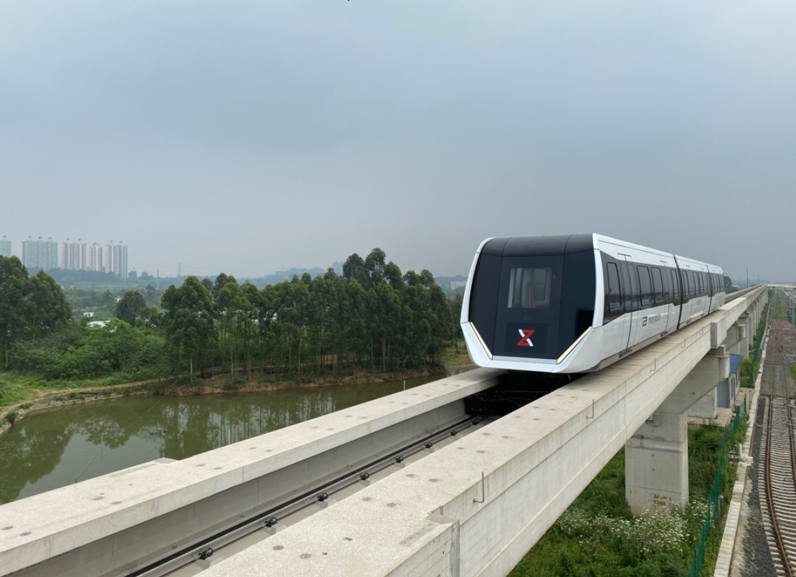

chengdu-xinzhu-road-and-bridge-machinery-maglev-train.jpg  
Maglev train project by Chengdu Xinzhu Road & Bridge Machinery Co., Ltd.- © Max Boegl

Contact person

Ute Braam  
Corporate Communications  
Phone: +49 8381 / 46 - 4403  
E-mail: ute.braam@liebherr.com

**Published by**

Liebherr-Aerospace & Transportation SAS   
Toulouse / France  
www.liebherr.com