Press release

XpertAssist – real-time remote support

⸺

A new service era

The next level of service

Low investment high return

Liebherr enhances its existing remote service app and takes service to the next level. XpertAssist is not just an audio-video connection but combines remote service and traditional technical expertise with a number of technical tools to provide advanced support for customers. The new service is available for crawler cranes, deep foundation equipment and maritime cranes.

Nenzing (Austria)/Rostock (Germany), August 2021 – Liebherr has further developed its remote service portfolio to provide even better support for its customers. XpertAssist is an annual subscription-based service, which combines several service tools to provide increased benefits such as reduced mean time to repair and therefore, costs. Real-time, fast and effective support is provided by Liebherr experts worldwide with second level backup support with OEM. Increased availability, longer service life, and reduced service costs are the advantages for each machine registered with XpertAssist.

A new service era

Following the success and high demand of the Remote Service tool that was introduced last year, Liebherr has further enhanced its remote portfolio taking service to the next level. XpertAssist combines real-time expert advice from experienced technicians with a wide range of technical tools through an audio-visual connection. Immediate qualified fault analysis and online troubleshooting backed by step-by-step instructions mean assistance can be maximised and on-site attendances can be reduced to a minimum. Any necessary site attendances are made as efficient as possible through audio-video calls to predefine requirements and so increase the first time fix rate. A debriefing via audio-video conference call to explain the work done, or to address possible findings is part and parcel of this new product. The mean time to repair is reduced by up to 50 %, and field service costs cut by up to 20 % per annum.

The next level of service

XpertAssist extends to predictive maintenance advice and reports on individual machines or entire fleets, for example, reports on safety or machine and engine utilisation. The interactive performance review and advice on preventive maintenance ensure high machine availability and early budget planning. Service technicians normally spend up to 45 % of their time just travelling to/from site - both time-consuming and costly for all parties. Thanks to XpertAssist, availability of experts is increased through elimination of avoidable travel giving them more time to do their actual job – attending to customer needs. Less travel, less CO2 emissions - the environment also benefits through the reduced carbon footprint. An increasingly important factor in today’s world.

Recent experience in the Middle East underlines the importance of quick and efficient technology when projects are thousands of kilometres away from base. “For our company, which has all operations and projects outside our home country of Turkey, such remote service is perfect,” explains Levent EKMEKÇİOĞLU, Company Manager of rem engineering, construction and trade co. ltd. He continues, “Assistance was provided by Liebherr remotely in Jordan with no travel or accommodation costs and no time delays. The issue was solved immediately to our utmost satisfaction and we are very grateful for this extended assistance.”

Low investment, high return

All that is needed for XpertAssist is an annual subscription, available for each individual machine or for entire fleets. As an option, Liebherr offers a high-quality, ready-to-use pre-installed tablet (LiTAB) enabling digital machine documentation and easy process data download, as well as remote operation monitoring, to name but a few of its many benefits. Further details are available from Liebherr’s worldwide network of service partners and online under [XpertAssist](https://www.liebherr.com/en/deu/products/maritime-cranes/services-and-support/customer-service-maritime-cranes/technical-support/xpertassist/xpertassist.html).

About the Liebherr Group

The Liebherr Group is a family-run technology company with a highly diversified product portfolio. The company is one of the largest construction equipment manufacturers in the world. It also provides high-quality and user-oriented products and services in a wide range of other areas. The Liebherr Group includes over 140 companies across all continents. In 2020, it employed around 48,000 staff and achieved combined revenues of over 10.3 billion euros. Liebherr was founded in Kirchdorf an der Iller in Southern Germany in 1949. Since then, the employees have been pursuing the goal of achieving continuous technological innovation, and bringing industry-leading solutions to its customers.

Images

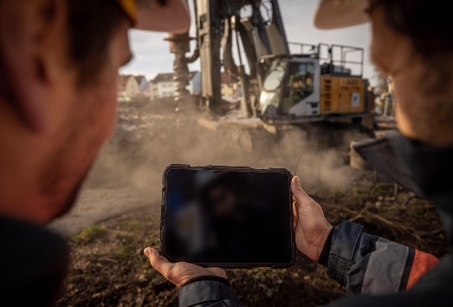

XpertAssist_LB-25.jpg

XpertAssist: the new level of real-time support for customers’ machines, wherever they are.

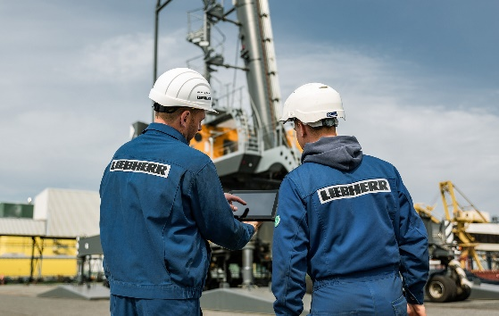

XpertAssist_Maritime_Cranes.jpg

XpertAssist: the new level of real-time support for customers’ machines, wherever they are.

Contact person

Aleksandra Krstic  
Marketing Manager Customer Service

Maritime Cranes, Crawler Cranes & Foundation Equipment  
Email: [aleksandra.krstic@liebherr.com](mailto:aleksandra.krstic@liebherr.com)

Published on behalf of

Liebherr-Werk Nenzing GmbH  
Nenzing / Austria

and

Liebherr-MCCtec Rostock GmbH  
Rostock / Germany

[www.liebherr.com](http://www.liebherr.com)