

Press release

The company Nouvelles Carrières d’Alsace (N.C.A) once again opts for Liebherr quality

⸺

The choice fell on a high-performance machine with optimised loading cycle times

Increased productivity with a new Generation 8 excavator

Nouvelles Carrières d'Alsace and Liebherr enjoy a long-term partnership

Nouvelles Carrières d'Alsace was on the lookout for a new Liebherr excavator as a replacement for its former R 944 C excavator. Following a final test phase, Nouvelles Carrières d'Alsace opted for the R 945 G8, which has the same digging power as the R 944 C.

Colmar (France), 27. August 2021 – A long-standing partnership has existed between Nouvelles Carrières d'Alsace and Liebherr since 1965. This historical connection, the quality of the customer service and the opportunity to order a customised excavator are key criteria for Nouvelles Carrières d'Alsace when choosing a Liebherr excavator. Production in France in the immediate proximity represents the quality of the machines in the eyes of the company.

The R 945 G8: a high_performance and economical crawler excavator

The R 945 G8 is in use for eight hours a day. It is operated by a single driver and is used primarily for extracting granite from the quarry. In this process, the blocks are sorted in accordance with their size and loaded into dump trucks, which transport them directly to the customers. The R 945 G8 is characterised by greater flexibility and movement accuracy than the R 944 C, thereby offering more productivity and comfort. The equipment with powerful LED lighting and an extended field of vision ensure additional safety. The R 945 G8 differs from the R 944 C in terms of lower fuel consumption. Nouvelles Carrières d'Alsace has already noticed a significant fuel saving: The R 945 G8 only consumes about half as much as the R  944 C, at 19 litres/hour. The users are able to estimate their future savings themselves with the [fuel savings calculator](https://www.liebherr.com/en/deu/specials/fuel-savings-calculator/tool/calculator.html).

The right excavator for the company’s requirements

The R 945 G8 has been configured in accordance with the specifications of Nouvelles Carrières d'Alsace. It is equipped with a SME boom of 6.15 metres in length and was supplied with a large, reinforced special bucket that is optimally suited to the requirements of the company. Its 2.60 metre long SME dipper arm makes it easy to load a semi-trailer up to the end of the skip. Nouvelles Carrières d'Alsace uses the LiDat system, allowing it to monitor the consumption of its Liebherr fleet remotely and draw comparisons across its various applications. The company also benefits from its proximity to the Liebherr-France SAS production site in Colmar, especially in terms of service.

About Nouvelles Carrières d'Alsace

Nouvelles Carrières d'Alsace is a French company employing 10 people, which was founded in 1965 and is based in Metzeral in the French département of Haut-Rhin in Alsace. Its field of activity is diverse and includes the quarrying, extraction, crushing and sale of gravel, granite and natural stones. The company collaborates in particular with the Conseil Général du Haut-Rhin in securing river banks in Alsace with rock fillings.

About the Liebherr Group

The Liebherr Group is a family-run technology company with a highly diversified product portfolio. The company is one of the largest construction equipment manufacturers in the world. It also provides high-quality and user-oriented products and services in a wide range of other areas. The Liebherr Group includes over 140 companies across all continents. In 2020, it employed around 48,000 staff and achieved combined revenues of over 10.3 billion euros. Liebherr was founded in Kirchdorf an der Iller in Southern Germany in 1949. Since then, the employees have been pursuing the goal of achieving continuous technological innovation, and bringing industry-leading solutions to its customers.

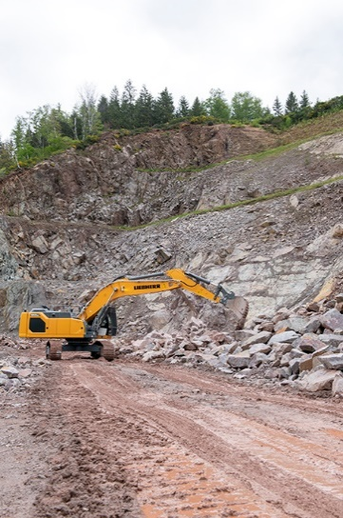Images

liebherr-crawler-excavator-r-945-g8-1.jpg  
The R 945 crawler excavator is distinguished by its smooth and precise movements.

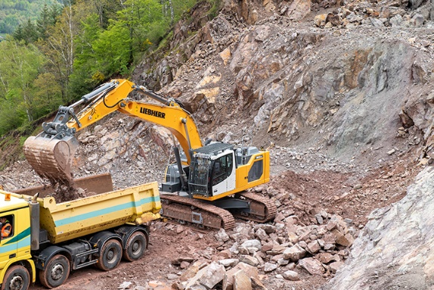

liebherr-crawler-excavator-r-945-g8-2.jpg  
Its SME dipper arm makes it easy to load articulated lorries up to the end of the skip.

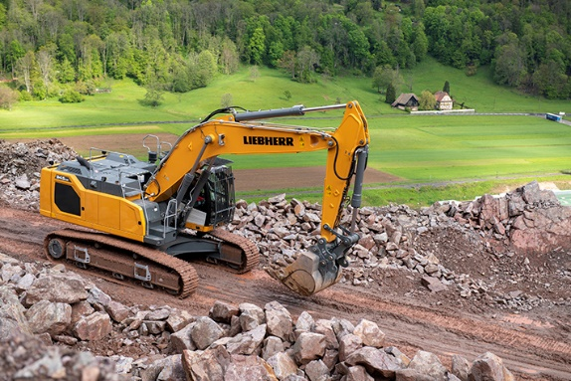

liebherr-crawler-excavator-r-945-g8-3.jpg  
The R 945 G8 boasts low fuel consumption. Liebherr customers who use the LiDat system are able to monitor the consumption of their fleet remotely.

Contact person

Alban Villaumé  
Marketing Manager  
Telefon: +0033 89 21 36 09  
E-Mail: alban.villaume@liebherr.com

Published by

Liebherr-France SAS   
Colmar / France  
www.liebherr.com