

Press Information

Smart support from Liebherr High-Top crane boosts production  
⸺

Antonio Basso S.p.A was the first customer in Italy to take delivery of a new-look Liebherr 1000 EC-H 50 Litronic crane

The tower crane is a reliable part of production processes at the company’s headquarters in Treviso

Liebherr was the only supplier with a suitable overall solution

The crane’s high handling capacity and digital connectivity make it the smart choice for Industry 4.0

Powerful, space-saving and solid – this is how Antonio Basso S.p.A, an Italian manufacturer of pre-cast concrete parts, describes the 1000 EC-H 50 Litronic crane from Liebherr. The crane moves pre-cast concrete parts weighing several tonnes on a daily basis at the company’s headquarters in Treviso and is intelligently networked with the ERP system there. The incline of the on-site crane track also played a pivotal role in opting for the new machine from Liebherr.

Treviso (Italy), August 31, 2021 – "The crane is like a Ferrari – it’s extremely fast," says managing director Giovanni Basso from Treviso. Antonio Basso S.p.A was the first customer in Italy to acquire a Liebherr 1000 EC-H 50 Litronic tower crane back in July 2019. Tower Crane Solutions (TCS) tailored the design of the crane to meet the requirements of the pre-cast concrete parts manufacturer. Giovanni Basso has been successfully deploying the largest standard crane in Liebherr’s EC-H series as a reliable part of the production process for two years now. He was the first customer in Italy and one of the first customers worldwide to receive the new-look 1000 EC-H 50 Litronic.

Twelve hours a day, five days a week: The 1000 EC-H 50 Litronic is in constant operation and is at its busiest in summer. The tower crane moves up to 45 tonnes during its work, which involves picking up pre-cast elements from production, delivering them to the storage area and then loading the parts onto trucks later on. “We produce the parts for foundations, floors, roofs and chimneys," explains Giovanni Basso. Façades in various designs and specially shaped bridge sections round off the company’s product portfolio.

Portal enables efficient operation

The crane is mounted on a 10-metre portal, has a jib length of 50 metres and a hook height of approx. 33 metres. The portal runs on rails so that the company can use the crane to cover every corner of the storage yard. “We have the ability to move pre-cast elements much faster than before thanks to the tower crane being on a rail-mounted portal, plus we have extra storage space underneath," says Giovanni Basso. “We don’t waste a single square metre of storage space. Thanks to the optimal use of space and the high handling capacity, we can achieve higher production volumes than before." He also has other Liebherr machines like concrete mixing plants.

The portal solution was one of the main reasons why the customer opted for the 1000 EC-H 50 Litronic. According to Giovanni Basso, Liebherr was the only supplier who came up with a suitable and complete solution regarding the incline of the on-site crane track. As a result of extensive calculations beforehand, the crane can now be operated safely and reliably anywhere within the yard. “We’re also very satisfied with the modern crane control system with PLC and especially the control of the slewing gears," says the managing director, adding that operation is easy and precise despite the crane’s enormous size.

Coordinated networking of systems

For the hoist unit, the ideal choice was the 110 kW version. “As a large number of trucks are loaded each day, the handling of materials needs to run smoothly and quickly," he explains. For the most part, the team operates the crane from inside its cabin: “It’s a much more comfortable experience up there. You have a better overview and can feel the crane – that’s not possible with a remote control." An interface between the crane control and the administrative production system ensures that every handled part can be tracked. “We’re living Industry 4.0," says Giovanni Basso enthusiastically.

The strong gusts of wind that the region experiences, which can reach speeds of over 180 kilometres per hour, were an additional consideration. To address this, the crane is secured with special rail clamps each evening to ensure that it stays in place. In the event of a severe storm, the Portal can also be secured with steel ropes to a foundation embedded in the ground. Giovanni Basso concludes, “Our production process wouldn’t work without the crane. It’s at the heart of our family business."

Father founded the company almost 50 years ago

Giovanni Basso’s father built up the company. Antonio Basso initially started out as a civil engineering contractor in 1972 and expanded his business to include the production of pre-cast concrete elements in 1976. At the end of the ’80s, the company experienced rapid growth thanks to a patent for an innovative roofing system for industrial buildings. The company’s headquarters and production facility are located near Treviso. There are also two further production sites in Grigno (Trentino) and Manfredonia (Foggia) belonging to the subsidiaries Antonio Basso Trentino S.r.l. and Antonio Basso Beton S.r.l..

About the Liebherr Tower Cranes Division

More than seven decades of experience have made Liebherr a recognised specialist for lifting technology on all types of construction sites. The range of Liebherr Tower Cranes encompasses an extensive selection of high-quality tower cranes that are used worldwide. This includes fast-erecting, top-slewing, luffing jib and special-purpose cranes as well as mobile construction cranes. In addition to these products, Liebherr Tower Cranes also offers a wide range of services that complete the company’s portfolio: Tower Crane Solutions, Tower Crane Center and Tower Crane Customer Service

About the Liebherr Group

The Liebherr Group is a family-run technology company with a highly diversified product portfolio. The company is not only one of the largest construction equipment manufacturers in the world, but also provides high-quality and user-oriented products and services in a wide range of other areas. Today, the Group consists of more than 140 companies across all continents, employs around 48,000 people and, in 2020, achieved a total turnover of over 10.3 billion euros. Liebherr has pursued its goal of satisfying customers with industry-leading solutions and shaping technological progress since its founding in 1949, in Kirchdorf an der Iller in Southern Germany.

Images

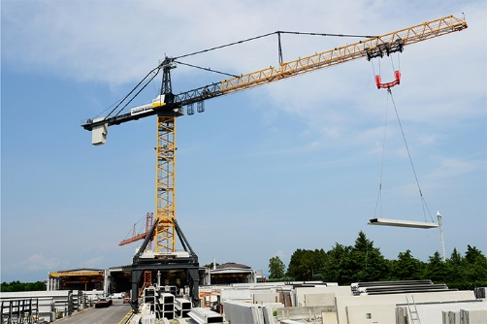  
liebherr-1000-ec-h-treviso01.jpg  
The largest standard crane from Liebherr’s EC-H series moves pre-cast concrete parts weighing several tonnes on a daily basis at the production site in Treviso.

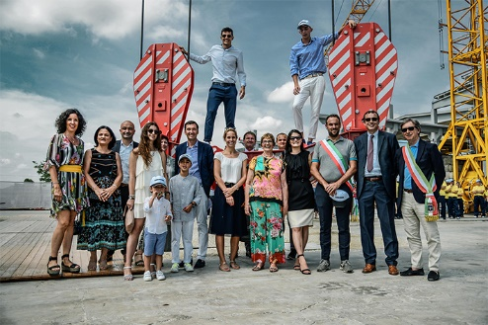  
liebherr-1000-ec-h-treviso 02.jpg  
Representatives of Liebherr, including Stéfanie Wohlfarth (Member of the administrative Board of Liebherr-International AG), and Niederstätter handed over the 1000 EC-H 50 Litronic to Antonio Basso S.p.A. together in July 2019.

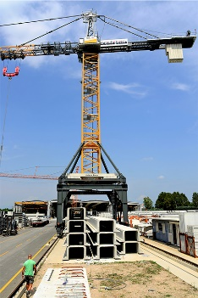  
liebherr-1000-ec-h-treviso 03.jpg  
Antonio Basso S.p.A took delivery of the 1000 EC-H 50 Litronic two years ago; it was a significant purchase for the company.

Contact person

Fabian Eber  
Global Communication  
Telephone: +49 7351/41 - 4397  
E-mail: fabian.eber@liebherr.com

Published by

Liebherr-Werk Biberach GmbH  
Biberach / Germany  
www.liebherr.com