

Press release

The first Liebherr R 936 Compact crawler excavator on Corsica

⸺

Power and robustness convince

Excellent maneuverability in confined spaces

Lanfranchi opts for a reliable and comfortable excavator

The Lanfranchi company performs earthworks and rock filling work in the Porto-Vecchio region on the island of Corsica, as well as work on traffic routes and various pipeline networks. The company was looking for an excavator with a weight of approx. 35 tonnes so that it could also handle more complex projects. It was to be versatile, easy to handle in confined spaces and comfortable for the operator.

Corsica (France), 6 September 2021 – The Liebherr branch in Rognac near Marseilles offered the company a type R 936 Compact crawler excavator. This excavator, with a weight of approx. 35 tonnes, rounds off the Liebherr range of compact excavators from 14 to 38 tonnes. A range of working equipment is available to make it even more versatile. The structural design of this machine facilitates safe working, even in cramped conditions.

Thomas Lanfranchi, CEO of Lanfranchi, values the reliability of Liebherr machines as well as the new generation of Stage V engines with their lower exhaust emissions.

The compact excavator – powerful and manoeuvrable

Lanfranchi has chosen the R 936 Compact to expand its machinery fleet. A Liebherr R 914 Compact crawler excavator had already been part of the fleet. Mr. Lanfranchi is extremely satisfied with the reliability, the comfort of the cab and the fast service provided by Liebherr's customer service department. The new machine is now able to take on more demanding tasks such as backfilling embankments or lifting heavy loads.

The new 190 kW / 258 hp engine with exhaust Stage V boasts lower fuel consumption than the previous generation of the R 914 compact excavator with exhaust Stage IV. The dozer blade as well as the Likufix hydraulic coupling system in combination with the quick tool change system turn the excavator into a versatile machine. The technical performance of the excavator has been optimised to achieve an even greater load capacity. The compact design of the top carriage, in combination with the assistance systems based on cameras, facilitates excellent handling and ensures enhanced safety even in confined spaces.

Gentle motion sequences ensure a high level of operator comfort

The Lanfranchi company wanted, above all, a machine that offered the operator a high level of comfort. Mathieu, the brother of the company boss and the only operator of the excavator, works on the machine for an average of seven hours a day. He appreciates how smooth the movements are combined with very high performance and breakout force. The low noise level in the cabin means that you can work all day without getting tired. The new LED lighting surrounding the excavator enlarges the driver's field of vision and thereby significantly increases the safety of people on the construction site.

About the Liebherr Group

The Liebherr Group is a family-run technology company with a highly diversified product portfolio. The company is one of the largest construction equipment manufacturers in the world. It also provides high-quality and user-oriented products and services in a wide range of other areas. The Liebherr Group includes over 140 companies across all continents. In 2020, it employed around 48,000 staff and achieved combined revenues of over 10.3 billion euros. Liebherr was founded in Kirchdorf an der Iller in Southern Germany in 1949. Since then, the employees have been pursuing the goal of achieving continuous technological innovation, and bringing industry-leading solutions to its customers.

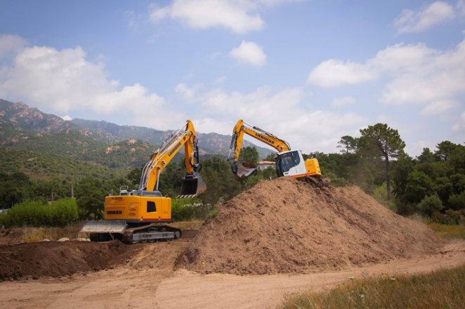Images

liebherr-crawler-excavator-r-936-compact-1.jpg  
The R 936 Compact excavator is an excellent solution for use on narrow construction sites right up to HGV loading.

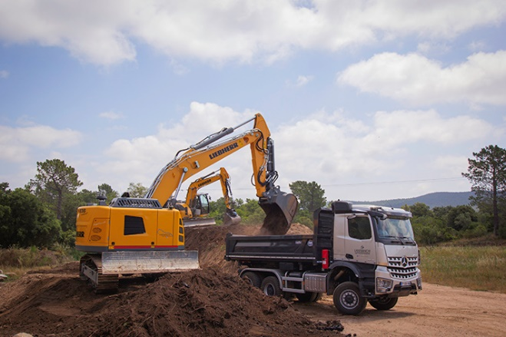

liebherr-crawler-excavator-r-936-compact-2.jpg  
The R936 Compact excavator is an excellent solution for use on narrow construction sites right up to HGV loading.

Contact person

Alban Villaumé  
Marketing Manager  
Tel: +0033 89 21 36 09  
E-Mail: alban.villaume@liebherr.com

Published by

Liebherr-France SAS   
Colmar / France  
www.liebherr.com