

Press release

Liebherr and ABB accelerate   
all-electric mine transition,   
focussing on haul truck trolley support

⸺

Liebherr and ABB have announced at MINExpo International® 2021, their partnership to explore the development of state-of-the-art technologies for overall electrification of mine sites.

With this agreement, Liebherr continues to execute its roadmap to achieve low fossil fuel solutions by 2022, along with fossil fuel-free solutions for the majority of applications by 2030.

This collaboration will focus on trolley support and the overall electrification of mining operations.

Liebherr, one of the world’s largest construction and mining equipment manufacturers, and ABB a leader in electrification and automation technologies, have signed a Memorandum of Understanding (MoU) to develop solutions for mine electrification which will reduce greenhouse gas (GHG) emissions associated with heavy machinery in mining.

Las Vegas (USA), 14 September 2021 – Liebherr Mining and ABB, two leading technology companies, have announced their collaboration to explore the development of state-of-the-art technology and equipment for overall electrification of mine sites, with a particular focus on trolley support. As a result of the project, both companies will be equipped to support mine operators that have a goal to significantly increase electrification of their operations. The collaborative efforts from Liebherr and ABB will improve both company’s understanding and awareness of potential electrification combinations for the mining industry, and drive future research and development opportunities.

Liebherr has existing electric mining equipment solutions and has supplied electrified haul trucks and mining excavators in multiple countries. For most Liebherr haul trucks, the company offers a trolley solution, including switch back capable trolley technology for the T 236. This technology was recently awarded the most innovative haulage technology in surface mining by Mining Magazine in the category “Load/Haul”. For their excavator range, Liebherr offers electrically powered solutions for all size classes, adaptable to different tensions and frequencies. Liebherr is engaging with multiple major mining companies for decarbonisation analysis, as part of their approach to zero emission mining. ABB will be a strong support for these discussions linked to mine electrification.

“The Liebherr Mining team shares our commitment to developing solutions for mining operations that have net zero emissions at their core,” said Mehrzad Ashnagaran, ABB’s Global Product Line Manager - Electrification and Composite Plant. “Building from our trolley assist infrastructure, which can reduce greenhouse gas emissions greatly, we can be part of wider electrification plans and help set bold targets for the near-future.”

“The ABB team is covering a very large footprint in the surface mining industry with a strong reputation in the supply of electrical infrastructure solutions,” said Peter Hoeher, Liebherr Mining Equipment Newport News Managing Director. “Trolley applications will be the key technology to reduce the overall GHG emissions from surface mining operations in the fastest way possible whilst maintaining all the benefits of haul trucks in terms of performance, cost, and operational flexibility. We also consider trolley as a key technology for fully electrified haul truck solutions.”

ABB has already collaborated with mining operators from initial feasibility studies, through concept development and full deployment. Its electrification solutions, including trolley assist, are already active in mines in Sweden and in late 2021 in Canada.

This partnership announcement follows a call from ABB earlier this year for greater collaboration between OEMs and key technology suppliers. The shared mission to develop a combination of solutions will enhance the efficiency and flexibility of customer businesses and contribute to the reduction of CO₂, supporting a sustainable society.

About the Liebherr Group

The Liebherr Group is a family-run technology company with a highly diversified product portfolio. The company is one of the largest construction equipment manufacturers in the world. It also provides high-quality and user-oriented products and services in a wide range of other areas. The Liebherr Group includes over 140 companies across all continents. In 2020, it employed around 48,000 staff and achieved combined revenues of over 10.3 billion euros. Liebherr was founded in Kirchdorf an der Iller in Southern Germany in 1949. Since then, the employees have been pursuing the goal of achieving continuous technological innovation, and bringing industry-leading solutions to its customers.

About ABB

ABB (ABBN: SIX Swiss Ex) is a leading global technology company that energizes the transformation of society and industry to achieve a more productive, sustainable future. By connecting software to its electrification, robotics, automation and motion portfolio, ABB pushes the boundaries of technology to drive performance to new levels. With a history of excellence stretching back more than 130 years, ABB’s success is driven by about 105,000 talented employees in over 100 countries.

Process Automation: ABB’s Process Automation business is a leader in automation, electrification and digitalization for the process and hybrid industries. We serve our customers with a broad portfolio of products, systems, and end-to-end solutions, including our #1 distributed control system, software, and lifecycle services, industry-specific products as well as measurement and analytics, marine and turbocharging offerings. As the global #2 in the market, we build on our deep domain expertise, diverse team and global footprint, and are dedicated to helping our customers increase competitiveness, improve their return on investment and run safe, smart, and sustainable operations.

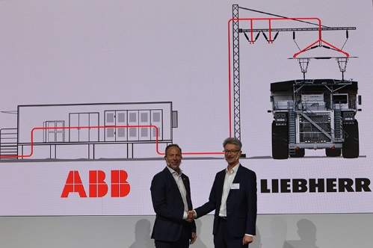Images

liebherr-partnership-agreement-ABB.jpg

Handshakes at MINExpo: Liebherr and ABB will be partnering in the development of state-of-the-art technologies for overall electrification of mine sites.

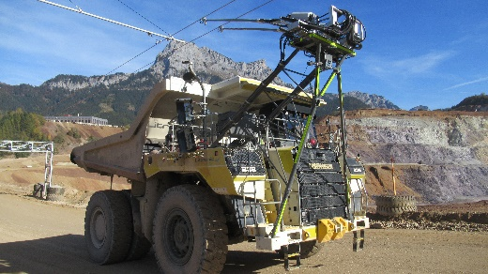

Liebherr-trolley-t236.jpg

Liebherr offers a Trolley Assist System for its haul truck range.

Contact person Liebherr

Swann Blaise  
Divisional General Manager, Marketing & Business Intelligence   
Telephone: [+1 757 928 2239](tel:+17579282239)  
E-Mail: swann.blaise@liebherr.com

Contact person ABB

Chris Brand  
Media Relations  
Telephone: +44 (0) 752 391 9978  
E-Mail: chris.g.brand@gb.abb.com

Published by

Liebherr-Mining Equipment SAS   
Colmar / France  
www.liebherr.com