

Press release

Liebherr-Mining introduces advanced Assistance Systems & On-board Analytics

⸺

Liebherr-Mining’s new Technology Product portfolio has been launched at MINExpo 2021, including Assistance Systems & On-board Analytics.

Liebherr Assistance Systems for excavators and trucks assist site operations to achieve a high level in safety, maintenance, and overall equipment effectiveness.

Liebherr Assistance Systems for trucks comprise the Trolley Guidance System and the Crusher Guidance System that reduce stress on the operator and maximise equipment performance.

On-board Analytics include Operational Excellence and Operational Analytics Suite for Liebherr excavators that support the operator to achieve optimal productivity.

Liebherr Mining has developed advanced Assistance Systems & On-board Analytics to further assist site operations to achieve a high level in safety, maintenance, and overall equipment effectiveness. By combining hardware and software, as only OEMs can do through the in-depth knowledge of their machine, Liebherr is increasing the performance of its mining equipment.

Las Vegas (USA), 14 September 2021 – Liebherr has presented the world premiere of its new Mining Technology Product portfolio at MINExpo 2021, which defines the company’s interoperable and scalable approach to their equipment, technology, and service product offerings. The Liebherr-Mining Technology Product portfolio includes Assistance Systems & On-board Analytics, Machine Automation, and Digital Services product lines, providing customers with flexible scope of supply solutions to increase safety and asset operational effectiveness.

Together, these products will support operator’s performance, optimise diagnostic processes, and automate machine functions, whilst integrating machine data and OEM expertise within the customer’s chosen technology landscapes.

The Liebherr Assistance Systems are advanced products and applications designed to support operators to become more efficient through analytics. The solutions further assist site operations to achieve a high level in safety, maintenance, and overall equipment effectiveness.

By developing its Assistance Systems and On-Board Analytics, Liebherr Mining continues to add value to customers’ new equipment and existing fleets through available retrofittable solutions. This equipment embedded technology also supports Liebherr Digital Services with the on-board generated and processed data providing further customer added value by combining with other Liebherr data and information.

The Assistance Systems product line for Liebherr excavators currently comprises of two product suites, the Operational Excellence and Operational Analytics - both will have additional solutions added to extend the suites’ products and features in the near future.

Operational Excellence Suite

The Operational Excellence Suite consists of on-board systems that support the operator to achieve optimal productivity and efficiency from the machine.

Today, this suite comprises of the **Truck Loading Assistant** that helps the operator to achieve optimal truck payloads avoiding truck under- and overloading. The on-board system computes the best truck loading strategy for efficient loading. The assistant measures the instantaneous bucket payload by means of a payload monitoring system (with 99% measurement accuracy) and provides real-time information to the operator of the truck loading progress.

Operational Analytics Suite

The Operational Analytics Suite are on-board products that monitor and display specific KPIs in real-time supporting the understanding of operational performance, machine operation and site application.

The Suite comprises of three products:

* **Performance Monitoring:**Provides detailed analysis and statistics of operator and machine performance (production KPIs, loading indicators, time distribution and energy efficiency) collected during work periods. This assistant offers operators a method to visualize and improve on their performance by allowing analysis and comparison of their previous work periods.
* **Application Severity**: Designed to enable detailed evaluation of the site application, this assistant quantifies and reports severity indicators by the machine sensing of the operating environment and calculates an overall severity score for the selected period. The algorithms provide insights into the impact and evolution of operating costs, productivity, and reliability throughout the machine’s life cycle.
* **Operational Conformance:**Monitors and detects non-conforming operational events to improve operator effectiveness. It provides results on how the machine was operated to identify training needs and to enable prediction of potential future maintenance cost profiles and machine availability.

The Liebherr Assistance Systems are available for most of the Liebherr mining excavator product range (R 9150, R 9200, R 9350, R 9400, R 996B, R 9600 and R 9800). Retrofit kits are readily available and can be installed during planned downtime periods. Upgrading a fleet with state-of-the-art onboard technologies has never been as easy.

Assistance Systems for Liebherr haul trucks

For Liebherr trucks, two products are currently available under the Assistance Systems product line: Trolley Guidance System, and Crusher Guidance System.

The **Trolley Guidance System** automatically steers the truck to maintain a consistent travel path while under the trolley power line, and automatically raises and lowers the pantograph. This system reduces stress on the operator, and maximises the utilisation of the Trolley Assist system, decreasing fuel consumption and CO2 emissions.

The **Crusher Guidance System** provides automatic steering assistance while backing into a fixed structure. It also has the capability to manage multiple crushers. This system reduces stress on the operator, contributes to faster cycle times, and reduces the risk of damage to the machine, tyres, and site infrastructure.

To complete the offering for trucks, a comprehensive suite of on-board Operational Excellence, Operational Awareness, Asset Health, and Operational Analytic products supporting manned and unmanned operations in sync with excavator developed products, will follow.

About the Liebherr Group

The Liebherr Group is a family-run technology company with a highly diversified product portfolio. The company is one of the largest construction equipment manufacturers in the world. It also provides high-quality and user-oriented products and services in a wide range of other areas. The Liebherr Group includes over 140 companies across all continents. In 2020, it employed around 48,000 staff and achieved combined revenues of over 10.3 billion euros. Liebherr was founded in Kirchdorf an der Iller in Southern Germany in 1949. Since then, the employees have been pursuing the goal of achieving continuous technological innovation, and bringing industry-leading solutions to its customers.

Images

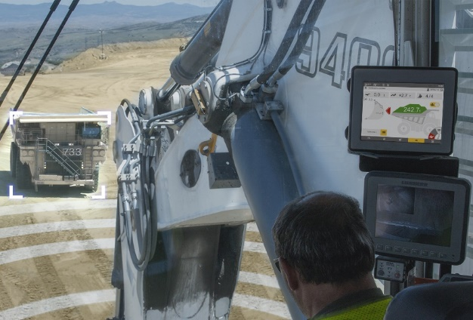

Liebherr-TLA.jpg  
The Truck Loading Assistant helps the operator to achieve optimal truck payloads and avoid truck under- and overloading.

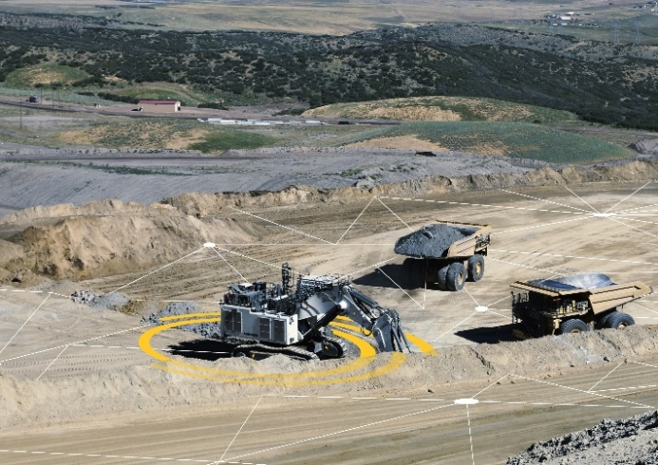

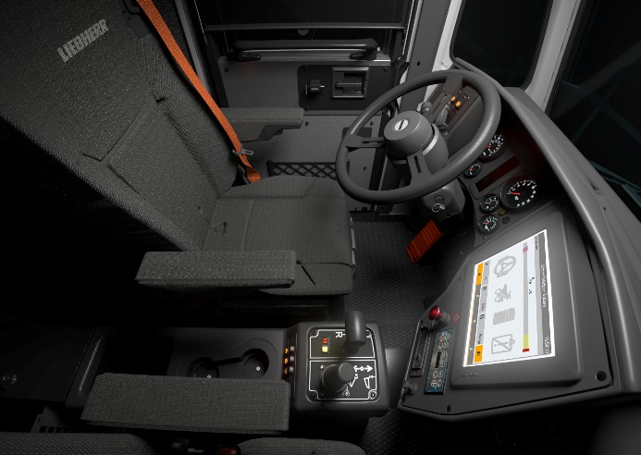liebherr-assistance-systems.jpg  
The Liebherr Assistance Systems are advanced onboard products and applications designed to support operators to become more efficient through analytics.

Liebherr-t274-cab-assistance-systems.jpg  
The Liebherr Assistance Systems for trucks in the T 274 cab.

**Contact person**

Swann Blaise    
General Manager, Marketing and Business Intelligence     
Telephone: +1 757 928 2239    
E-Mail: swann.blaise@liebherr.com

**Published by**

Liebherr-Mining Equipment Colmar SAS     
Colmar / France    
www.liebherr.com