

Press release

Liebherr Mining presents next generation, interoperable machine automation

⸺

At MINExpo 2021Liebherr showcases the development of autonomous solutions supported by an open and interoperable mine autonomy platform.

Liebherr has developed an industry-first open protocol, to deliver next generation autonomous haulage solutions.

Semi-automatic Bucket Filling Assistant and the new LiReCon teleoperations system offer the first steps towards machine automation for Liebherr’s excavator and dozer product lines.

Liebherr Mining’s machine automation philosophy supports open and interoperable mine automation platforms, giving customers choice in their equipment, autonomy, and infrastructure ecosystem. The developments in Liebherr’s autonomous haulage technology, as well as the first products toward machine automation for excavators and dozers, are proving the company is well-equipped to deliver next generation mine autonomy solutions.

Las Vegas (USA), 14 September 2021 – Liebherr has presented the world premiere of its new Mining Technology Product portfolio at MINExpo 2021, which defines the company’s interoperable and scalable approach to their equipment, technology, and service product offerings. The Liebherr Mining Technology Product portfolio includes Machine Automation, Digital Services, and Assistance Systems & On-board Analytics product lines, providing customers with flexible scope of supply solutions to increase safety and asset operational effectiveness. Together, these products will support operator’s performance, optimise diagnostic processes, and automate machine functions, whilst integrating machine data and OEM expertise within the customers chosen technology landscapes.

Mine automation has become increasingly important for mine operators, with the approach enhancing safety, improving operational efficiency, increasing productivity, and reducing operating costs. For automation of Liebherr trucks, excavators, and dozers, the company is developing the next generation of autonomous solutions with the utmost safety and operational efficiency, supported by an open and interoperable mine autonomy platform.Interoperable mine autonomation provides customers with the freedom to choose their preferred combinations of equipment, on-board autonomous solutions, and central control platforms.​

Autonomous haulage solution

Liebherr’s autonomous haulage solution delivers the next generation of on-board intelligence, with reduced dependency on site infrastructure and centralised supervisory systems. Together with vehicle-to-vehicle technologies, Liebherr’s smart autonomous solutions provide on-board obstacle avoidance and load area path planning capabilities for optimisation of traffic flow. Liebherr’s solutions offer a high level of safety integrity with the introduction of an 8-layer safety concept in combination with the latest on-board perception technologies for long range, high resolution and 360-degree coverage, which is unique to the Liebherr offering.

Liebherr offers flexible scope of supply solutions giving customers the freedom of choice in selection of best-in-class base machines, automation, traffic management, and fleet management systems. These scalable solutions meet all use cases, ranging from stand-alone to fully integrated large-scale life of mine deployments:

* **Autonomy ready kit**: machine designed and configured with drive-by-wire capability
* **Autonomy kit**: autonomous machine equipped with on-board perception and robotics, capable of integration via an open protocol to traffic management solutions
* **Complete solution**: complete autonomous haulage solution integrated with traffic and fleet management systems

Industry-leading open protocol

Liebherr’s interoperable autonomy products for mixed fleet applications, have the capability to interface with multiple traffic and fleet management systems.​

Liebherr has developed and proven the world’s first open software interface between its Autonomy Kit and independent suppliers of Traffic Management Systems (TMS). The protocol will not only enable customers to choose their preferred Traffic Management solution, but will also enable autonomous machines, including autonomous light vehicles, to coexist within a common autonomous ecosystem.

The interface control document (ICD) developed by Liebherr enables the next generation of interoperable mine automation. Having proven the software interface with multiple TMS providers, Liebherr will now make their protocol available for wider industry adoption. The protocol will also be provided to the International Standards Organisation as Liebherr continues to pursue its vision of open interoperable mine automation for the benefit of the industry’s operators and suppliers.

Having just announced a global framework agreement, Liebherr and Hexagon Mining have integrated their complimentary technology products using the open software interface. As a result of this agreement, Hexagon technology, including its autonomous mission management system, will be used in the mine automation options offered by Liebherr to customers.

“From the beginning, our approach has focused on developing machine automation solutions that are truly interoperable. As a result, our system architectures enable seamless integration at multiple layers to unlock value for customers that has not been possible until now. We’re looking forward to making some more exciting announcements in that regard as we continue to work with our business partners to deliver the next generation of machine automation,” said Scott Bellamy, Head of Product Management – Mining Trucks, Liebherr Mining.

Excavator automation

Liebherr Mining excavators are designed with the technological foundations to enable the integration of the future automation systems. Liebherr Automation Readiness provides drive-by-wire capability with the required interfaces, technical support, and access to excavator built-in functions.​

Liebherr offers on its new excavator generations, on-board control and actuation systems to provide semi-automatic machine functions supporting the operator with productivity, consistency, and safety performance.

The Bucket Filling Assistant (BFA) is the first automation product to support the Liebherr hydraulic excavator portfolio, paving the way towards machine automation. A combination of two innovative engineering developments, the Liebherr Bucket Filling Assistant allows faster and easier bucket filling with consistent bucket fill factors especially in blocky or hard digging conditions. As a result, the overall effectiveness of bucket filling is maintained without being influenced by operator fatigue.    
Semi-Automatic Bucket Fillingallows the operator to realise the bucket filling cycle automatically with a single joystick movement.

**Teleoperations for Liebherr dozers**

Liebherr is developing new operational capabilities through teleoperation. This new technology will enhance operations and ease logistical challenges, moving the operators away from the field. Teleoperation associated with Liebherr automation systems will progressively change the way of operating excavators and dozer toward autonomous operations.

Introduced for the first time at MINExpo, Liebherr Remote Control (LiReCon) teleoperation system offers increased safety, comfort, and productivity for the operation of Liebherr mining dozers in challenging and dangerous work conditions. Suitable for all dozer applications, LiReCon is the result of continuous development from Liebherr and their expertise with dozers and teleoperation systems. This next generation teleoperation system consists of the Liebherr Remote Control teleoperation stand (a state-of-the-art operator workspace with all required controls) and onboard dozer installations: cameras for all different angles and views, microphones for recording machine sounds, radio link receiver and transmitter. The high-resolution main screen provides complete view of the worksite and around the dozer. The optional active person recognition system identifies people and obstacles in the work area further enhancing safety.

As standard, LiReCon uses a secure self-contained radio mesh network that can be extended by additional gateways, enabling high signal quality even in difficult terrain or long range. The LiReCon package can be tailored to each customer and mine site depending on their specific requirements and can also integrate into an existing network.

LiReCon allows fast shift changes between operators and reduces idle and downtime. As the operator is no longer tied to the machine, LiReCon also enables customers to access new extraction areas, safely extending the range of applications for Liebherr mining dozers.

About the Liebherr Group

The Liebherr Group is a family-run technology company with a highly diversified product portfolio. The company is one of the largest construction equipment manufacturers in the world. It also provides high-quality and user-oriented products and services in a wide range of other areas. The Liebherr Group includes over 140 companies across all continents. In 2020, it employed around 48,000 staff and achieved combined revenues of over 10.3 billion euros. Liebherr was founded in Kirchdorf an der Iller in Southern Germany in 1949. Since then, the employees have been pursuing the goal of achieving continuous technological innovation, and bringing industry-leading solutions to its customers.

Images

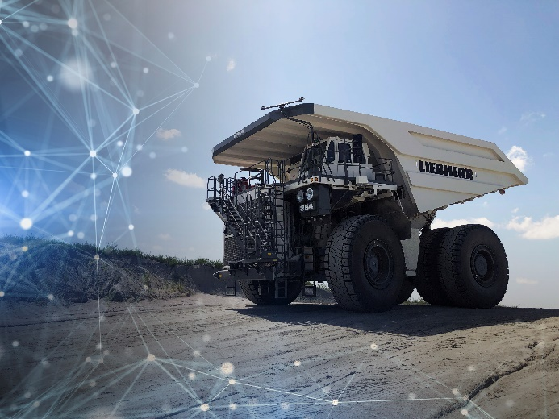

Liebherr-autonomous-haulage-solution.jpg  
Liebherr’s autonomous haulage solution delivers the next generation of onboard intelligence.

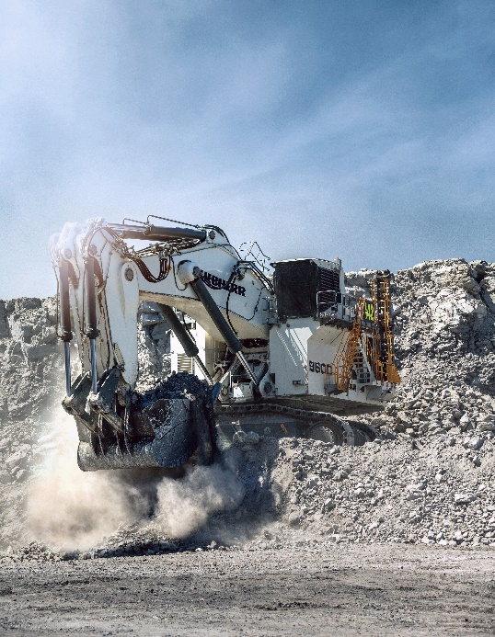

Liebherr-r9600-BFA.jpg  
Bucket Filling Assistant is the first automation product to support the Liebherr hydraulic excavator portfolio.

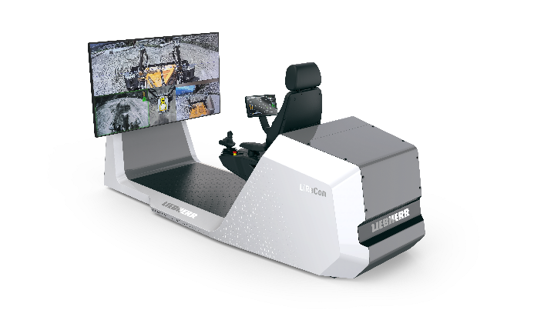

Liebherr-lirecon-teleoperations-stand.jpg  
Liebherr Remote Control teleoperation system offers increased safety, comfort, and productivity for the operation of Liebherr mining dozers.

**Contact person**

Swann Blaise    
General Manager, Marketing and Business Intelligence     
Telephone: +1 757 928 2239    
E-Mail: swann.blaise@liebherr.com

**Published by**

Liebherr-Mining Equipment Colmar SAS     
Colmar / France    
www.liebherr.com