Press release

Liebherr presents rough-terrain crane LRT 1090-2.1 at MINExpo in Las Vegas

⸺

The LRT 1090-2.1 rough-terrain crane is on display at the Liebherr booth at MINExpo 2021 in Las Vegas

Designed with a focus on safety, the LRT 1090-2.1 features VarioBase ® variable support base and a comfortable and safe cabin for crane operators

**Liebherr is showcasing the LRT 1090-2.1 rough-terrain crane at MINExpo International® 2021 in Las Vegas from 13-15 September. The 100-US-ton (90 metric tonnes) crane was designed to deliver a high safety level. It is fitted as standard with an outrigger monitor, which automatically detects the support status and includes it in the crane control system. It is also delivered as standard with the VarioBase® variable support base, enhancing flexibility on site and increasing the crane’s lifting capacity.**

Las Vegas (USA), 13 September 2021 - High safety levels in every respect were the main priority for the design of the Liebherr LRT 1090-2.1 rough-terrain crane. It features an outrigger monitoring system as standard. The support status, on tyres or outriggers, is detected automatically and saved to the crane controller. The attachment of the ballast to the turntable and the installation of the optional double folding jib including its angle adjustment are also recorded and monitored.

The VarioBase® variable support base developed by Liebherr, and fitted as standard on the LRT 1090-2.1, makes an important contribution to enhancing safety. VarioBase® allows each individual outrigger beam to be extended to arbitrary lengths. The crane work is controlled by the load moment limiter within the LICCON controller which calculates the maximum load capacities precisely for the current situation. This prevents accidents by human error during the assembly process and when hoisting loads. VarioBase® also provides greater flexibility on site. As a result of the increased lifting capacities when hoisting over the supports, the crane can hoist loads normally reserved for the next size crane class.

Safety is also enhanced by providing greater comfort for the crane operator. For example, the crane cabin is 220 mm / 8.5" wider than other standard cabins on the market. It can be tilted backwards to provide greater comfort when hoisting loads to great heights. Clear, self-explanatory controls make the crane easy to handle. They allow the crane operator to focus on the task at hand: working with the crane and the load. A cooler and USB charging socket are standard features in the cabin.

Ladders, a large number of handles, and an electrically extending platform on the cabin, ensure safe access to the crane. The LRT 1090-2.1 features a wide range of storage boxes for accessories, rigging equipment, and support timber as standard. There is also a storage facility for the crane hook.

**Excellent off-road capacity and low cost global transport**

The LRT 1090-2.1 is powerful and robust, has excellent off-road capability, and is also highly manoeuvrable. It is powered by a Cummins diesel engine which meets all current emissions regulations. The 201 kW / 270 hp engine supplies a maximum torque of 990 Nm / 730 lb-ft. A 6-speed powershift transmission from DANA and large 29.5 R25 tyres guarantee the required off-road capability for the crane. All-wheel and crab steering ensure easy handling and high manoeuvrability in constricted conditions.

The LRT 1090-2.1 measures 3.87 m / 12'8" in height and 3.3 m / 10'10" wide and is transported on public roads with a low loader. The crane’s curb weight is less than 121,000 lbs (55 tonnes) with complete equipment including ballast, or under 88,000 lbs (40 tonnes) without ballast and equipment, meaning the crane can be transported worldwide at low cost. The LRT 1090-2.1 can be readied for use quickly and is easy to assemble once onsite. The outrigger pads, which remain inside the width of the vehicle, contribute to this quick setup as they are not required to be removed for transport.

**High lifting capacities with long telescopic boom**

The LRT 1090-2.1 features a 47 m / 154 ft telescopic boom. Its telescoping system consists of a two-stage hydraulic cylinder with a rope extension mechanism. The boom can be extended easily with two telescoping modes: strong or long. The extension mechanism has been designed for high telescoping lifting capacities.

A second winch and the rooster sheave are included as standard on the basic machine for two-hook operation. As an option, a 10.5 - 19 m / 34.5 - 62 ft double folding jib can be installed on the telescopic boom. It can be attached at an angle of 0°, 20° or 40°.

About Liebherr-Werk Ehingen GmbH

Liebherr-Werk Ehingen GmbH is a leading manufacturer of mobile and crawler cranes. Its range of mobile cranes extends from 2-axle 35 tonne cranes to heavy duty cranes with a lifting capacity of 1200 tonnes and a 9-axle chassis. Its lattice boom cranes on mobile or crawler crane chassis deliver lifting capacities of up to 3000 tonnes. With universal boom systems and extensive additional equipment, they can be seen in action on construction sites throughout the world. The Ehingen site has a workforce of 3,500. Extensive, global service guarantees the high availability of Liebherr mobile and crawler cranes. In 2020, the Liebherr plant in Ehingen recorded a turnover of 2 billion euros.

About the Liebherr Group

The Liebherr Group is a family-run technology company with a highly diversified product portfolio. The company is one of the largest construction equipment manufacturers in the world. It also provides high-quality and user-oriented products and services in a wide range of other areas. The Liebherr Group includes over 140 companies across all continents. In 2020, it employed around 48,000 staff and achieved combined revenues of over 10.3 billion euros. Liebherr was founded in Kirchdorf an der Iller in Southern Germany in 1949. Since then, the employees have been pursuing the goal of achieving continuous technological innovation, and bringing industry-leading solutions to its customers.

Image

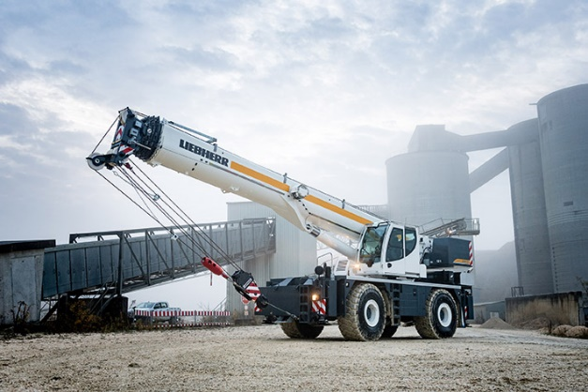  
  
liebherr-lrt1090-2.1.jpg   
The Liebherr rough-terrain crane LRT 1090-2.1 is designed for high capacity and safety.

**Contact person**

Wolfgang Beringer  
Marketing and Communication  
Phone: +49 7391/502-3663  
E-Mail: wolfgang.beringer@liebherr.com

**Published by**

Liebherr-Werk Ehingen GmbH   
Ehingen (Donau) / Deutschland  
[www.liebherr.com](http://www.liebherr.com)