

Press release

Liebherr unveils latest additions to mining equipment portfolio

⸺

The introduction of the R 9150 G7, R 9200 G7, and R 9600 G8, also marks the beginning of a new naming strategy for Liebherr mining excavators, using a generation status based on the technology level within the equipment.

The integration of the D9816 diesel engine into the new T 274 truck marks the launch of the Liebherr D98 engine series for Liebherr mining equipment.

Liebherr Remote Control teleoperation boosts safety, comfort, and productivity for the PR 776 Liebherr mining dozer.

Liebherr has unveiled its latest innovative equipment, technology, and services for the mining industry at MINExpo International® in Las Vegas. The display at the expo, which includes products from Liebherr’s Mining, Components, as well as Mobile and Crawler Cranes product segments, showcases Liebherr’s cutting-edge developments improving operational safety, sustainability, and performance.

Las Vegas (USA), 13 September 2021 – Liebherr presents the latest editions and upgrades for its mining product range at MINExpo International® 2021. Including equipment from its hydraulic excavator, haul truck, dozer, components, and rough terrain mobile crane product lines, the OEM’s product developments have been driven by modern technology to improve safety, sustainability, and performance for the mining industry.

New technology generation status for Liebherr excavators

Liebherr Mining has introduced a new naming strategy for its hydraulic excavator product line. To achieve alignment within the Earthmoving and Mining product segments of the Liebherr Group, a generation status based on the technology level within the equipment will be used to provide product designations.

Liebherr’s current excavator product line begins with Generation 6, with the R 9150 and R 9200 holding Generation 7 status, and the newly released R 9600 holding the most technologically advanced generation status, Generation 8.

R 9150 G7 excavator - highest excavating forces with reduced fuel consumption

The newest generation of the R 9150 is presented on the MINExpo booth. The 130 t / 143 ton excavator with the proven 565 kW / 757 HP Liebherr V12 diesel engine is equipped with an 8.8 m3 / 11.5 yd3 EVO bucket and Liebherr GET.

The R 9150 G7 is a perfect loader for 50 t up to 100 t trucks and offering a wide array of uses, this machine reaches the highest excavating forces and an optimal cycle time.

All Generation 7 mining excavators will be equipped with the necessary hardware to receive the optional Assistance Systems and will be equipped with Liebherr Power Efficiency (LPE) as standard. This specific engine and hydraulic management drastically reduces fuel consumption by adapting piloting processes according to operator requirements and machine condition, by electronically controlling pressure and oil flow and by reducing hydraulic throttling and load profile of the engine for increased component lifetime.

The machine also comes with an intelligent power management system with a closed-loop swing circuit. Kinetic energy is recovered when the swing motion is used during deceleration to drive the main and auxiliary pumps. Together with LPE, this reduces fuel consumption even more and supports faster boom lift speed. Cylinder dampening through IMUs provides smoother attachment movements without affecting attachment speed.

The independent cooling system provides independently and electronically managed oil and water-cooling fans. The oversized cooling systems reduce parasitic demand on engine horsepower ensuring maximum available horsepower is provided to the excavator working circuits.

The valve bank control system has also been renewed with under slung arch hoses to improve lifetime, new flow optimised hose fittings, reduced hydraulic pressure losses, and pilot valves integrated into valve blocks.

R 9600 G8 excavator – new standards

Earlier this year Liebherr Mining launched the new R 9600 after years of development. This 600 t excavator sets new standards in open pit mining. The successor of the popular R 996B entered the market after gaining a year of field experience in Australia, the largest market for 600 t class excavators. A total of 9 units will have been commissioned in the country by end of 2021. The R 9600 will enter serial production at the end of this year.

Customer input has played an important and pivotal role in the development of this new machine. Engineering, sales, and marketing teams have collected feedback and insights from mine site equipment operators, maintenance personnel, and procurement groups as well as executive management to have a clear understanding of the challenges they meet every day. The new R 9600 aims to reach the highest standard in terms of safety, sustainability, performance, lifetime, Total Cost of Ownership (TCO), ease of maintenance, and more.

In April 2021, a production study was conducted by Liebherr-Australia at Curragh North mine site to measure operational efficiency of the new R 9600 as an individual unit, as well as in comparison to the R 996B operating at the site. Thiess Pty Ltd has held successive mining services con­tracts at Curragh North since 2004. This production study determined the R 9600 to be 19.6% more productive and 19.8% faster than the R 996B on site. With 18.2% less annual fuel consumption, the new Liebherr 600 t class mining excavator has 40% more fuel efficiency than its predecessor.

The clear advantages of the R 9600 not only in comparison to the R 996B but also as a leader in the   
600 t mining excavator class, has led the customer Thiess to purchase two additional R 9600 units for 2022 for a separate mining services contract.

The R 9600 is equipped with two QSK50 Cummins engines with advanced combustion technologies. For emission regulated regions, a US EPA Tier 4f / EU Stage V compliant version is available with the latest SCR after-treatment technology. Complying with stringent emission regulations, the SCR system reduces nitrogen oxides by injecting a liquid reductant into the exhaust stream.

An electric drive version will soon be available - a productive choice to balance performance with environmental consciousness.

This Generation 8 hydraulic excavator also includes the newest technological innovations developed by Liebherr Mining. The excavator is equipped as standard with Liebherr Power Efficiency, Assistance Systems (included in the first year) with a large 15” touch screen, and the latest electronic architecture leading the way towards machine automation and state-of-the-art on-board technologies.

On the MINExpo booth, visitors can interact with the brand-new R 9600 cab designed by operators for operators – it is a first-class 14 m3 / 494 ft3 working space. The cab design reduces vibrations and limits noise to 69 dB(a), providing a comfortable working environment for the operator.

T 274 mining truck

Liebherr has recently extended its product offering with the T 274, a class-leading 305 t / 336 tons haul truck. This new truck bridges the gap between the T 284 and T 264. Designed and adapted from years of experience in mining truck development, the T 274 is a true 305 tonne machine that provides fast cycle times, higher production rates, low fuel consumption, and a low cost per tonne. This new truck follows the same base design as the T 284, benefitting from its decades of field experience. Operators and technicians can expect to experience first-class comfort and safety while driving and servicing this truck.

A wide range of options are available for the T 274 and the entire Liebherr haul truck product line, including the Liebherr Trolley Assist System and the newly announced Liebherr next generation, interoperable machine automation.

The T 274 presented at MINExpo is equipped with the Liebherr D9816 engine. This marks the beginning of the engine series integration into Liebherr mining equipment.

Trolley Assist System

As displayed on the T 274 at MINExpo 2021, the Liebherr Trolley Assist System uses an overhead pantograph to connect the electric-drive system to a mine site’s electrical network, fuelled by the customer’s energy source of choice. The Trolley Assist System offers increased truck fleet productivity, or reduction in fleet size, while maintaining yearly production when compared with standard trucks.

The potential for significant reduction of diesel fuel consumption and carbon footprint by decreasing the truck fleet’s CO2 emissions, demonstrates the Trolley Assist System as an effective first step on the road to zero emission mine sites of the future.

Liebherr already delivers proven field experience with 45 Liebherr trucks fitted with the Trolley Assist System currently in operation across three mine sites, with more to be commissioned in 2022.

Liebherr engine integration

The integration of the D9816 into the new T 274 marks an important milestone for Liebherr-Components and Liebherr Mining: the integration of the latest engine series in Liebherr mining equipment. The Liebherr Group’s shared in-house competencies across different product segments further strengthen the company’s vertical integration strategy.

Specifically designed for the mining industry, the D98 series completes the already existing Liebherr engine portfolio for mining equipment and expands it to the upper power range. The series will be offered as an alternative option to the already existing engines.

Liebherr engines have already proven their performance in smaller size excavators and dozers. With the D98, Liebherr offers further advantages also for larger excavators and trucks. In addition, the engine series provides for outstanding low fuel consumption and emission reduction. The engine is also compatible for use with Hydrotreated Vegetable Oil (HVO) fuel that can significantly reduce C02 emissions. With this, Liebherr is pursuing major assets for its Mining Zero Emission Program. Various units of the series are already in operation in different countries worldwide, showing positive results.

PR 776 mining dozer and Liebherr Remote Control

Liebherr’s flagship mining dozer has set a new benchmark in efficient dozing in the mining industry. As the only 70 t class mining dozer featuring a hydrostatic travel drive, and an average of 38 litres of fuel burnt per hour, the PR 776 offers best-in-class efficiency for customers. Powerful Liebherr diesel engines in combination with the standard ECO mode, allows operators to choose between high performance and maximum efficiency. Field experience proves the PR 776’s pushing performance ability with best-in-class tonnes-per-litre.

To withstand the ambient temperatures in different regions, the PR 776 dozer can be optionally equipped with an arctic package. In addition, a special high-altitude package has been developed to handle oxygen saturation of only 50%, as implemented in a copper mine in Maizhokunggar Tibet, situated nearly 5,500 meters above sea level.

Liebherr mining dozers provide first class cabin comfort. Operators appreciate the convenience and simplicity of a single joystick. Safety is enhanced via 360-degree blade and ripper visibility, provided by large panoramic windows and integrated ROPS / FOPS in the cab structure.

Introduced for the first time at MINExpo, Liebherr Remote Control (LiReCon) teleoperation system offers increased safety, comfort, and productivity for the operation of Liebherr mining dozers in challenging and dangerous work conditions. Suitable for all dozer applications, LiReCon is the result of continuous development from Liebherr and their expertise with dozers and teleoperation systems.

This next generation teleoperation system consists of the Liebherr Remote Control teleoperation stand (a state-of-the-art operator workspace with all required controls) and onboard dozer installations: cameras for all different angles and views, microphones for recording machine sounds, radio link receiver and transmitter. The high-resolution main screen provides a complete view of the worksite and around the dozer. The optional active person recognition system identifies people and obstacles in the work area further enhancing safety.

As standard, LiReCon uses a secure self-contained radio mesh network that can be extended by additional gateways, enabling high signal quality even in difficult terrain or long range. The LiReCon package can be tailored to each customer and mine site depending on their specific requirements and can also integrate into an existing network.

LiReCon allows fast shift changes between operators and reduces idle and downtime. As the operator is no longer tied to the machine, LiReCon also enables customers to access new extraction areas, safely extending the range of applications for Liebherr mining dozers.

About the Liebherr Group

The Liebherr Group is a family-run technology company with a highly diversified product portfolio. The company is one of the largest construction equipment manufacturers in the world. It also provides high-quality and user-oriented products and services in a wide range of other areas. The Liebherr Group includes over 140 companies across all continents. In 2020, it employed around 48,000 staff and achieved combined revenues of over 10.3 billion euros. Liebherr was founded in Kirchdorf an der Iller in Southern Germany in 1949. Since then, the employees have been pursuing the goal of achieving continuous technological innovation, and bringing industry-leading solutions to its customers.

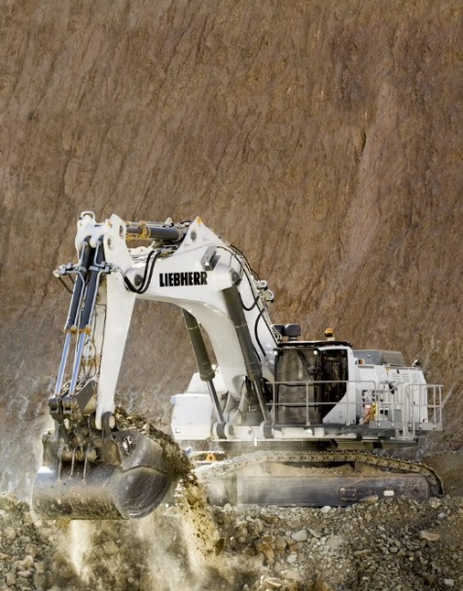Images

Liebherr-R-9150-G7.jpg   
The Truck Loading Assistant helps the operator to achieve optimal truck payloads and avoid truck under- and overloading.

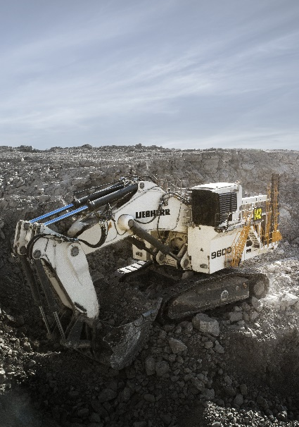

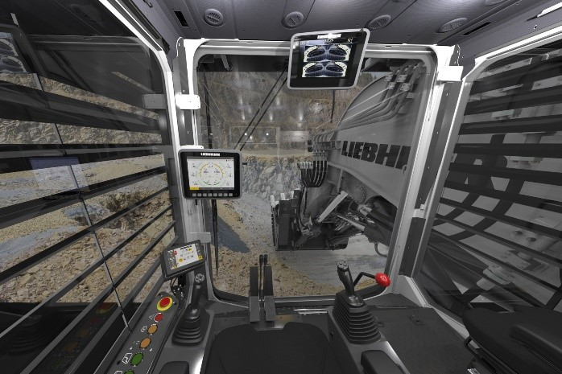Liebherr-r9600-excavator.jpg   
R 9600, the next generation of Liebherr mining excavators

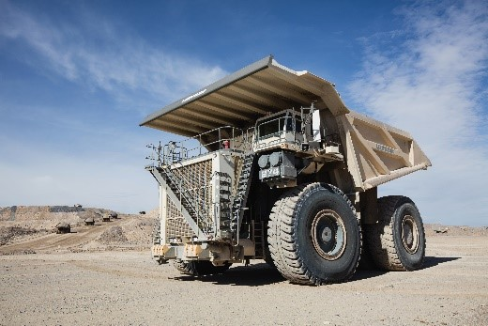Liebherr-R-9600-cab.jpg   
The brand new cab of the R 9600.

Liebherr-T274-mining-truck.jpg

The T 274 is a true 305 tonne machine that provides fast cycle times, higher production rates, low fuel consumption, and a low cost per tonne.

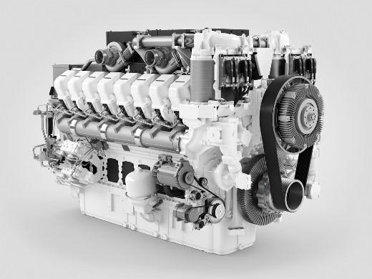

liebherr-diesel-engine-d9816-mining.jpg

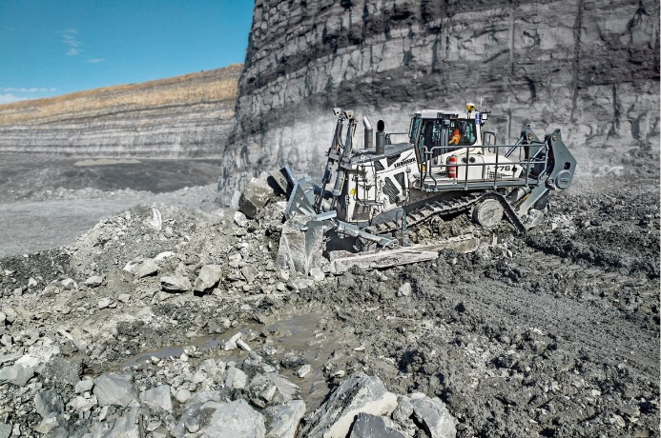The T 274 equipped with the Liebherr D9816 engine marks the beginning of the engine series integration into Liebherr mining equipment.

Liebherr-pr776-mining-dozer.jpg  
The PR 776 70 tonne mining dozer.

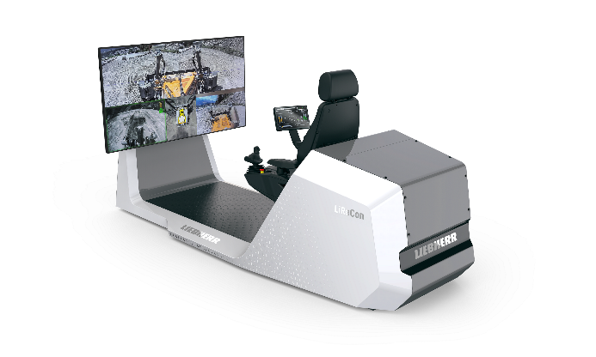

liebherr-lirecon-teleoperations-stand.jpg

The PR 776 dozer will feature the new LiReCon Liebherr teleoperation system, which provides additional comfort and safety for operators in tough mining applications.

Contact person

Swann Blaise    
General Manager, Marketing and Business Intelligence     
Telephone: +1 757 928 2239    
E-Mail: swann.blaise@liebherr.com

Published by

Liebherr-Mining Equipment Colmar SAS     
Colmar / France    
www.liebherr.com