

Press information

“Blue Beast” makes its debut – first Liebherr LTM 1650-8.1 for ALL Erection & Crane Rental

⸺

New Liebherr LTM 1650-8.1 delivered to ALL Erection & Crane Rental

First lift took place in Cleveland, Ohio, United States

The 8 axle crane convinced at first sight

**The newly delivered LTM 1650-8.1, called the “Blue Beast” performed its first lift for ALL Erection & Crane Rental. Delivering an outstanding performance at the first job site, the equipment specialist from ALL is looking forward to the upcoming jobs with the new 700 t ( 770 US-t) crane.**

Ehingen (Donau) (Germany), 23 September 2021 – The “Blue Beast", an all-terrain crane with the industry’s largest lifting capacity on eight axles, made its debut recently on a project at a Veterans Administration Hospital in Cleveland, Ohio, United States. The newly delivered Liebherr LTM 1650-8.1, dubbed the “Blue Beast” due to its cobalt blue paint job, performed its inaugural lift for ALL Erection & Crane Rental, the flagship branch of the ALL Family of Companies.

Introduced at Bauma, the world’s leading construction machinery trade fair in 2019, the LTM 1650-8.1 is Liebherr’s successor to the LTM 1500-8.1, the best-selling large crane ever. It ups the ante with a 700 t (770 US-t) capacity, exceeding its predecessor’s capacity by between 15 and 50 percent, depending on the equipment package selected. Units are made-to-order, with ALL placing its order very early enabling a delivery in the second quarter of 2021.

**Perfect capacity for the job**

The job at the VA hospital involved construction of a mechanical room and lifting six air handler sections. The crane was set up on the street and had to lift over another building to reach the work area. Its capacity was perfect for the job. “Given where we had to set up the crane, higher-capacity machines wouldn’t have fit, and cranes small enough to fit couldn’t lift the necessary weight at that distance,” said Brian Meek, equipment specialist for ALL Crane.

One of the hallmarks of the LTM 1650-8.1’s design is its ability to set up close to buildings and obstructions while safely maintaining its swing, going where possibly no All Terrain crane of its size could ever go before. Beside other features, this is also offered by the VarioBallast® system, which provides high performance with a smaller ballast radius. Ballast radius can be infinitely adjusted between 6,4 and 8,4 m (21 and 27.5 ft) using a simple hydraulic slewing mechanism.

In tight spaces, even with its back literally against a wall, it will still handle significant picks. It gives plant and facility managers a new way of thinking about how they maintain equipment and where they can install bigger pieces of equipment.

The LTM 1650-8.1 also has two telescopic boom lengths 54 or 80 m (177 or 263 ft) with an easy change system, adding great flexibility. The long boom system is available when needed, and the short one reduces transport costs and setup time. The long boom configuration is also ideal for long-reach, up-and-over applications, providing additional luffing jib strength – just like conditions encountered in the inaugural job.

**Convincing right from the start**

In this instance, 22 m (73 ft) of main boom included 87 m (287 ft) of luffing jib. It could easily handle the 7 t (17,000-pound) air handler sections, each 9 m (30 ft) long. The operator picked each section from a flatbed parked on the street, lifted and swung over the interceding building, and set each piece atop the target structure behind it.

“This lift is a perfect showcase for the capabilities of the LTM 1650-8.1,” said Meek. “It has the footprint of a 500 t crane and packs the punch of a 700 t crane. I’ve never seen a large crane built this efficiently. Its assembly is much smoother than even a typical 600 t crane, which will save money on set-up for customers in the long run. I’m excited to see what doors this crane will open to new kinds of jobs.”

**About ALL**

The ALL Family of Companies is one of the largest privately held crane rental and sales operation in North America, with 33 branches operating under the ALL, Central, Dawes, Jeffers, and ALT names. Since 1964, the ALL Family has been a leader in the heavy lift industry, offering rental, sales, parts, and unparalleled service to customers. Our market strengths include commercial construction, roads & bridges, power generation, plants & processing, facility maintenance and more. With one of the largest and most modern fleets of equipment on the continent and generations of industry veterans who lend their experience every day, we are proud to say that no job is too tough for ALL.

About Liebherr-Werk Ehingen GmbH

Liebherr-Werk Ehingen GmbH is a leading manufacturer of mobile and crawler cranes. Its range of mobile cranes extends from 2-axle 35 tonne cranes to heavy duty cranes with a lifting capacity of 1200 tonnes and a 9-axle chassis. Its lattice boom cranes on mobile or crawler crane chassis deliver lifting capacities of up to 3000 tonnes. With universal boom systems and extensive additional equipment, they can be seen in action on construction sites throughout the world. The Ehingen site has a workforce of 3,600 employees. Extensive, global service guarantees the high availability of Liebherr mobile and crawler cranes. In 2020, the Liebherr plant in Ehingen recorded a turnover of 2 billion euros.

About the Liebherr Group

The Liebherr Group is a family-run technology company with a highly diversified product portfolio. The company is one of the largest construction equipment manufacturers in the world. It also provides high-quality and user-oriented products and services in a wide range of other areas. The Liebherr Group includes over 140 companies across all continents. In 2020, it employed around 48,000 staff and achieved combined revenues of over 10.3 billion euros. Liebherr was founded in Kirchdorf an der Iller in Southern Germany in 1949. Since then, the employees have been pursuing the goal of achieving continuous technological innovation, and bringing industry-leading solutions to its customers.

**Pictures**

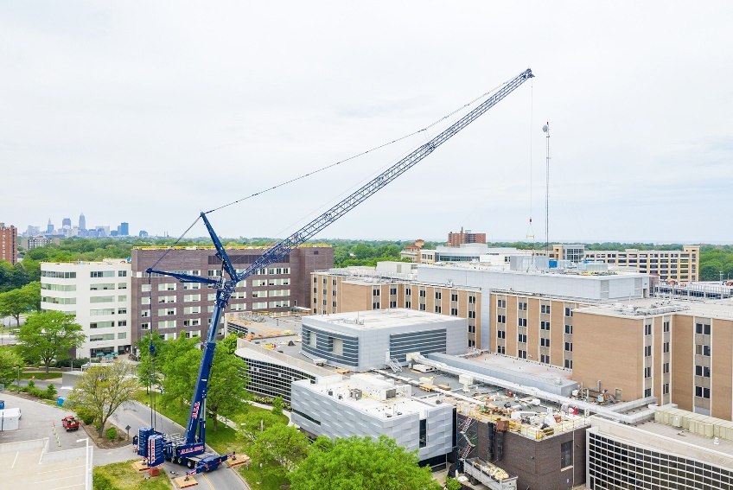

liebherr-all-kran-ltm1650-8.1-ohio1.jpg  
The new LTM 1650-8.1 from ALL on its first job in Ohio, US.

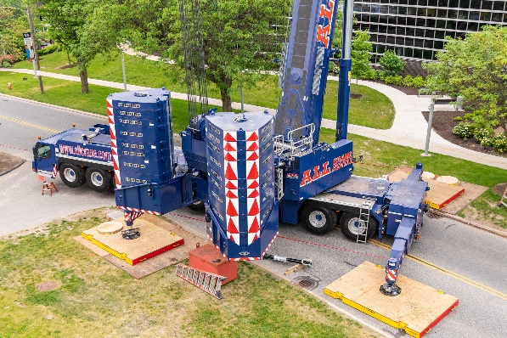

liebherr-all-kran-ltm1650-8.1-ohio2.jpg  
Set up in a quite tight enclosure, the new mobile crane convinced its owner completely.

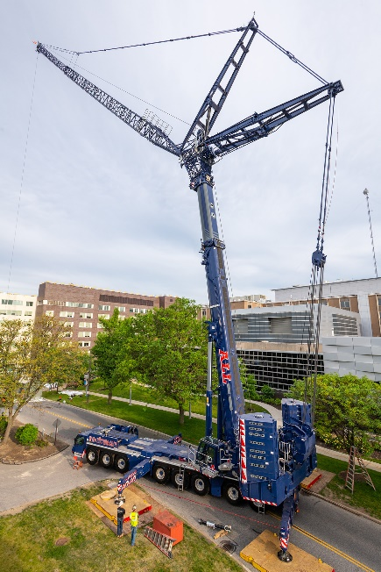

liebherr-all-kran-ltm1650-8.1-ohio3.jpg   
The long boom system was necessary to lift the load across the first building onto the VA Hospitals.

Contact:

Wolfgang Beringer  
Marketing and Communication  
Telefon: +49 7391 / 502 - 3663  
E-Mail: [wolfgang.beringer@liebherr.com](mailto:wolfgang.beringer@liebherr.com)

Published by

Liebherr-Werk Ehingen GmbH   
Ehingen (Donau) / Deutschland  
www.liebherr.com