

Press release

Crane fleet expansion – Baumann takes delivery of Liebherr LTM 1150-5.3 mobile crane

Baumann closes gap between 130 and 200 tonne lifting capacity

Powerful 66 metre telescopic boom and extremely compact dimensions of the LTM 1150-5.3 win the order

Viktor Baumann GmbH & Co. KG has 130 years of experience in heavy haulage, crane operations and assembly work

Viktor Baumann GmbH & Co. KG from Bornheim has taken delivery of a new Liebherr LTM 1150‑5.3 mobile crane. The crane and heavy haulage contractor from the south of North Rhine Westphalia intends to use the 150 tonne machine to expand its range of services with 5-axle cranes. The compact dimensions of the LTM 1150-5.3 and its 66 metre telescopic boom were the main criteria behind the decision to buy it.

Ehingen (Donau) (Germany), 28 September 2021 – “We wanted to close the gap between 130 and 200 tonnes of lifting capacity in our fleet”, explains Sabine Baumann-Duvenbeck. The Managing Director of Viktor Baumann GmbH & Co. KG is delighted with the decision to buy a 150 tonne mobile crane: “With its 66 metre telescopic boom, the LTM 1150-5.3 has a very long mast with good lifting capacity values, yet is also very compact.”

**Long, powerful telescopic boom**

Liebherr first unveiled the new LTM 1150-5.3 to the public in autumn last year as the successor to the LTM 1130-5.1, around 1500 of which had been built. The telescopic boom on the new crane is six metres longer than the one on its predecessor. At the same length of 60 metres, the new 5-axle crane can hoist twelve tonnes when fully raised – 1.5 tonnes more than its predecessor. When fully extended to 66 metres, the new crane has a lifting capacity of over nine tonnes. That makes it perfect for erecting tower cranes and radio masts. Lattice extensions enables the new 150-tonne crane to achieve hook heights of up to 92 metres and radii of up to 72 metres.

As a result of its long boom, Baumann is planning to use the new LTM 1150-5.3 for erecting and dismantling construction cranes and for jobs in chemical plants where high hoisting heights are required.

Despite the average 15 percent higher performance, the Liebherr engineers managed to match the low gross weight of the predecessor crane – with an axle load of twelve tonnes, the new LTM 1150-5.3 can carry nine tonnes of ballast on public roads. Sabine Baumann-Duvenbeck continues: “That makes the LTM 1150-5.3 ideal for versatile, flexible use. The new crane also features some fantastic technical equipment such as ECOmode and ECOdrive to save on fuel consumption and CO2 emissions and also to reduce noise.”

Viktor Baumann GmbH & Co. KG has 130 years of experience in heavy haulage, crane operations and assembly work. The company currently employs around 120 staff and operates 26 cranes, 24 of which were supplied by Liebherr.

About Liebherr-Werk Ehingen GmbH

Liebherr-Werk Ehingen GmbH is a leading manufacturer of mobile and crawler cranes. Its range of mobile cranes extends from 2-axle 35 tonne cranes to heavy duty cranes with a lifting capacity of 1200 tonnes and a 9-axle chassis. Its lattice boom cranes on mobile or crawler crane chassis deliver lifting capacities of up to 3000 tonnes. With universal boom systems and extensive additional equipment, they can be seen in action on construction sites throughout the world. The Ehingen site has a workforce of 3,500. Extensive, global service guarantees the high availability of Liebherr mobile and crawler cranes. In 2020, the Liebherr plant in Ehingen recorded a turnover of 2.03 billion euros.

About the Liebherr Group

The Liebherr Group is a family-run technology company with a widely diversified product range. The company is one of the largest manufacturers of construction machines in the world, but also supplies technically advanced, user-focused products and services in many other sectors. The group currently comprises more than 140 companies based in every continent of the world, has a workforce of around 48,000 and recorded a consolidated total turnover of more than 10.3 billion euros in 2020. Since it was founded in 1949 in Kirchdorf an der Iller in southern Germany, Liebherr’s aim has been to win customers by supplying high quality solutions and to contribute to technological progress.

**Photographs**

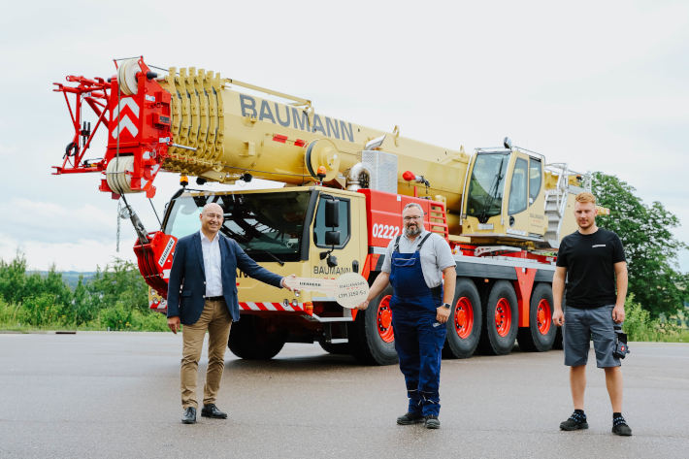

liebherr-ltm1150-5-3-baumann.jpg  
Crane handover in Ehingen. From left to right: Erich Schneider (Liebherr-Werk Ehingen GmbH), Kai Wiering (Viktor Baumann GmbH & Co. KG) and Marcellus Abele (Liebherr-Werk-Ehingen GmbH).

Contact person

Wolfgang Beringer  
Marketing and Communication  
Phone: +49 7391/502 - 3663  
Email: wolfgang.beringer@liebherr.com

Published by

Liebherr-Werk Ehingen GmbH  
Ehingen (Donau) / Germany  
www.liebherr.com