Press release

Liebherr exclusive provider for Lineage 1000 landing gear overhaul

⸺

Liebherr-Aerospace has been selected by Embraer as its exclusive provider of landing gear overhaul services for the whole Lineage 1000 fleet for the next ten years. The overhauls will be performed at Liebherr-Aerospace’s OEM facility in Lindenberg (Germany).

Lindenberg (Germany), September 2021 – Liebherr-Aerospace recently struck up an exclusive partnership with Embraer covering the overhaul services for the landing gear systems of the Lineage 1000 until 2031. The agreement marks a significant step forward in Liebherr’s successful worldwide landing gear overhaul campaign.

“We are very honored and proud to count Embraer Executive Jet Services among our customers. This exclusive contract represents another major milestone in our long-term partnership trajectory. Our teams are ready and fully committed to provide to Embraer and its customers the best in class experience on landing gear overhauls,” said Christian Franz, Director Customer Services at Liebherr-Aerospace Lindenberg (Germany).

“We are glad to announce the agreement with Liebherr-Aerospace for this essential service. Our Lineage customers will be very well served by Liebherr’s experience and knowledge,” said Marsha Woelber, Head of Worldwide Executive Jets Customer Support & Aftermarket Sales, Embraer Service & Support.

The Embraer Lineage 1000 is an ultra-large private jet based on the successful E190 commercial aircraft platform. After its entry-into-service, in 2009, Embraer launched a new variant, the Lineage 1000E, in 2013, and today the aircraft is operated all over the world.

The complete landing gear system for the Lineage 1000 has been developed, manufactured and certified by the OEM Liebherr-Aerospace in Lindenberg (Germany), Liebherr’s center of competence for flight controls, actuation, landing gear systems, gears, gearboxes as well as electronics.

About Liebherr-Aerospace & Transportation

Liebherr-Aerospace & Transportation SAS, Toulouse (France), is one of eleven divisional control companies within the Liebherr Group and coordinates all activities in the aerospace and transportation systems sectors.

Liebherr-Aerospace is a leading supplier of systems for the aviation industry and has more than six decades of experience in this field. The range of aviation equipment produced by Liebherr for the civil and military sectors includes flight control and actuation systems, gears and gearboxes, landing gear and air management systems as well as electronics. These systems are deployed in wide-bodied aircraft, single aisle and regional aircraft, business jets, combat aircraft, military transporters, military training aircraft, civil helicopters and combat helicopters.

Liebherr’s aerospace and transportation systems division employs around 6,000 people. It has four aviation equipment production plants at Lindenberg (Germany), Toulouse (France), Guaratinguetá (Brazil) and Nizhny Novgorod (Russia). These production sites offer a worldwide service with additional customer service centers in Saline (Michigan/USA), Seattle (Washington/USA), Montreal (Canada), Hamburg (Germany), Moscow (Russia), Dubai (UAE), Bangalore (India), Singapore and Shanghai (People’s Republic of China).

About the Liebherr Group

The Liebherr Group is a family-run technology company with a highly diversified product portfolio. The company is one of the largest construction equipment manufacturers in the world. It also provides high-quality and user-oriented products and services in a wide range of other areas. The Liebherr Group includes over 140 companies across all continents. In 2020, it employed around 48,000 staff and achieved combined revenues of over 10.3 billion euros. Liebherr was founded in Kirchdorf an der Iller in Southern Germany in 1949. Since then, the employees have been pursuing the goal of achieving continuous technological innovation, and bringing industry-leading solutions to its customers.

Image

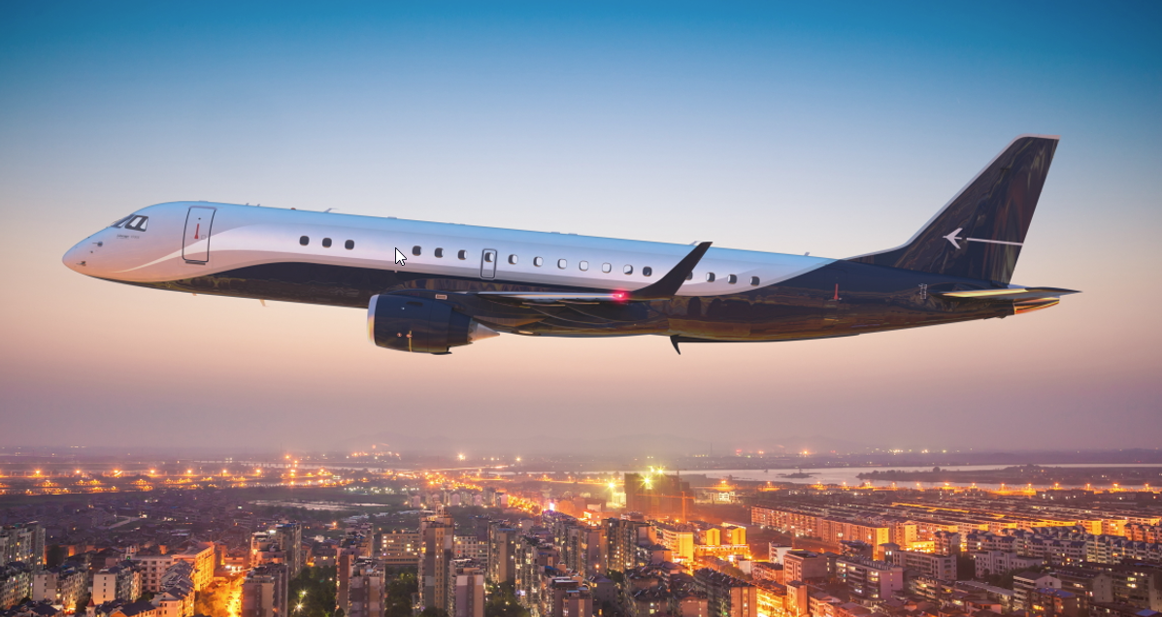

Lineage-1000E-Exterior.jpg  
Liebherr has developed and manufactured the landing gear system of the Lineage 1000. - © Embraer

Contact person

Ute Braam  
Corporate Communications  
Phone: +49 8381 / 46 - 4403  
E-Mail: ute.braam@liebherr.com

Published by

Liebherr-Aerospace & Transportation SAS   
Toulouse / France  
www.liebherr.com