

Press release

Allamanno: Liebherr wheel loader and crawler excavator in the French département of Hautes-Alpes

⸺

L 538 Wheel Loader: Convincing safety, reliability and performance

R 922 G8 Crawler Excavator: Quality and performance are crucial

LIKUFIX: standard at Allamanno for a long time now

Allamanno has recently purchased an L 538 wheel loader and an R 922 crawler excavator. The machines meet all the customer's safety and quality requirements. In the future, they will work both in urban environments and in the preparation of ski slopes at higher altitudes.

Colmar (France), 9 September 2021 – In addition to its performance and reliability, the Liebherr L 538 Allamanno wheel loader also impressed with its safety concept - a very important point for both partners. The L 538 is equipped with an active assistance system for detecting people, a solution developed by Liebherr which is fully integrated into the machine control system. It is designed to optimise the safety and comfort of the machine operator by reporting the presence of people behind the machine through audible signals and on-screen warnings. Active personnel detection can distinguish between people and objects using the latest camera technology, so that unnecessary warning signals are avoided. This reduces the driver's workload and lowers the risk of accidents: on construction sites in the city, where many people are on the move, as well as in the mountains, where visibility is not always good due to the terrain.

The R 922 G8: Versatility and productivity with the LIKUFIX hydraulic coupling system

The R 922 G8 has recently become part of Allamanno's machine fleet. Liebherr’s Generation 8 crawler excavators are characterised by high tractive and digging forces as well as increased performance, which is achieved by a powerful exhaust Stage V engine. An LED lighting system ensures additional safety. At Allamanno, they particularly appreciate the comfort and reliability of the R 922 G8, with almost 2,000 operating hours per year. It is manoeuvrable and fast and can be used for numerous classic earthworks, for example for preparing slopes before the winter season.

The new R 922, like all of Allamanno’s excavators, is fitted with a LIKUFIX hydraulic quick coupling systems which maximises the productivity of the excavator. The operator can change mechanical and hydraulic tools easily, quickly and safely from the cab. Earthmoving and trenching buckets complete the range of equipment on the R 922 G8 for the various construction sites.

A solid and close partnership

“The cooperation with Liebherr extends to concrete mixers and mobile cranes. In our collaboration with several business units of the group, we can speak of a true partnership,” confirms Aymeric Cuvelier, who is responsible for machine equipment at Allamanno. This partnership is based on shared values as well as a close relationship with a personal togetherness. “It is very important to have real contacts on the phone,” notes Aymeric Cuvelier. Equally important for Allamanno is the French or European origin of Liebherr products.

The Liebherr brand also enjoys a very good reputation for the quality and responsiveness of its after-sales service. Its efficient organisation is fully confirmed by Allamanno: “The customer service - both from Liebherr and Ets PIC - is very well organised, competent and responsive. The machines are also thoughtfully designed, especially for our mountain applications.”

About the Liebherr Group

The Liebherr Group is a family owned technology company with a broadly diversified product range. The company is one of the world's leading manufacturers of construction machinery, but also offers high-quality, user-centred products and services in many other areas. The Group today numbers more than 140 companies on all continents, employs around 48,000 staff and generated a consolidated total turnover of more than 10.3 billion euros in 2020. Since Liebherr was founded in 1949 in Kirchdorf an der Iller in southern Germany, it has pursued the objective of inspiring its customers with outstanding solutions and contributing to technological progress.

Images

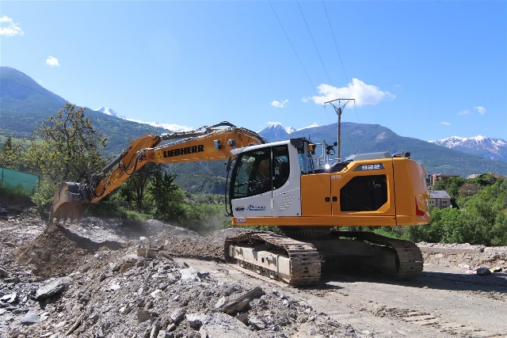

liebherr-crawler-excavator-r-922-g8-1.jpg  
The R 922 G8 crawler excavator from Liebherr on a construction site in the highlands of Embrun in the French département of Hautes-Alpes.

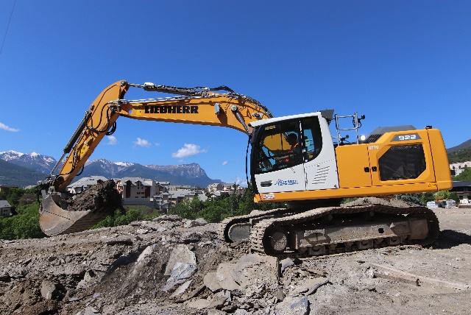

liebherr-crawler-excavator-r-922-g8-2.jpg   
The R 922 G8 offers increased productivity through the LIKUFIX hydraulic coupling system.

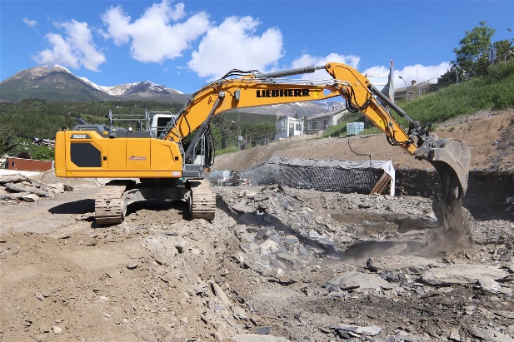

liebherr-crawler-excavator-r-922-g8-3.jpg  
With its higher digging and tractive forces, the R 922 G8 achieves significant increases in performance.

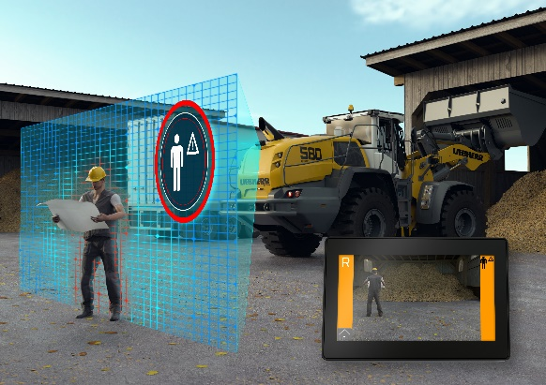

liebherr-wheel-loader-active-rear-personnel-detection.jpg  
The active rear personnel detection helps prevent accidents that result in personal injury.

Contact person

Alban Villaumé  
Marketing Manager  
Telephone: +0033 89 21 36 09  
E-Mail: alban.villaume@liebherr.com

Published by

Liebherr-France-SAS   
Colmar, France  
[www.liebherr.com](http://www.liebherr.com)