

Press release

First Liebherr crawler excavator R 934 G8 in Corsica goes to the Graziani TP company

⸺

New, more environmentally friendly generation of engines

Innovative maintenance access design

Graziani opts for a powerful and comfortable excavator

Graziani TP has been active in various areas of public and private construction since 2005. Located in the heart of the Alta Rocca, in Levie, the company benefits from its central location: The south of Corsica is also easily accessible. The company currently has 65 employees. For larger jobs such as extensive earth or rock demolition, the company was looking for an excavator with a higher weight class than the machines in its existing fleet.

Levie (France), 7 October 2021 – Managing Director Frederick Graziani particularly appreciates the reliability of the new Liebherr Generation 8 crawler excavators. He is very concerned about the profitability of his machine fleet and is therefore convinced by the new generation of excavators with their low fuel consumption.

The Liebherr branch in Rognac near Marseilles offered the company a type R 934 crawler excavator: This excavator, with a weight of around 35 tonnes, rounds off the series of Generation 8 crawler excavators. A range of working equipment is available to make it even more versatile and robust. The design of this machine ensures safe working and easy maintenance.

The right crawler excavator for Graziani TP's needs

To optimally meet Graziani TP's requirements, the R 934 G8 has been equipped with an underswing guard and Liebherr's LIKUFIX hydraulic system, which enables simple and safe tool changes from the cab. A hydraulic rock breaker (HRB) is also used to break rock into pieces and load them into trucks before transporting them to the customer.

The R 934 has the characteristic design of Generation 8 and offers increased performance. This is ensured by the higher torque of the upper carriage of these crawler excavators. The new, robust X-form undercarriages ensure greater stability. The automatic central lubrication ensures a longer service life of the parts and at the same time improves the productivity of the machines.

This new crawler excavator is now the largest in the Graziani TP fleet. With its various features, it will support Graziani TP in the further development of its business.

**High profitability – a machine produced in Europe**

The R 934 G8 features a new equipment design that optimises the load curve and improves the moment of inertia during rotation. This reduces fuel consumption compared to the previous generation of machines. It offers a low consumption of 18 l/h at a working rhythm of 6.5 hours per day. “This is very important for the profitability of the excavator,” confirms Frederick Graziani and as he further explains: “It makes no difference whether the machine is made in Italy, Germany or France. The good price-performance ratio, the good reputation of the Liebherr brand and the responsiveness of the customer service were important purchasing criteria.”

Equipped with a powerful Phase V engine, the R 934 G8 complies with European emission standards to protect the environment while offering the customer a reliable and efficient product.

About the Liebherr Group

The Liebherr Group is a family owned technology company with a broadly diversified product range. The company is one of the largest manufacturers of construction machinery in the world. In addition, it also offers high-quality, user-centred products and services in many other areas. Currently, the group comprises more than 140 companies on all continents. As of 2020, it employed more than 48,000 people and generated a total consolidated sales of more than EUR 10.3 billion. Liebherr was founded in 1949 in Kirchdorf an der Iller in southern Germany. Since then, the employees have pursued the goal of winning over customers with sophisticated solutions while contributing to technological progress.

Photos

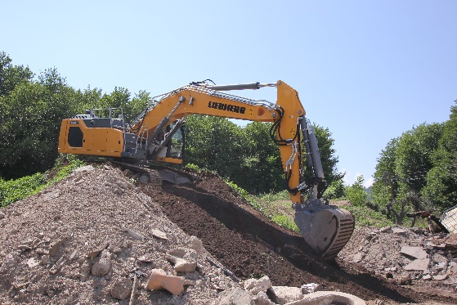

liebherr-crawler-excavator-r-934-g8-1.jpg  
The R 934 G8 has optimised traction power for easy driving on slopes.

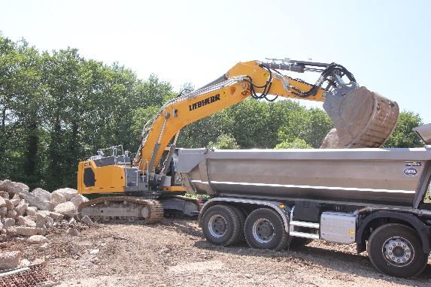

liebherr-crawler-excavator-r-934-g8-2.jpg  
Equipped with an underswing guard, the R 934 G8 enables safe truck loading.

Contact person

Alban Villaumé  
Marketing Manager  
Telephone: +33 89 21 36 09  
E-Mail: alban.villaume@liebherr.com

Published by

Liebherr-France SAS  
Colmar, France  
www.liebherr.com