Press release

Liebherr to supply thrust reverser actuation system for Rolls-Royce Pearl® 10X engine

⸺

Liebherr-Aerospace has been selected by Spirit AeroSystems to supply the thrust reverser actuation system for the Rolls-Royce Pearl® 10X engine. It is the first thrust reverser actuation system contract for Liebherr and thus marks an important milestone in the company’s history.

Lindenberg (Germany), October 2021 – Liebherr-Aerospace Lindenberg GmbH (Germany), center of excellence for flight controls, actuation, landing gear systems, gears, gearboxes as well as electronics, was selected by Spirit AeroSystems to supply the thrust reverser actuation system. A first in the history of the German aircraft OEM.

Leveraging on its expertise, Liebherr developed the new system in a short time with low development risk. It is fully compliant to the latest REACH (Registration, Evaluation and Authorization of Chemicals) requirements, which is an important step on the path towards more environmental friendly aircraft.

Liebherr profits from its knowledge of hydraulic and mechanical actuation that is proven by uncountable flight hours in commercial and business aviation. The thrust reverser actuation is being developed based on technologies that are available and mature at Liebherr.

Despite the very demanding situation during the Covid-pandemic, which allows only virtual meetings, the high quality of the cooperation between Spirit AeroSystems and Liebherr enabled the development team to achieve the first significant development milestone in time. The successful Preliminary Design Review was as well a demonstration of the seamless collaboration within the worldwide Liebherr liaison network, in this case with the Liebherr office in Seattle, WA (USA), which assures always the proximity to the Customer.

Liebherr is very pleased to be able to count Spirit AeroSystems among its customers and is looking forward to continue the successful collaboration.

About Liebherr-Aerospace & Transportation

Liebherr-Aerospace & Transportation SAS, Toulouse (France), is one of eleven divisional control companies within the Liebherr Group and coordinates all activities in the aerospace and transportation systems sectors.

Liebherr-Aerospace is a leading supplier of systems for the aviation industry and has more than six decades of experience in this field. The range of aviation equipment produced by Liebherr for the civil and military sectors includes flight control and actuation systems, gears and gearboxes, landing gear and air management systems as well as electronics. These systems are deployed in wide-bodied aircraft, single aisle and regional aircraft, business jets, combat aircraft, military transporters, military training aircraft, civil helicopters and combat helicopters.

Liebherr’s aerospace and transportation systems division employs around 6,000 people. It has four aviation equipment production plants at Lindenberg (Germany), Toulouse (France), Guaratinguetá (Brazil) and Nizhny Novgorod (Russia). These production sites offer a worldwide service with additional customer service centers in Saline (Michigan/USA), Seattle (Washington/USA), Montreal (Canada), Hamburg (Germany), Moscow (Russia), Dubai (UAE), Bangalore (India), Singapore and Shanghai (People’s Republic of China).

About the Liebherr Group

The Liebherr Group is a family-run technology company with a highly diversified product portfolio. The company is one of the largest construction equipment manufacturers in the world. It also provides high-quality and user-oriented products and services in a wide range of other areas. The Liebherr Group includes over 140 companies across all continents. In 2020, it employed around 48,000 staff and achieved combined revenues of over 10.3 billion euros. Liebherr was founded in Kirchdorf an der Iller in Southern Germany in 1949. Since then, the employees have been pursuing the goal of achieving continuous technological innovation, and bringing industry-leading solutions to its customers.

Image

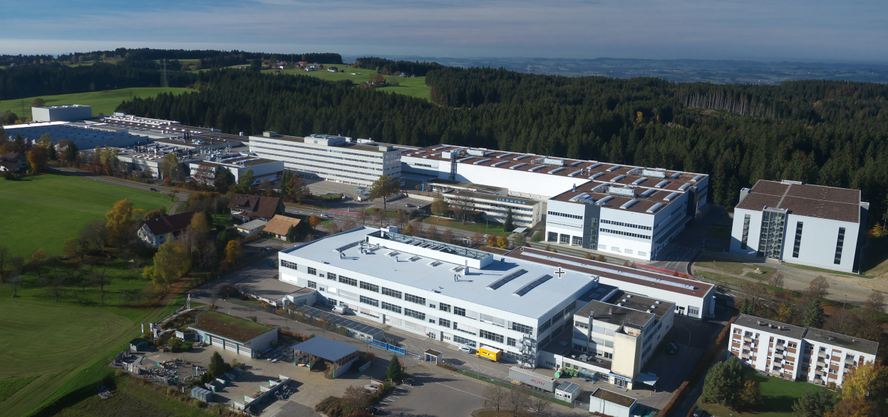

Liebherr-Aerospace Lindenberg GmbH, Lindenberg (Germany) - © Liebherr

Contact person

Ute Braam  
Corporate Communications  
Phone: +49 8381 / 46 - 4403  
E-mail: ute.braam@liebherr.com

Published by

Liebherr-Aerospace & Transportation SAS   
Toulouse / France  
www.liebherr.com