Press release

Modern Liebherr mixing plant of type Betomix 2.5 in operation in Berlin

⸺

Mixing plant produces up to 115 m³ concrete per hour

Aggregates can be fed to the plant from an HGV

Cladding and heating designed for winter operation

Comprehensive equipment

A new Betomix 2.5 mixing plant from Liebherr has been in operation for Heidelberger Beton GmbH since summer 2020. The plant is equipped to the highest safety standards. The ready-mixed concrete plant supplies quality concrete to the Berlin region.

Bad Schussenried (Germany), 18th October 2021 - The ultra-modern and well-equipped Betomix 2.5 further expands the ready-mixed concrete services of Heidelberger Beton GmbH in Berlin. The mixing plant delivers up to 115 m³ output per hour with its proven DW 2.5 twin-shaft mixer. The automatic high pressure cleaning system cleans the mixer and collecting funnel largely automatically, whereby the daily manual cleaning times are reduced to a minimum. Plenty of space on the mixer platform and generous platforms and walkways make all areas of the plant easily accessible.

Galvanised steel construction

The entire steel structure of the mixer and weigher platform, the skip elevator and the weighing belt have been hot-dip galvanised for a long service life. The latest generation of the Betomix horizontal mixing plant series has been successfully established worldwide for many years, thanks to its modular concept. This design facilitates numerous variants in accordance with customer requirements and equipment, such as the bucket elevator for feeding.

Storage for aggregates and cement

The inline silo with seven chambers holds around 350 m³ of aggregates; four of the seven chambers are divided. A recessed charging hopper allows the sand and gravel delivery to be tipped out at ground level by dump trucks; a wheel loader is not required. A bucket elevator transports the materials upwards onto a reversing belt for feeding the chambers. Four of the chambers are equipped with the Litronic FMS moisture measurement sensors developed by Liebherr; the sand moisture levels are measured up to 40 times per second.

Six cement silos with a total cement store volume of 600 tonnes are available for cement storage. By dividing two silos, it is possible to store a total of eight types of binding agents. During winter operation, a heating system conducts warm air into the aggregate silos. This guarantees operation during the cold season.

High safety standards

Heidelberger Beton GmbH placed great importance on the issue of safety when planning the plant. Through additional characteristics, it was possible to enhance the safety standards even further: For example, all walkways were designed with a width of 800 millimetres instead of 600 mm and were realised in slip resistance class R11. Heidelberger Beton GmbH paid particular attention to emergency exit, rescue and escape routes. The plant design includes no ladders for ascending and descending; instead, all areas up to the top of the cement silos are accessible via stairs. All pneumatic components that pose a risk of crushing are safeguarded during maintenance work by lockable ball valves. Electric drives are protected by lockable inspection switches.

The plant is secured with a transfer key locking system. In this way, all maintenance points that pose a potential risk include a consistent process of unlocking and locking before maintenance work is possible to deliver maximum hazard reduction. Accessing these areas during plant operation would be life-threatening.

Mixing plant with a wide range of equipment

The entire mixing plant is equipped with extensive accessories. These include video surveillance systems for monitoring in various areas, a traffic light system on the silo chambers for the levels and vibrators on the silo walls. Air dispersion receptacles are used for material with poor sliding characteristics. The accessories are completed by a 60 millimetre insulating lining for the plant and dust filter systems.

About the Liebherr Group

The Liebherr Group is a family-run technology company with a broadly diversified product range. The company is one of the largest construction machinery manufacturers in the world, but also offers high-quality, benefit-oriented products and services in many other areas. Today, the group comprises more than 140 companies on all continents, employs around 48,000 people and generated a consolidated total turnover of more than 10.3 billion Euros in 2020. Since its foundation in 1949 in Kirchdorf an der Iller in southern Germany, Liebherr has pursued the goal of impressing its customers with sophisticated solutions and contributing to technological progress.

Image

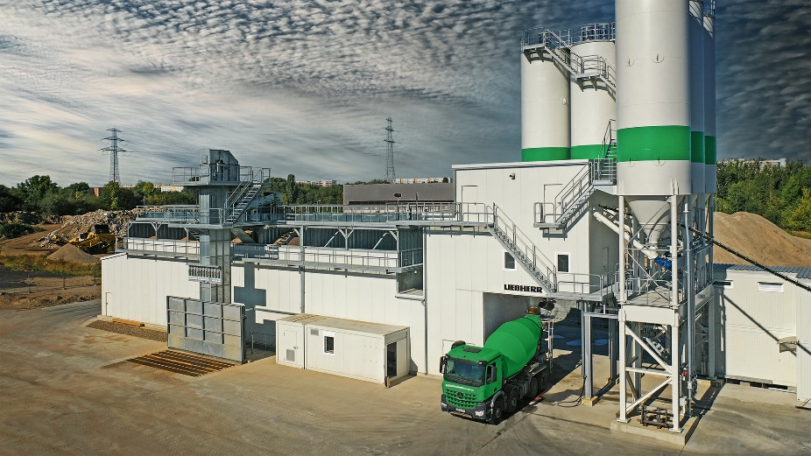

liebherr-concrete-plant-betomix.jpg  
The Betomix 2.5 from Liebherr reliably delivers every concrete quality desired.

Contact person

Klaus Eckert

Head of marketing

Telephone: +49 7583 949-328

E-mail: klaus.eckert@liebherr.com

Published by

Liebherr-Mischtechnik GmbHBad Schussenried, Germany  
www.liebherr.com