Press release

Liebherr spare parts for overhaul of CTA’s 5000-series level control systems

⸺

**Liebherr-Transportation Systems will deliver spare parts for the overhaul of the Chicago Transit Authority’s (CTA) electro-hydraulic level control systems, which were developed and manufactured by Liebherr for the 5000-series rail vehicles. Delivery has already started this year and will be completed by the beginning of 2025. The system overhauls will be carried out in the workshops of the CTA Rail Maintenance Facility in Skokie, Illinois (USA) by the CTA service team.**

Korneuburg (Austria), October 2021 – Liebherr-Transportation Systems will be the supplier of spare parts for the regular, specified and comprehensive overhaul of the CTA’s electro-hydraulic level control systems featured on its 5000-series heavy rail vehicles. This includes all maintenance and wear parts to be replaced in the 714 hydraulic units as well as the 2,856 level control actuators.

“We are very happy knowing that our quality and know-how will play a role in the CTA continuing to operate their vehicles safely and offer their passengers in the Chicago metropolitan area the highest level of travel comfort,” states Wolfgang Böttcher, Director Customer Support, Liebherr-Transportation Systems GmbH & Co KG.

**Safety and comfort**

The electro-hydraulic level control systems for the heavy rail vehicles were delivered by Liebherr to Bombardier Transportation for installation in the bogies of the cars. The system adjusts the carriage body of the vehicle so that the floor height corresponds to the height of the train station platform. Four hydraulic cylinders are activated per vehicle, which position the carriage body until the exit edge matches the height of the platform. This makes boarding and exiting for all passengers considerably easier; particularly for those with limited mobility, passengers with wheeled luggage and families with prams and other accessories for small children.

**About Liebherr-Transportation Systems**

Liebherr’s transportation systems division supplies cab and saloon heating, ventilation and air conditioning (HVAC) systems, thermal management systems for diverse mobile and stationary e-mobility applications, hydraulic actuation systems, dampers and hydraulic load levelling equipment for rail vehicles of all kinds. Liebherr has many years of experience in the development, manufacture, and field service of these technologies, offering support throughout the entire product lifecycle. The company invests continuously in its R&D activities in order to offer its customers new generations of diverse transportation systems solutions.

Liebherr-Transportation Systems has four production plants in Korneuburg (Austria), Marica (Bulgaria), Pinghu (China) and Zhuji (China). In addition to its own sales and service centers, the division has access to the Liebherr Group’s extensive and unique technologies as well as development and service facilities around the world. This global set-up means that Liebherr-Transportation Systems is there for its customers wherever they may be.

**About the Liebherr Group**

The Liebherr Group is a family-run technology company with a highly diversified product portfolio. The company is one of the largest construction equipment manufacturers in the world. It also provides high quality and user-oriented products and services in a wide range of other areas. The Liebherr Group includes over 140 companies across all continents. In 2020, it employed around 48,000 staff and achieved combined revenues of over 10.3 billion euros. Liebherr was founded in Kirchdorf an der Iller in Southern Germany in 1949. Since then, the employees have been pursuing the goal of achieving continuous technological innovation, and bringing industry-leading solutions to its customers.

Image

5000_4-copyright-CTA.jpg  
CTA 5000 series - © CTA

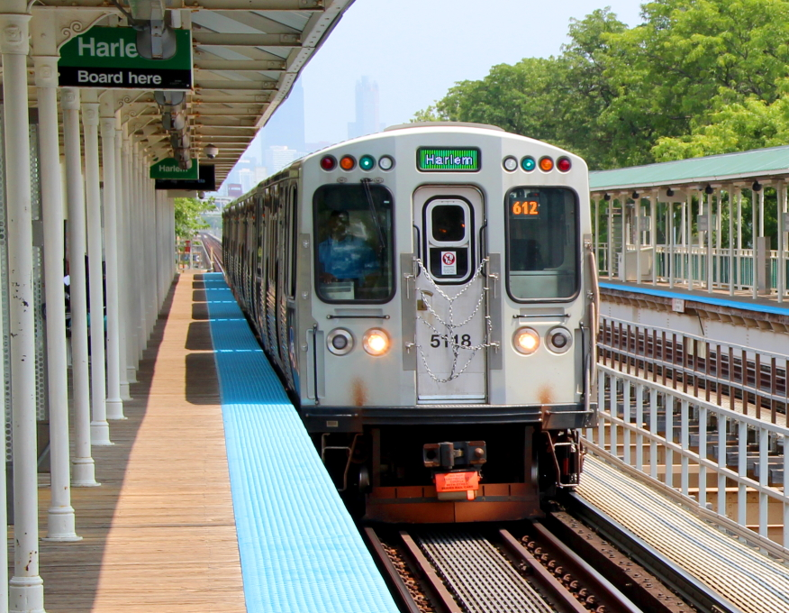

Contact

Ute Braam  
Corporate Communications  
Tel: +49 8381 46 4403  
E-mail: ute.braam@liebherr.com

**Published by**

Liebherr-Aerospace & Transportation SAS  
Toulouse, France  
www.liebherr.com