

Press release

Third Liebherr LR 11000 crawler crane delivered to Felbermayr

⸺

Third Liebherr LR 11000 crawler crane delivered to Felbermayr

The crane giant builds wind farm in eastern Austria

The new purchase features all the latest crawler crane technology innovations

A Liebherr LR 11000 crawler crane in its smart blue livery left the factory in Ehingen in early summer. Its destination – Austria. Its job – wind turbine erection. Its new owner – Felbermayr Holding GmbH. This was the third of these modern 1000 tonne cranes bought by the family run business, which operates throughout Europe. The powerful crawler crane was supplied with all the latest features, including the VarioTray detachable suspended ballast and the V-Frame hydraulically adjustable folding frame. Felbermayr has already placed an order for another large Liebherr crane in the form of an LR 1800-1.0. This will be delivered shortly.

Ehingen (Donau) (Germany), 22 October 2021 – Work is currently being carried out in Burgenland, Austria, on repowering an existing wind farm. Old, small wind turbines on the extensive fields on the border with Slovakia are being dismantled to make way for more modern systems. Felbermayr’s brand new Liebherr LR 11000 crawler crane has been working on the new, significantly more powerful wind turbines since July. A total of ten turbines with a rotor diameter of 138 metres and a rating of 4.2 megawatts is to be installed.

The brand new 1000 tonne crane features a 168 metre lattice boom, a derrick boom and an F2 jib, which is ideal for erection work in a wind farm – 15 metres long and slightly angled. It enables the topmost components of the wind turbines, with their massive hub heights of 160 metres, to be installed safely with adequate space to manoeuvre the various components.

The heaviest components, and therefore the largest load cases for the LR 11000, are the stator and rotor, which are assembled to make the generator. Installing these parts sees a gross load of around 88 tonnes on the crane hook. A total of 380 tonnes of central, suspended and slewing platform ballast ensure that the crawler crane has adequate stability when handling these loads, a hoist height of 160 metres and a required radius of around 32 metres. A further 450 tonnes of ballast is available on site. However, this reserve is only required to raise and lower the massive lattice boom and can be pinned to the suspended ballast pallet in just a few minutes.

Just six days required to relocate to a new site

When the weather plays ball, the crane team and assembly team can erect a wind turbine on the existing 85 metre tower in around four days. The LR 11000 is then dismantled and transported to the next site in the wind farm. Liebherr continually works on developing the handling procedures for setting up its crawler cranes, and this is clearly shown when relocating the 1000 tonne crawler crane – only around six days are required after installing the final rotor blade until the crawler crane is fully set off again and ready to start work at the new site.

The Liebherr LR 11000 has become an essential tool for Felbermayr both for jobs at wind farms and for work in industry. It is the most powerful lifting equipment in the company’s impressively large crane fleet. One of the very first of these cranes to be made was delivered to the Austrian group in summer 2014. In addition, the double “Power Boom”, which boosts lifting capacity, was also installed for the very first time on a blue LR 11000 operated by Felbermayr. At the time, a nacelle around 200 tonnes was hanging on the hook and the crawler crane managed to install what at the time was one of the largest rotor stars in the world with a diameter of 152 metres in a single hoist.

Heavy loads, mega transports, massive infrastructure and special projects – all these and more are part of the portfolio of the Felbermayr Group whose cranes and machines can often be seen in Austria with the striking blue livery. The company has expanded massively, above all in the states of Austria, over the last 30 years. Family-run Felbermayr now has a total of 72 sites in 19 countries around Europe.

About Liebherr-Werk Ehingen GmbH

Liebherr-Werk Ehingen GmbH is a leading manufacturer of mobile and crawler cranes. Its range of mobile cranes extends from 2-axle 35 tonne cranes to heavy duty cranes with a lifting capacity of 1200 tonnes and a 9-axle chassis. Its lattice boom cranes on mobile or crawler crane chassis deliver lifting capacities of up to 3000 tonnes. With universal boom systems and extensive additional equipment, they can be seen in action on construction sites throughout the world. The Ehingen site has a workforce of 3,500. Extensive, global service guarantees the high availability of Liebherr mobile and crawler cranes. In 2020, the Liebherr plant in Ehingen recorded a turnover of 2.03 billion euros.

About the Liebherr Group

The Liebherr Group is a family-run technology company with a widely diversified product range. The company is one of the largest manufacturers of construction machines in the world, but also supplies technically advanced, user-focused products and services in many other sectors. The group currently comprises more than 140 companies based in every continent of the world, has a workforce of around 48,000 and recorded a consolidated total turnover of more than 10.3 billion euros in 2020. Since it was founded in 1949 in Kirchdorf an der Iller in southern Germany, Liebherr’s aim has been to win customers by supplying high quality solutions and to contribute to technological progress.

**Photographs:**

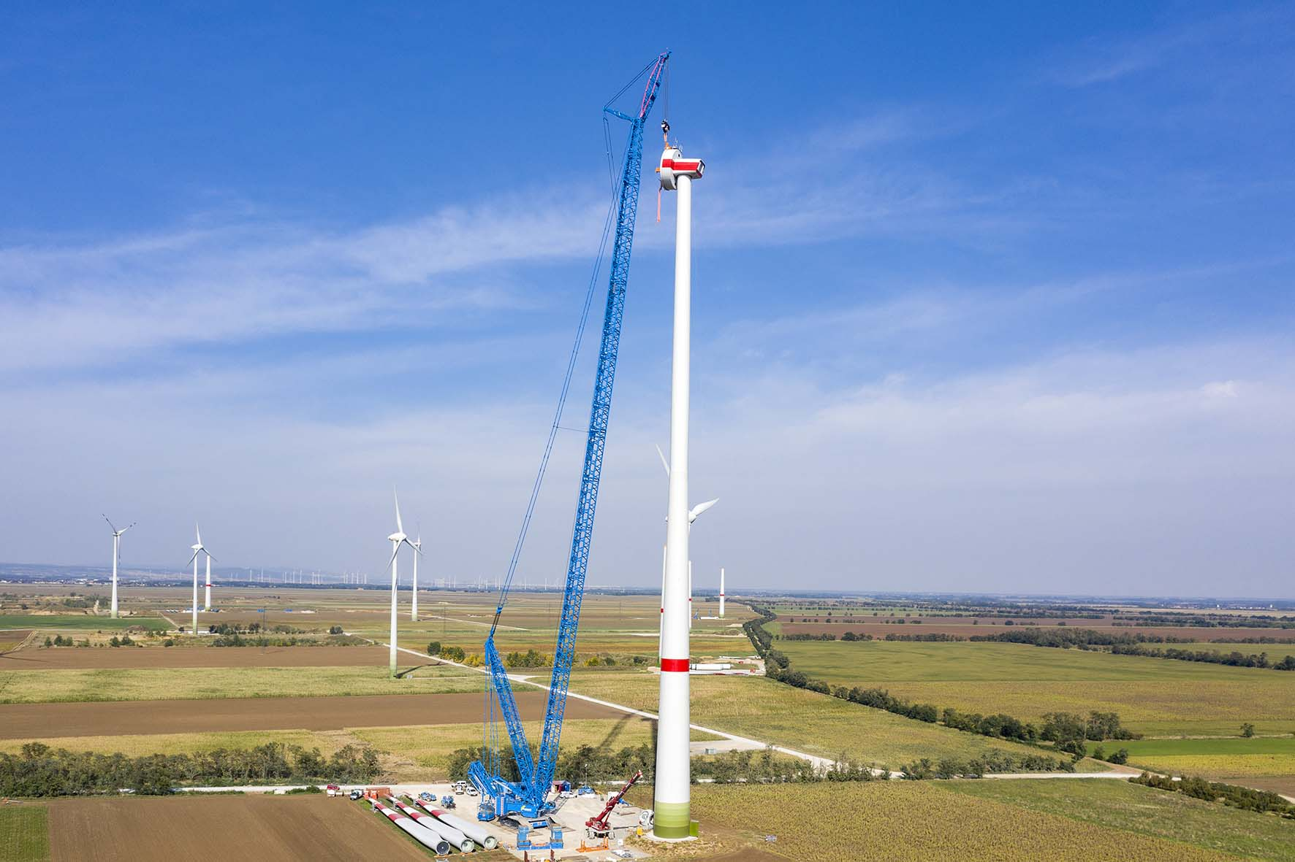

liebherr-lr11000-felbermayr-01.jpg  
Future-proof – Felbermayer’s new LR 11000 crawler crane shows its strengths at the wind farm.

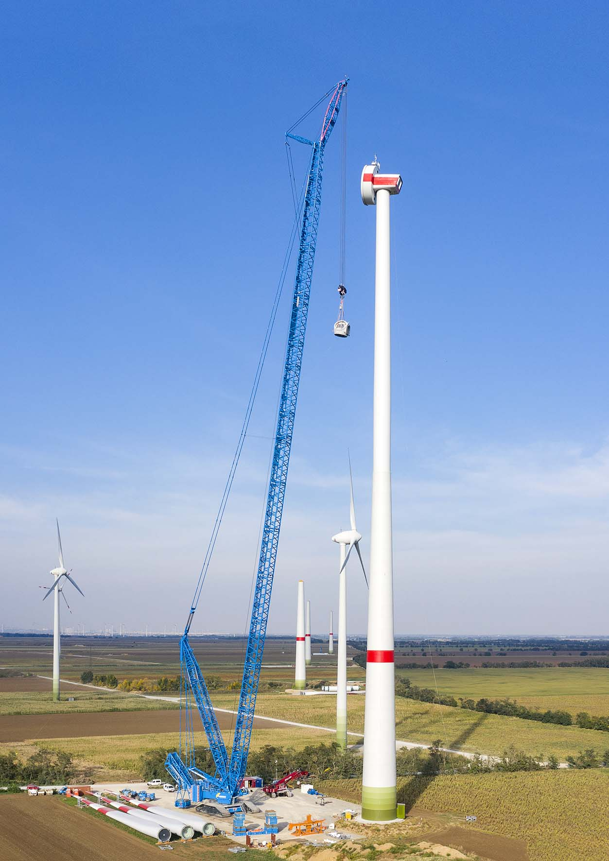

liebherr-lr11000-felbermayr-02.jpg  
Upwards – the hub on the LR 11000’s hook goes up into the sky. The component is installed at an altitude of 160 metres. The three rotor blades are already waiting on the site.

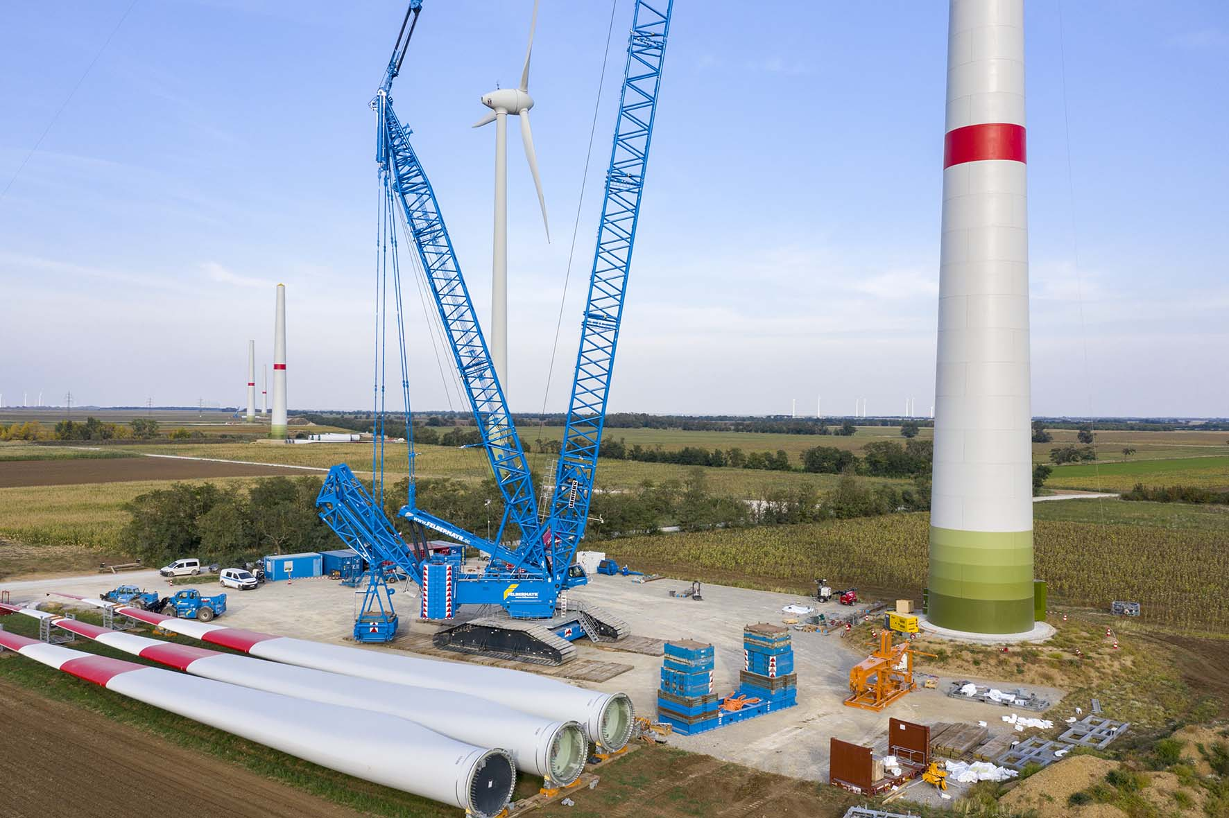

liebherr-lr11000-felbermayr-03.jpg   
Compact, modern and powerful – Felbermayr’s new LR 11000 has a whole host of innovative features. VarioTray and V-Frame save the crane team a great deal of work on site.

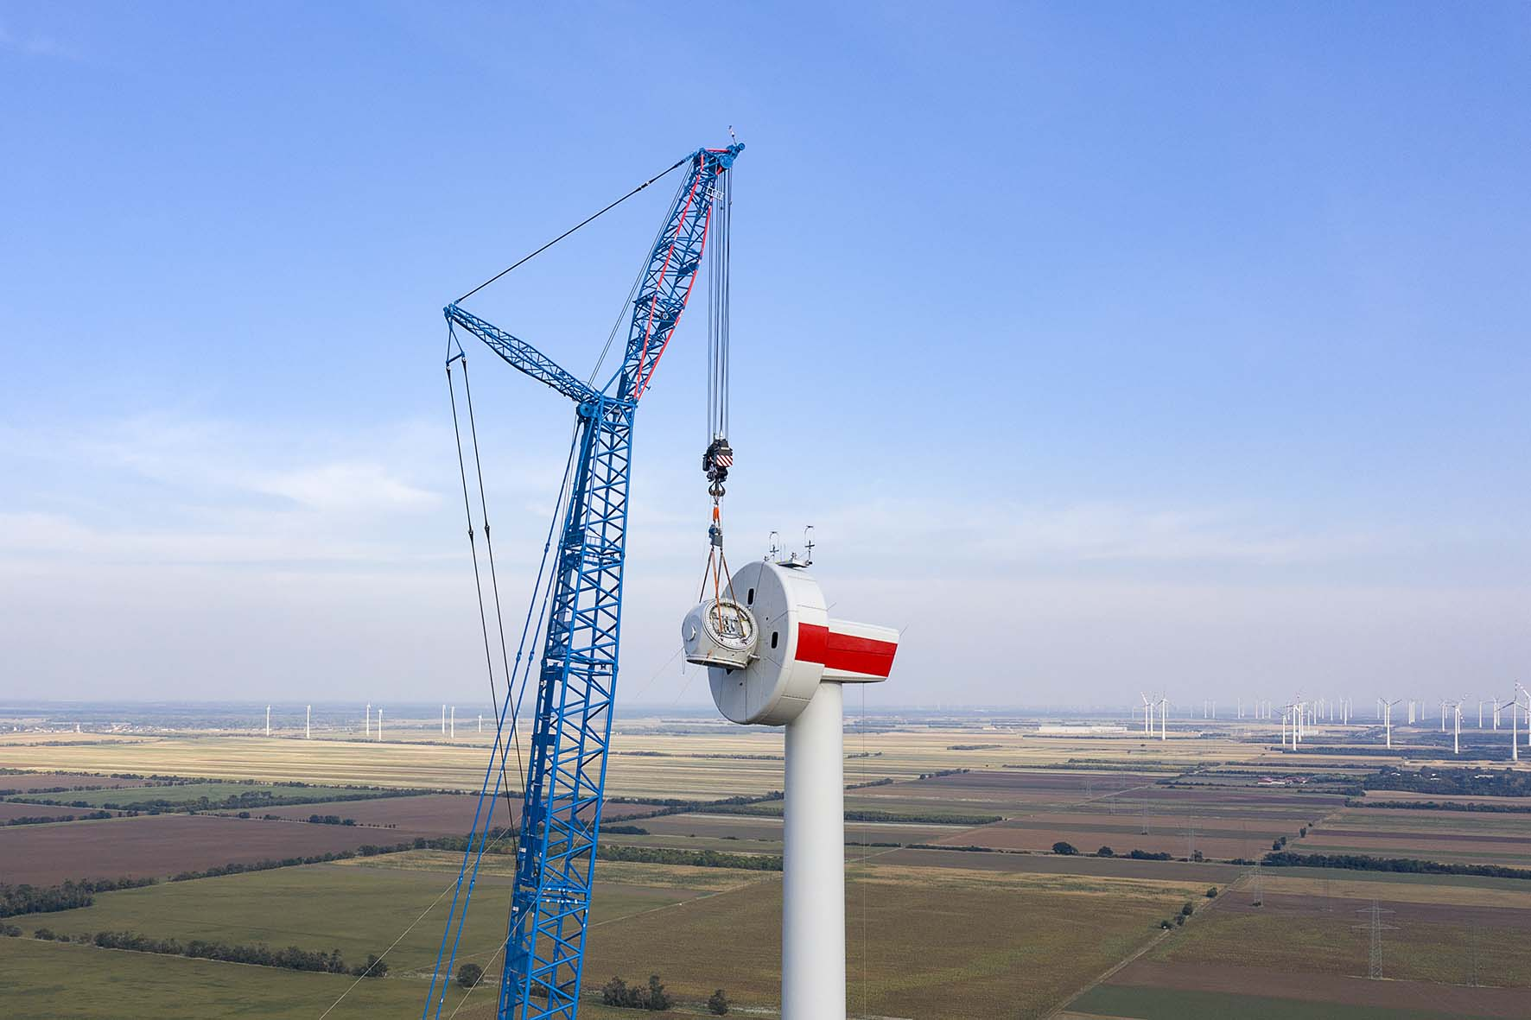

liebherr-lr11000-felbermayr-04.jpg  
Well designed – the 15 metre lattice jib on the 168 metre boom makes for safe handling with the top components of the wind turbine during the assembly process. Our photograph shows the installation of the hub.

**Contact person:**

Wolfgang Beringer  
Marketing and Communication  
Phone: +49 7391/502-3663  
E-Mail: wolfgang.beringer@liebherr.com

Published by

Liebherr-Werk Ehingen GmbH  
Ehingen (Donau) / Germany  
www.liebherr.com