

**Press release**

**The end of an era – the last LR 1600/2 leaves the Liebherr Plant in Ehingen**

⸺

The 223rd and last LR 1600/2 crawler crane leaves the factory in Ehingen

First delivered in 2008, the boom configurations grew along with its range of jobs

Successor LR 1700-1.0 in action around the world since June 2021

The end of an era after 220 models built – production of one of Liebherr’s most successful crawler cranes is being discontinued. The last LR 1600/2, which was primarily designed and used for wind power jobs, will be delivered at the end of October. Its successor is the LR 1700-1.0, which Liebherr launched in June 2021 and which has already become very popular all over the world as the new standard in the crawler crane segment for wind power.

Ehingen (Donau) (Germany), 29 October 2021 – The 600 tonne LR 1600/2 crawler crane is being removed from the Liebherr crawler crane portfolio. 223 of them have been built and delivered to customers over a period of almost 13 years. Its successor has already been launched in the form of the LR 1700-1.0.

**LR 1600/2 large volume wind power crane**

The LR 1600/2 was originally designed as a crane for wind power and the first one was delivered in summer 2008. In addition to the standard version, a version with narrow crawler track, known as the LR 1600/2-W, was also marketed successfully over a period of ten years. The main feature of this version was the fact that it could travel along narrow crawlers in wind farms considerably more easily than the standard version. The narrow track version accounted for around one-quarter of all these cranes in worldwide use.

Initially, the LR 1600/2 was delivered in its SL4DFB configuration, designed for wind turbines with a hub height of 130 to 135 metres. In this configuration, the crane had a main boom of 138 metres and a fixed jib of 12 metres. This was the benchmark for turbines with a hub height of 135 metres. Over the next few years, however, the size of wind turbines increased dramatically up to hub heights of 150 metres or more. This altered the requirements for the crane which the designers at Liebherr followed closely. The lifting capacities and hoisting heights of the boom systems were continuously modified with the SL10 and SL13 versions, which both became established on the market. These booms enabled the crane to handle wind turbines with hub heights of 150 metres.

However, the LR 1600/2 was not just used for wind power, it was also used in industry and for infrastructure projects shortly after the first one was delivered to its customer. Often equipped with a ballast wagon or suspended ballast, the 600 tonne crane impressed users with its lifting capacity. Over the years, Liebherr unveiled more innovations for its crawler crane portfolio, such as the B2 guide and VarioTray for suspended ballast, which eliminates the complicated stacking and unstacking of ballast slabs by simply disconnecting a whole ballast pallet.

**Successor standing ready**

The final LR 1600/2 will be delivered to van Adrighem based in the Netherlands at the end of October. However, its successor is already on the market in the form of the LR 1700-1.0. The first of these was delivered in June 2021. The new 700 tonne crane meets the new requirements which the LR 1600/2 could no longer satisfy. New wind turbines with hub heights of 165 metres, requiring loads of over 100 tonnes to be hoisted to this height, are challenges to which Liebherr has responded with its new LR 1700-1.0. It is significantly more powerful than its predecessor and in some load cases even comes close to the LR 1750/2.

About Liebherr-Werk Ehingen GmbH

Liebherr-Werk Ehingen GmbH is a leading manufacturer of mobile and crawler cranes. Its range of mobile cranes extends from 2-axle 35 tonne cranes to heavy duty cranes with a lifting capacity of 1200 tonnes and a 9-axle chassis. Its lattice boom cranes on mobile or crawler crane chassis deliver lifting capacities of up to 3000 tonnes. With universal boom systems and extensive additional equipment, they can be seen in action on construction sites throughout the world. The Ehingen site has a workforce of 3,500. Extensive, global service guarantees the high availability of Liebherr mobile and crawler cranes. In 2020, the Liebherr plant in Ehingen recorded a turnover of 2.03 billion euros.

About the Liebherr Group

The Liebherr Group is a family-run technology company with a widely diversified product range. The company is one of the largest manufacturers of construction machines in the world, but also supplies technically advanced, user-focused products and services in many other sectors. The group currently comprises more than 140 companies based in every continent of the world, has a workforce of around 48,000 and recorded a consolidated total turnover of more than 10.3 billion euros in 2020. Since it was founded in 1949 in Kirchdorf an der Iller in southern Germany, Liebherr’s aim has been to win customers by supplying high quality solutions and to contribute to technological progress.

**Photographs**

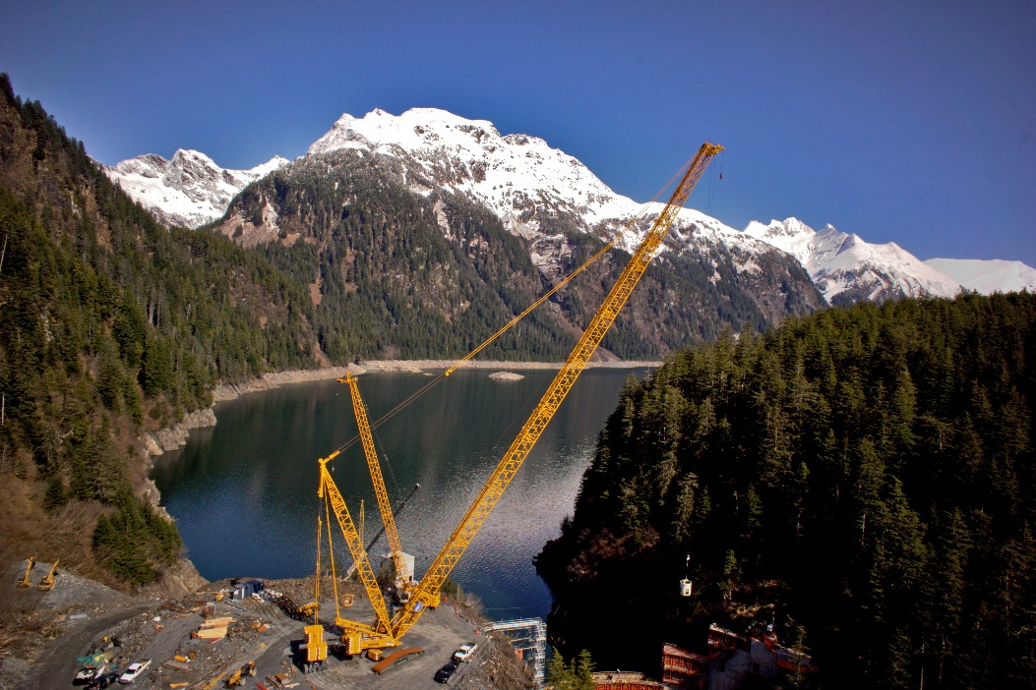

liebherr-lr1600-1.jpg  
With ballast wagon – the LR 1600/2 installing a dam wall in Alaska.

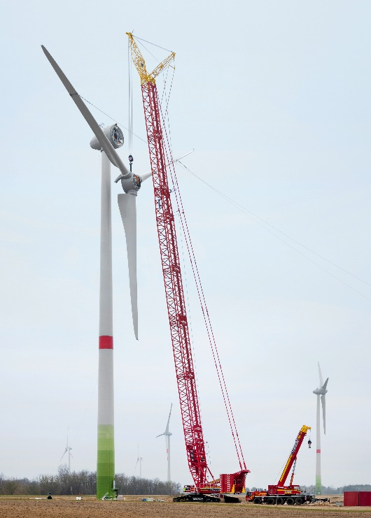

liebherr-lr1600-2.jpg  
A daily job for the LR 1600/2: installation of wind power components.

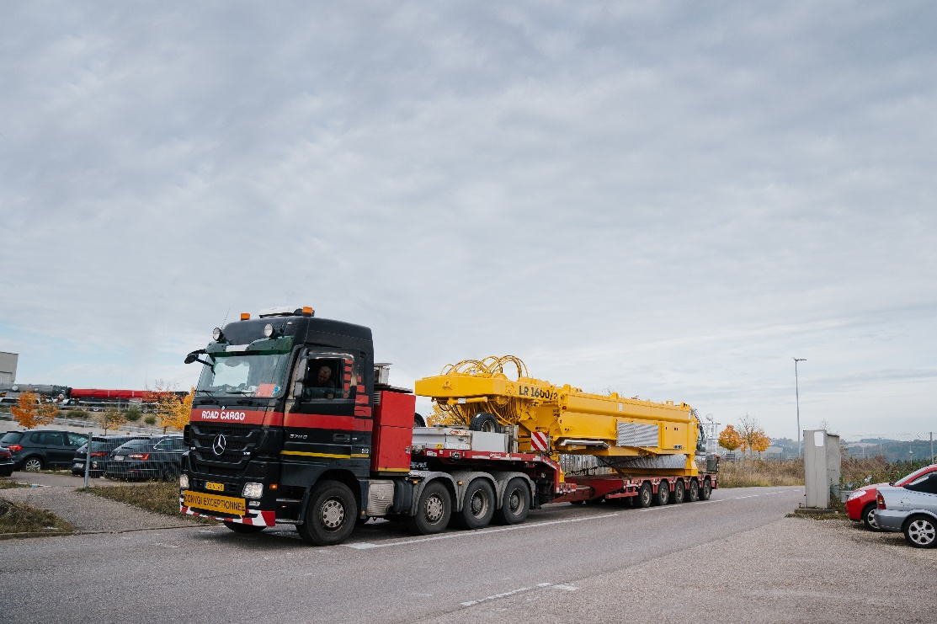

liebherr-lr1600-3.jpg  
Departure of the last of its kind – the slewing platform of the last LR 1600/2 leaves the crane factory in Ehingen.

Contacts

Wolfgang Beringer  
Marketing and Communication  
Phone: +49 7391/502 - 3663  
Email: wolfgang.beringer@liebherr.com

Published by

Liebherr-Werk Ehingen GmbH  
Ehingen (Donau) / Germany  
www.liebherr.com