Press release

Liebherr ends first half of the year with positive result

⸺

Following a sharp increase in turnover, incoming orders at the highest level and increasing investments, the Liebherr Group reports a positive performance for the first half of 2021. The company expects that this trend will continue throughout the current year.

Bulle (Switzerland), 27 October 2021 – With a turnover of € 5,616 million as at 30 June 2021, the first half of 2021 was very pleasing for the Liebherr Group. The company achieved an increase in turnover of € 663 million or 13.4% compared to the previous year.

Revenues in the Earthmoving, Material Handling Technology, Deep Foundation Machines, Mobile and Crawler Cranes, Tower Cranes, Concrete Technology and Mining product segments grew by over 16% altogether. In the other product segments, including Maritime Cranes, Aerospace and Transportation Systems, Gear Technology and Automation Systems, Refrigeration and Freezing, as well as Components and Hotels, the turnover increased by over 7% as a whole.

The regional distribution of turnover shifted in the first half of 2021 towards European and American markets. In some instances, significant revenue increases were achieved there. In many markets in Asia, Africa, as well as the Near and Middle East, the influence of the pandemic on business can still be felt, which is reflected in sales losses.

Positive order situation

The order intake improved considerably in all product segments of the Liebherr Group. Liebherr has never received so many orders within a half year – proof of the high international demand for products and services of the Liebherr Group. Due to the strong demand and the current tense situation in some procurement markets, the current volume of orders on hand of the Liebherr Group is also at a high level.

Investments in location expansion

The investments of the Liebherr Group have also increased substantially. Amongst other things, Liebherr is investing in the expansion of its sites. For example, two large-scale projects are to be realised in the coming years at Liebherr-Werk Ehingen GmbH: Firstly, the new construction of the Repair Centre South Germany in the Berg industrial park in Ehingen (Germany) is planned by 2022; in addition, the new spare parts and shipment warehouse will be in operation by 2024. Secondly, Liebherr in Ehingen wants to extend its factory premises with a green factory by 2030 in order to expand its production capacities for the increasing demand for mobile and crawler cranes.

Outside Europe Liebherr has started the construction of a new premises at the Dalian site in China. In doing so, the Liebherr Group is expanding the production of large diameter bearings, gearboxes and hydraulic cylinders for the Chinese market. The production is expected to start at the end of 2022.

Product highlights with focus on alternative drives

As a technology company, the Liebherr Group pursues the goal of shaping the technological progress in the industries that are important for the company. Across all product segments the engineers in the Liebherr Group work on innovative solutions. Digitalization is one focal point of the development activities, another focal point is new drive technologies for the construction and mining industry, aerospace, rail cars and agricultural machines amongst others. In the area of construction machines the following new products with drive innovations took centre stage at Liebherr in the first half of 2021:

* In March, Liebherr launched its new mobile construction crane MK 73-3.1. The power for the compact, electric taxi crane can be supplied from the construction site or by means of an integrated generator.
* With the R 9600, Liebherr introduced the new generation of hydraulic mining excavators in the same month and sets standards in the area of open-pit mining equipment: The models are available with different drives including an electric drive.
* The new electric crawler excavators R 976-E and R 980 SME-E also work with zero local emissions. With low-cost maintenance and lower operating costs, the excavators guarantee the familiar high performance and reliability also in extreme conditions.
* Since this year, the first all-electric truck mixers from Liebherr enable quiet and zero-emission concrete transport. The drum drive developed by Liebherr and ZF comprises a low-maintenance, efficient unit of electric motor and mixer transmission. For the first time the truck and the mixer are powered from the traction battery.
* The LR 1250.1 unplugged, the first battery-operated crawler crane in the world, which has been available since 2020, received an award: At the ESTA Awards for the crane and heavy equipment industry the Liebherr crane won in the category "Innovation Manufacturer". Driven by an electric motor with a system performance of 255 kilowatts and a maximum load bearing capacity of 250 tonnes, the LR 1250.1 unplugged has the same performance as the conventionally driven crane version.

Outlook for the second half of 2021

Owing to the positive development of the demand in the first half of 2021, the Liebherr Group currently expects to attain the second highest turnover in the Group's history by the year end and therefore only slightly below the turnover of the year prior to the corona pandemic. A change in the macroeconomic conditions, the difficult situation on the procurement markets or even recent restrictions of business due to the corona pandemic pose risks for the further positive development, whose impacts however remain controllable for 2021.

About the Liebherr Group

The Liebherr Group is a family-run technology company with a highly diversified product portfolio. The company is one of the largest construction equipment manufacturers in the world. It also provides high-quality and user-oriented products and services in a wide range of other areas. The Liebherr Group includes over 140 companies across all continents. In 2020, it employed around 48,000 staff and achieved combined revenues of over 10.3 billion euros. Liebherr was founded in Kirchdorf an der Iller in Southern Germany in 1949. Since then, the employees have been pursuing the goal of achieving continuous technological innovation, and bringing industry-leading solutions to its customers.

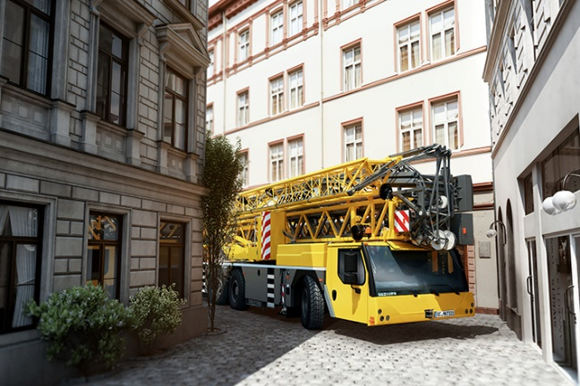Images

liebherr-mobile-construction-crane.jpg  
The compact and maneuverable mobile construction crane MK 73-3.1

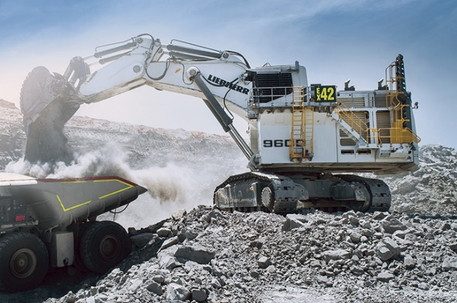

liebherr-mining-excavator.jpg  
The R 9600 is the next generation of hydraulic mining excavators

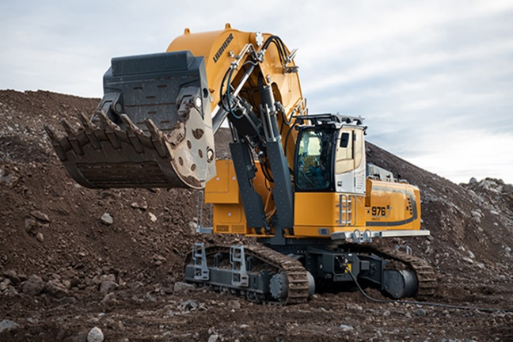

liebherr-excavator.jpg

liebherr-crawler-excavator.jpg   
The electric crawler excavator R 976-E not only works extremely quietly, but also with zero local emissions

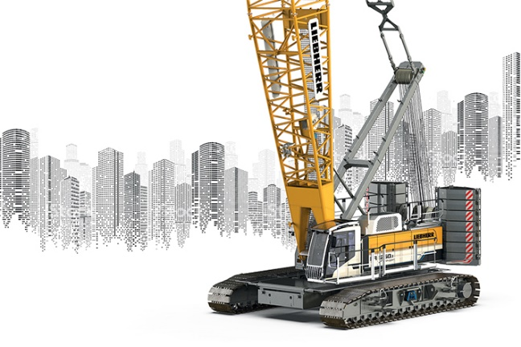

liebherr-crawler-crane.jpg  
The LR 1250.1 unplugged is the world's first battery-operated crawler crane

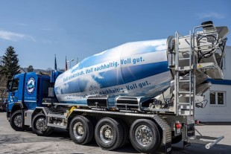  
liebherr-truck-mixer.jpg  
The new all-electric truck mixer in the ETM range from Liebherr is delivered

Contact person

Philipp Hirth  
Head of Public & Media Relations  
Phone: +49 7351 41 - 4445  
E-mail: [philipp.hirth@liebherr.com](mailto:philipp.hirth@liebherr.com)

Published by

Liebherr-International AG  
Bulle / Switzerland  
www.liebherr.com