Press information

Mukran Port relies on Liebherr on the New Silk Road

⸺

Liebherr mobile harbour crane, type LHM 550 is the third LHM for Mukran Port Terminals GmbH in Sassnitz, Germany

The crane has a maximum lifting capacity of up to 144 tonnes and will be used primarily for the growing project business and increasing container handling volume

The LHM 550 is the best-selling model in the Liebherr mobile harbour crane portfolio

**Following a period of rental, Mukran Port Terminals GmbH at the Port of Sassnitz has purchased its third Liebherr mobile harbour crane, type LHM 550. With a maximum lifting capacity of up to 144 tonnes, the machine offers a wide range of applications. This is the sixth Liebherr mobile harbour crane in Sassnitz. This means that the port town on the island of Rügen has the highest LHM-density in the German speaking DACH region.**

Rostock (Germany), October 2021 - Mukran Port is a crucial link in the New Silk Road. The port acts as an interface for international transport chains for rail, sea, and road. Transportation of goods to and from China only takes twelve days. In terms of infrastructure, Mukran Port is also ideally equipped for logistics, even for heavy loads. Mukran Port Terminals has successfully operated two LHM 400 mobile harbour cranes for years. The terminal operator has now increased its crane fleet again to meet the growing demand from its customers.

**Suitable for any application**

A year ago, Mukran Port Terminals leased a Liebherr LHM 550 mobile harbour crane. The performance and flexibility of the multipurpose handling machine convinced Mukran Port Terminals to purchase the machine.  
  
"With the new mobile harbour crane, we are strengthening our position as a multipurpose port for future business in the project cargo sector. We are also taking into account the rapid development of traffic on the New Silk Road via the Mukran site as a crucial link," reports Harm Sievers, Managing Director of the operating company Mukran Port Terminals.  
  
"With our trio of Liebherr cranes, we are ideally equipped to meet the increasing demands of the future. The versatility of the LHM 550 fits perfectly with the daily requirements at our terminal," Sievers adds.  
The multifunctionality of Liebherr mobile harbour cranes makes them attractive for all areas of application in the port. Thanks to the simple modular design, lifting devices can be replaced within a short time.

**LHM 550 - a bestseller**

With over 300 units sold, the LHM 550 is the bestseller in Liebherr's mobile harbour crane product portfolio. With a radius of 54 metres, the LHM 550 is the perfect crane for bulk handling in the Capesize ship class. In container handling, ships of the New Panamax class are the optimal working environment for the LHM 550. General cargo and heavy lift applications complete the field of application of this crane type. The innovative hydrostatic drive concept ensures increased efficiency and reduced fuel consumption compared to conventional drive types on the market.

About Liebherr-MCCtec Rostock GmbH

Liebherr-MCCtec Rostock GmbH is one of the leading European manufacturers of maritime handling solutions. The product range includes ship, mobile harbour and offshore cranes. Reach stackers and components for container cranes are also included in the product portfolio.

About the Liebherr Group

The Liebherr Group is a family-run technology company with a broadly diversified product range. The company is one of the world's largest manufacturers of construction machinery, but also offers high-quality, user-oriented products and services in many other areas. Today, the group comprises more than 140 companies on all continents, employs around 48,000 people and generated total consolidated sales of more than EUR 10.3 billion in 2020. Since its foundation in 1949 in Kirchdorf an der Iller in southern Germany, Liebherr has pursued the goal of convincing its customers with sophisticated solutions and contributing to technological progress.

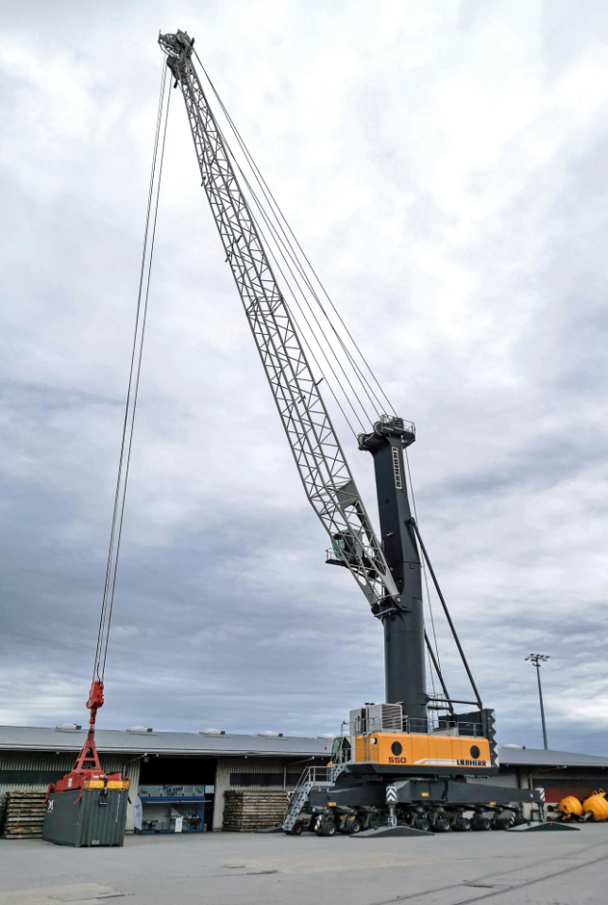Image

liebherr-lhm-550-mobile-harbour-crane-mukran-port-germany-europe-1.jpg  
The Liebherr LHM 550 mobile harbour crane, which was taken over from a lease, will be used primarily for the growing project business and increasing container handling at Mukran Port.

Contact

Philipp Helberg

Tel: +49 381 6006 5024

Email: philipp.helberg@liebherr.com

Published by

Liebherr-MCCtec Rostock GmbH

Rostock / Germany

www.liebherr.com