

Press release

Unique – Dźwig-Mar takes delivery of the first LTM 1650-8.1 in Poland

⸺

Polish crane and heavy haulage contractor Dźwig-Mar s.c. upgrades fleet with Liebherr LTM 1650-8.1

Enormous lifting capacities and modern technology behind the purchase decision

Reliable Liebherr service in Poland important for Dźwig-Mar

“The LTM 1650-8.1 has a unique design and concept. It is variable and powerful, yet compact”, says Marcin Zielonka, Managing Director at Dźwig-Mar s.c. The Polish crane and heavy haulage contractor took delivery of the first LTM 1650-8.1 mobile crane from Liebherr in Poland. The new crane will upgrade the company’s fleet which consists of over thirty Liebherr cranes.

Ehingen (Donau), (Germany), 27 October 2021 – The expansion in the number of wind turbines in Poland continues apace. For Marcin Zielonka and his company Dźwig-Mar s.c. it means: “We have higher demand for large cranes. The 8-axle model will upgrade our fleet to meet the increased demand for cranes in this class. It is now our largest mobile crane.” In addition to the erection of wind turbines, the LTM 1650-8.1 will also carry out hoisting work at heavy industry sites such as refineries.

The LTM 1650-8.1 features the very latest technology and is designed to deliver maximum performance together with high flexibility and economy. “This heavy duty crane can handle hoisting work normally reserved for the 700 tonne class effortlessly but has the dimensions of a 500 tonne crane”, says Marcin Zielonka. “In addition, VarioBallast® delivers enormous benefits.” The variable hydraulic adjustment of the ballast radius from 6.4 metres to 8.4 metres saves on ballast transport if there is sufficient space available. It also enables jobs requiring high lifting capacity to be carried out on constricted sites. At the same time, the 8-axle crane is designed to be set up quickly using its smart set-up processes and can also be transported economically.

For Dźwig-Mar, which has a workforce of around 50, the LTM 1650-8.1 is one of three new cranes in 2021 – the company has already modernised its fleet by investing in an LTM 1130-5.1 and an LTM 1350-6.1. “We buy Liebherr because we have had a good, solid partnership with the company for many years. In addition, Liebherr’s service in Poland is excellent and totally reliable”, says Marcin Zielonka.

About Liebherr-Werk Ehingen GmbH

Liebherr-Werk Ehingen GmbH is a leading manufacturer of mobile and crawler cranes. Its range of mobile cranes extends from 2-axle 35 tonne cranes to heavy duty cranes with a lifting capacity of 1200 tonnes and a 9-axle chassis. Its lattice boom cranes on mobile or crawler crane chassis deliver lifting capacities of up to 3000 tonnes. With universal boom systems and extensive additional equipment, they can be seen in action on construction sites throughout the world. The Ehingen site has a workforce of 3,600. Extensive, global service guarantees the high availability of Liebherr mobile and crawler cranes. In 2020, the Liebherr plant in Ehingen recorded a turnover of 2 billion euros.

About the Liebherr Group

The Liebherr Group is a family-run technology company with a widely diversified product range. The company is one of the largest manufacturers of construction machines in the world, but also supplies technically advanced, user-focused products and services in many other sectors. The group currently comprises more than 140 companies based in every continent of the world, has a workforce of around 48,000 and recorded a consolidated total turnover of more than 10.3 billion euros in 2020. Since it was founded in 1949 in Kirchdorf an der Iller in southern Germany, Liebherr’s aim has been to win customers by supplying high quality solutions and to contribute to technological progress.

Photograph

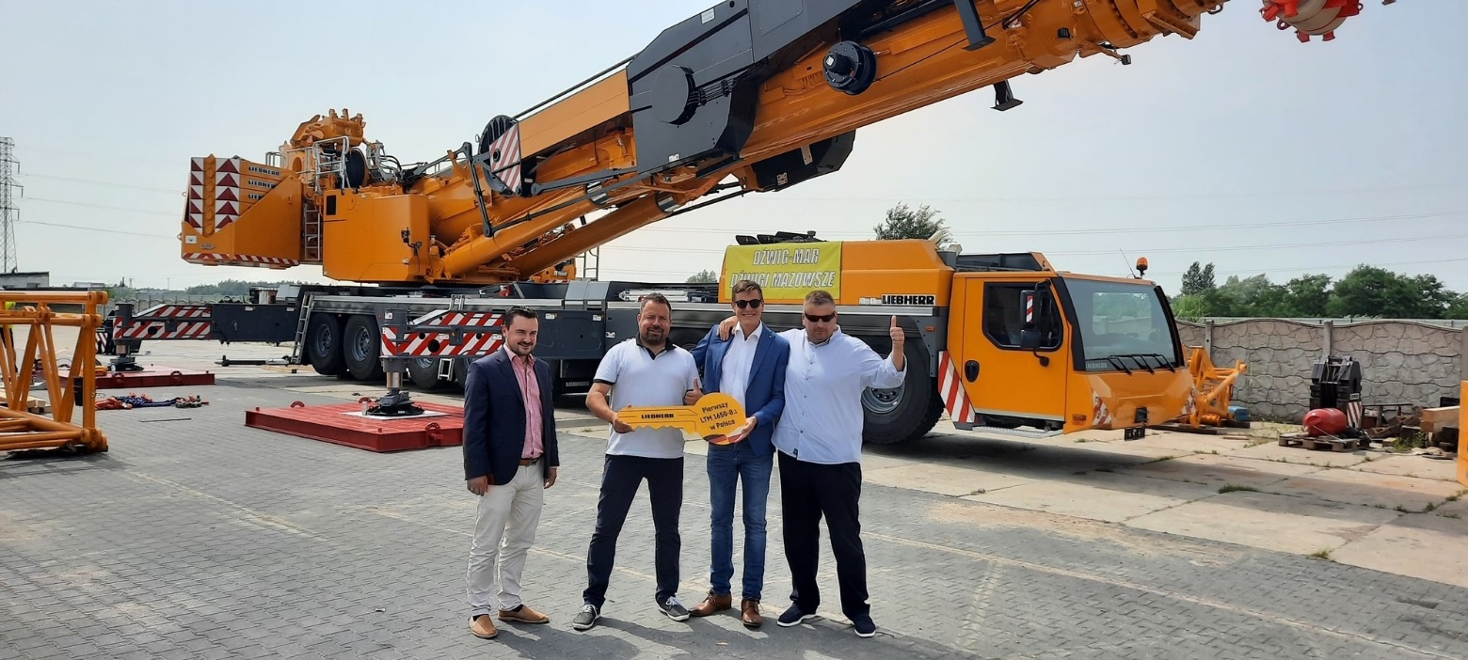

liebherr-dzwig-mar-ltm-1650-8-1.jpg  
Crane handover in Poland (from left to right): Artur Heiduk (Liebherr-Polska Sp. z o.o.), Bartosz Rybarczyk (Dźwig-Mar s.c.), Florian Floess (Liebherr-Werk Ehingen GmbH), Marcin Zielonka (Dźwig-Mar s.c.). The photograph has been produced in compliance with current covid safety regulations: Vaccinated, Recovered, Tested.

**Contact person**

Wolfgang Beringer  
Marketing and Communication  
Phone: +49 7391/502-3663  
Email: [wolfgang.beringer@liebherr.com](mailto:wolfgang.beringer@liebherr.com)

**Published by**

Liebherr-Werk Ehingen GmbH  
Ehingen (Donau), Germany  
[www.liebherr.com](http://www.liebherr.com)