

Press Release

Liebherr-France SAS: Christophe Sanchez replaces Martin Schickel as Director General

⸺

* Christophe Sanchez appointed Managing Director of Liebherr-France SAS
* An era ends at Liebherr for his predecessor Martin Schickel
* Liebherr-France SAS in Colmar (France): a site undergoing full expansion

It is the end of an era, both for the general management of Liebherr-France SAS and for the entire Liebherr Group. Martin Schickel is retiring after more than 44 years with the company. He is handing over the reins to the person who already replaced him as General Director of Liebherr-Location-France SAS in June 2020: Christophe Sanchez.

Colmar (France), 2 November 2021 - Liebherr-France SAS will have a new commercial director from 1 November 2021. Christophe Sanchez is succeeding Martin Schickel at the helm of the historic Liebherr site in France. Liebherr-France SAS, founded 60 years ago, is responsible, among other things, for the development and production of the group's crawler excavators in Colmar.

Christophe Sanchez takes over the reins

Mr Sanchez joined Liebherr-France SAS in 2002 as Export Manager for Italy, Spain and North America. In 2007, he became sales manager for the industrial and electric excavators produced at the Colmar site. From 2012 to 2020, he was General Director of Liebherr EMtec Italia SpA, which is responsible for sales and after-sales service of Liebherr construction machinery on the Italian market. On 1 June 2020, he has already taken over the management of Liebherr-Location France SAS from Martin Schickel. He has also been General Director of Liebherr-France SAS since 1 November 2021.

Liebherr-France SAS: a site undergoing full expansion

When Hans Liebherr, the founder of the Liebherr Group, decided 60 years ago to build a new production facility for crawler excavators, he chose Colmar for several reasons: On the one hand, because the city of Colmar was already a European hub for numerous important transport routes at that time. Secondly, because a production site in France would facilitate integration into the French economic market.

The factory, built in 1961 in the industrial area of the Alsatian city, initially comprised a production hall and an administration and service room building. The rapid development of the company enabled a subsequent expansion of the facilities. Today there are nine buildings with a built-up area of 148,000 m² on a total area of 34.5 ha.

The current product range of Liebherr-France SAS includes around 30 crawler excavator models, from the R 914 Compact to the R 980 SME, for use in earthworks and quarries. Production also includes electric excavators and a range of special equipment for specific tasks such as demolition, material handling, bridge or tunnel applications. The crawler excavators with an operating weight of 14 to 100 tonnes are equipped with Liebherr engines with an output of 90 to 420 kW. In 2022, the production programme will comprise 2,150 machines. This exceptional figure is the result of continuous investment and thus permanent development, which secures the Group's presence in the European, French and Alsatian industrial landscape.

Martin Schickel: “yellow blood” since 1977

Martin Schickel, the face of Liebherr-France SAS, is retiring after 50 years in the profession and more than 44 years with the group of companies. Martin Schickel has been with Liebherr since 1977, where he was initially employed in quality assurance at Liebherr-France SAS in Colmar. In 1988, it joined the sales department, which it headed from 1995. In 2001, he was appointed Deputy General Manager of Liebherr-Location France SAS, based in Niederhergheim (France), with responsibility for construction equipment rental in France. He has been the General Director of the same company since 2006. In this role, Mr. Schickel was also responsible for Liebherr Rental Partners in Germany since 2010 and for Liebherr Rental Limited U.K. since 2012. On 1 June 2015, he took over the commercial management of Liebherr-France SAS.

He is leaving his post after Liebherr-France SAS reached the record mark of 2,000 machines produced this year. With a production plan for 2,150 machines next year, Martin Schickel has laid the foundation for a secure and sustainable future.

About the Liebherr Group

The Liebherr Group is a family owned technology company with a broadly diversified product range. The company is one of the largest manufacturers of construction machinery in the world. However, it also offers high-quality, user-oriented products and services in many other areas. Today, the group comprises more than 140 companies on all continents. In 2020, it employed around 48,000 people and generated a total consolidated turnover of over 10.3 billion Euros. Liebherr was founded in 1949 in Kirchdorf an der Iller in southern Germany. Since then, the employees have pursued the goal of convincing their customers with sophisticated solutions and contributing to technological progress.

Photos

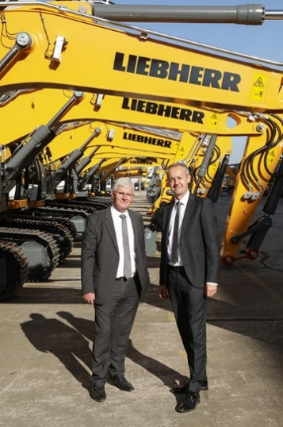

liebherr-france-sas-new-managing-director.jpg  
Christophe Sanchez (right) is succeeding Martin Schickel (left) at the helm of the historic Liebherr site in France.

Contact person

Alban Villaumé  
Marketing Manager  
Tel.: +33 89 21 36 09  
E-mail: alban.villaumé@liebherr.com

Published by

Liebherr-France SAS  
Colmar, France  
www.liebherr.com