Press release

Profitability as a unique selling point: Three Liebherr L 586 XPower® wheel loaders for BTB Group Berlin

⸺

* **Excellent fuel efficiency with power-split transmissions critical factor in purchasing decision**
* **Liebherr integrates custom paintwork for wheel loaders directly into the production process**
* **Liebherr wheel loaders support the BTB Group in innovative recycling of building materials**

**Building for Berlin since 1990 – the family-run BTB Group Berlin offers everything from earthmoving to recycling from a single supplier. Three new Liebherr L 586 XPower® wheel loaders have recently been added to the company's fleet. They replace L 580 XPower® machines purchased in 2017, which have performed reliably. Their fuel efficiency, compared to other wheel loaders of the same size, was an important criterion in the purchasing decision. The new wheel loaders are also visually-impressive with their special paintwork in the BTB Group corporate design. The keys were handed over in person by Oliver Hanneck, salesman at Liebherr-Baumaschinen Vertriebs- und Service GmbH Berlin.**

Berlin (Germany), 3 November 2021 – Three new L 586 XPower® units have recently been put into operation at BTB Group Berlin's 25-hectare recycling facility. A multitude of recycling plants – approved in accordance with the German Emission Control Act (BImSchG) – operate at the complex, and a total of up to one million tonnes of mineral and non-mineral construction waste is processed, handled, and reused annually. The new Liebherr wheel loaders feed crushers and screeners with construction waste and load lorries with processed material. The L 586 XPower®, Liebherr's largest wheel loader, only requires two to three cycles to load a lorry. This ensures quick and resource-efficient handling of material.

**Economical and resource-efficient due to power-split transmission**

“Powerful, efficient and noticeably more fuel-efficient than the competition: these were the reasons behind our purchasing decision,” reveals BTB Group Berlin company owner Philip Breul. The power-split drive concept of the XPower® wheel loaders is what enables this. XPower® provides a combination of hydrostatic and mechanical drives. The interaction between the two adapts automatically and continuously to the respective application. This, together with Liebherr Power Efficiency (LPE), ensures a fuel reduction of up to 30% compared with other wheel loaders in this size class.

**Liebherr integrates special paintwork for wheel loaders directly into the production process**

Having a fleet painted in the company's own design is not only good marketing, but also a source of pride for many organizations. For this reason, the BTB Group ordered the three new L 586 XPower® units from Liebherr in its company colours. The specialists at Liebherr's Bischofshofen plant implement special paintwork directly in the production process. This means that the individual components are painted before assembly and then incorporated into the regular production process. This procedure saves subsequent painting and manual reworking. Liebherr thus achieves a higher degree of quality with custom paintworks.

**Forward-looking and innovative: BTB Group Berlin as a growing family business**

Like Liebherr, the BTB Group Berlin is a family-run company that stands for versatility in the construction industry. In 1990, Reimar Breul founded the steadily-growing company, which now has over 100 employees. As a specialist in civil engineering, demolition, disposal, and recycling, the BTB Group is in charge of numerous major construction sites in the Berlin area. The company is forward-looking in the field of recycling and uses innovative concepts to produce new building materials from what was once useless construction waste, all of which is aided by numerous construction machines from Liebherr.

About Liebherr-Werk Bischofshofen GmbH

Liebherr-Werk Bischofshofen GmbH develops, produces and sells wheel loaders from the Liebherr Group. The plant, in the federal state of Salzburger Land (Austria) has grown steadily over the decades thanks to sustainable innovations, creative solutions and high-quality standards. The wheel loader range is constantly being expanded and includes different models in four different product groups: Compact loaders, Stereoloaders, midsized all-round wheel loaders, and large wheel loaders, which impress with their innovative drive designs.

About the Liebherr Group

The Liebherr Group is a family-run technology company with a highly diverse product portfolio. The company is not only one of the largest construction equipment manufacturers in the world, but also provides high-quality and user-oriented products and services in a wide range of other areas. The Liebherr Group includes over 140 companies across all continents, employs around 48,000 staff and in 2020 achieved combined revenues of over 10.3 billion euros. Since its foundation in 1949 in Kirchdorf an der Iller in Southern Germany, Liebherr has been pursuing the goal of achieving continuous technological innovation, and bringing industry-leading solutions to its customers.

**Images**

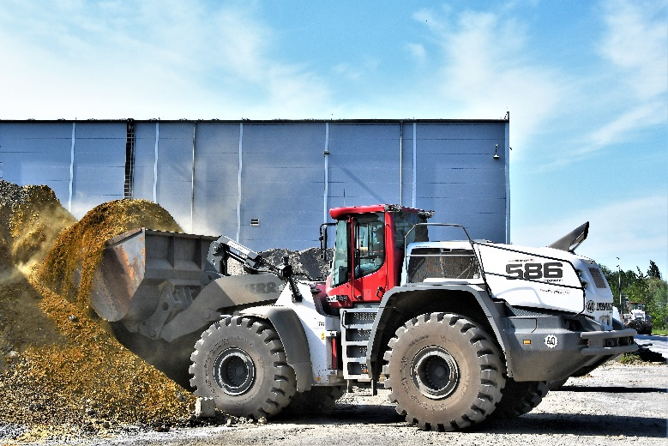

liebherr-wheel-loader-l586-btb-gruppe.jpg  
One of the new L 586 XPower® units at BTB Group Berlin.

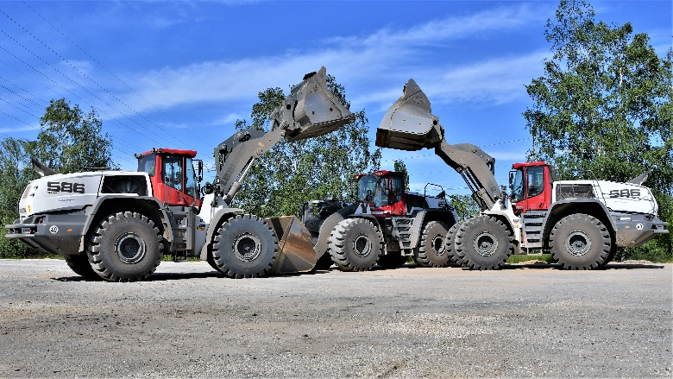

liebherr-three-new-wheel-loaders-l586-for-btb-gruppe.jpg  
The three new Liebherr wheel loaders in the corporate colours of the BTB Group.

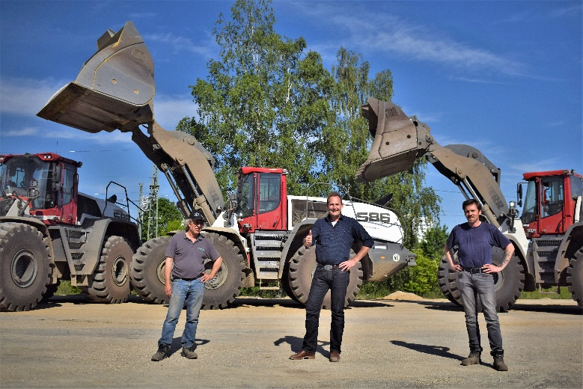

liebherr-wheel-loaders-l586-xpower-machine-handover-btb-gruppe.jpg  
Oliver Hanneck (centre) hands over the L 586 XPower® wheel loaders to the machine operators. The locally applicable Corona specifications were complied with.

Contact person

Martin Koller  
Marketing and Public Relations  
Phone: +43 50809 11475  
email: martin.koller.lbh@liebherr.com

Published by

Liebherr-Werk Bischofshofen GmbH  
Bischofshofen/Austria  
www.liebherr.com