**Press release**

**Rounding off the portfolio – Seeland decides to purchase the Liebherr LTM 1150-5.3**

⸺

LTM 1150-5.3 purchased to meet high demand

The very latest crane technology and long term partnership were key

Longest telescopic boom in its class

Gustav Seeland GmbH has purchased a 150 tonne mobile crane to meet high demand. A Liebherr LTM 1150-5.3 has now rounded off the Hamburg-based crane and heavy haulage contractor’s portfolio. The very latest crane technology and long term partnership were key factors in choosing Liebherr once again.

Ehingen (Donau) (Germany), 3 November 2021 – Liebherr first unveiled the LTM 1150-5.3 a year ago using the slogan “The jewel in your fleet” – not at a trade show as is the standard procedure, but virtually as a result of the coronavirus pandemic. This flexible all-rounder has the longest telescopic boom in this crane class at 66 metres and can compete with crane models in the 200 tonne lifting capacity class. It delivers outstanding lifting capacities when fully raised and at large radii. And it is immediately ready for use once it reaches the site. This is because the new 150 tonne crane carries nine tonnes of a ballast with a gross weight of 60 tonnes. That means it can complete lots of jobs without requiring additional ballast transport vehicles. That saves time, money and makes the crane even more valuable to crane contractors.

Managing Director at Gustav Seeland GmbH, Johann Evers, explains: “We identified the need in the market and invested on the basis of customer demand. After holding internal discussions with our dispatch and crane operators, we decided on the Liebherr 150 tonner. The LTM 1150-5.3 will enhance the Seeland crane portfolio.”

The important thing for Seeland was that the crane is state of the art to enable the contractor to offer its customers individual modern crane solutions and services. The LTM 1150-5.3 will be used, among other things, for internal relocations, alignment work, assembly jobs, bridge installations, loading and unloading jobs, handling work and recovery jobs.

Long term partnership

Gustav Seeland GmbH has a long term business relationship with Liebherr. The company has an 80-strong workforce and operates a total of 17 cranes in a wide variety of designs. Eight of its ten all-terrain cranes have been supplied by Liebherr. In summer 2021, an LTM 1060-3.1 was added to the fleet and an LTF 1045-4.1 truck mounted telescopic crane is scheduled to be delivered shortly. Evers continues: “We attach special value to the sort of all-round service that Liebherr provides all the time and in which we have been placing our trust for years. We like the transparency of the company and we regard Liebherr as an excellent partner.”

About Gustav Seeland GmbH

One of the largest providers of heavy haulage logistics services in Germany, Gustav Seeland GmbH can find the appropriate solution to even the most complex tasks. Its range of services includes the full gamut of heavy and special haulage, mobile crane work, hybrid fleet, industrial assembly work, engineering and heavy goods warehousing. A partner and founding member of BigMove AG, the company has a pan-European network and also has an enormous fleet of vehicles. Seeland is certified to ISO 9001:2015, SCCP:2011 and EcoProfit and is actively supporting the reduction of CO2 emissions through its membership of the “Hamburg Environmental Partnership” in several ways, including its increasing investment in hybrid vehicle technology.

About Liebherr-Werk Ehingen GmbH

Liebherr-Werk Ehingen GmbH is a leading manufacturer of mobile and crawler cranes. Its range of mobile cranes extends from 2-axle 35 tonne cranes to heavy duty cranes with a lifting capacity of 1200 tonnes and a 9-axle chassis. Its lattice boom cranes on mobile or crawler crane chassis deliver lifting capacities of up to 3000 tonnes. With universal boom systems and extensive additional equipment, they can be seen in action on construction sites throughout the world. The Ehingen site has a workforce of 3,500. Extensive, global service guarantees the high availability of Liebherr mobile and crawler cranes. In 2020, the Liebherr plant in Ehingen recorded a turnover of 2.03 billion euros.

About the Liebherr Group

The Liebherr Group is a family-run technology company with a widely diversified product range. The company is one of the largest manufacturers of construction machines in the world, but also supplies technically advanced, user-focused products and services in many other sectors. The group currently comprises more than 140 companies based in every continent of the world, has a workforce of around 48,000 and recorded a consolidated total turnover of more than 10.3 billion euros in 2020. Since it was founded in 1949 in Kirchdorf an der Iller in southern Germany, Liebherr’s aim has been to win customers by supplying high quality solutions and to contribute to technological progress.

Photographs:

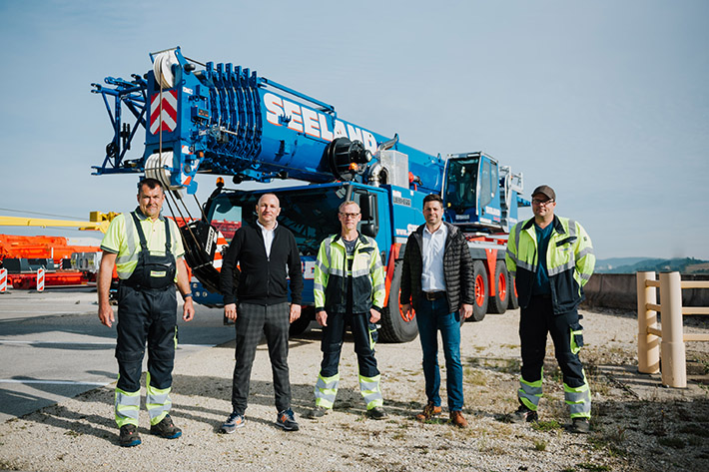  
liebherr-ltm1150-5-3-seeland-1.jpg  
From left to right: Holger Krause, Guido Neumann, Ronny Pillkahn (all from Gustav Seeland GmbH), Alexander Schwald (Liebherr-Werk Ehingen GmbH), Hendrik Willers (Gustav Seeland GmbH). The locally applicable Corona specifications were complied with.

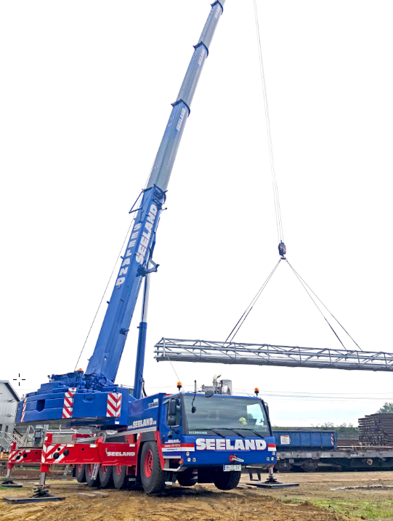  
liebherr-ltm1150-5-3-seeland-2.jpg  
Radii of up to 39 metres during one of its very first jobs – the new LTM1150-5.3 showed exactly what it could do in Hamburg by hoisting a 5.6 tonne pipe bridge.

Contacts

Wolfgang Beringer  
Marketing and Communication  
Phone: +49 7391/502 - 3663  
Email: wolfgang.beringer@liebherr.com

Published by

Liebherr-Werk Ehingen GmbH  
Ehingen (Donau) / Germany  
www.liebherr.com