

Press release

Travelling up to the treeline with snow chains

⸺

LTM 1160-5.2 working on important power line on the edge of the Austrian Alps

Three Liebherr mobile cranes operated by Prangl GmbH in action at altitudes of up to 1800 metres

Cranes have to ascend site roads with gradients of up to 26 percent

In Austria, work is currently proceeding at full speed on the "Salzburg line", the country's most important electricity infrastructure project. The Salzburg line runs for a total length of 128 kilometres through the province of Salzburg in partly alpine terrain. The Liebherr mobile cranes working on the construction of the massive electricity pylons have had to access sites at altitudes of up to 1800 metres above sea level.

Ehingen (Donau) (Germany), 9 November 2021 – A Liebherr LTM 1160-5.2 mobile crane from Austrian crane contractor Prangl GmbH has been working on the construction of electricity pylons in the Austrian mountains since February this year. The crane has had to be set up in various configurations depending on set-up area for it and the height of the pylon being erected. For the highest pylons, the LTM 1160-5.2 is set up with its maximum configuration. “Three telescopic extension each measuring seven metres on the 62 metre boom and the 19 metre double folding jib enable us to reach a maximum hoist height of 99 metres”, says Oliver Thum. He is planning and managing this extensive, challenging job for Prangl in his capacity as a Technical External Services Specialist at the company. "We have bought a telescopic extension specially for this job. We have obtained two others from one of our other Liebherr cranes from our branch in Vienna.” These telescopic extensions can also be used for all current LTM models with lifting capacities from 100 to 180 tonnes. These lattice boom elements are even fully compatible with the LTR 1100 telescopic crawler crane.

Snow and gradients challenge cranes and drivers

The crane job in the Austrian mountains will last into summer 2022 – with a few months off for a winter break. “On some occasions we actually had to put snow chains on our crane to get to the site. But we always have them with us anyway”, says Thum about this extraordinary job in the mountains where the teams had to work in snowy conditions even in May. In addition, some of the access routes for the mobile cranes involve climbing extreme gradients. “The steepest access route that we had to cover with the LTM 1160-5.2 was around 23 percent.” An LTM 1090-4.2, which, along with an LTM 1070-4.2, is also being used sporadically for this job, even had to climb access routes with a gradient of 26 percent.

On the sites themselves, the cranes generally had to manage with extremely restricted set-up areas. The highly flexible VarioBase® support system, which all three of the Liebherr mobile cranes used for the job feature among their equipment, managed to overcome even restricted conditions without compromising safety or lifting capacity.

Some of the sites in the mountainous region, however, could not be reached at all with the off-road cranes. In these cases, the pylons had to be erected with the help of helicopters or using cable cars. A Liebherr crane completed the erection work lasting several days at all the other sites, however. The weight of the components of the massive pylons, which will later support high voltage cables carrying 380 kV, is up to eight tonnes. “We still have lots of pylons to install – we will certainly be working here until well into next summer”, says Oliver Thum.

So Prangl’s yellow cranes will continue to be a common sight on the partly non-metalled tracks up to the treeline. Family-run Prangl GmbH was founded in 1965 currently has a workforce of around 700, and in addition to six sites in Austria, also has offices and outlets in Hungary, Slovenia, Croatia, Bosnia and Herzegovina as well as Sweden. The specialist heavy haulage, transport and lifting logistics contractor has a large fleet which includes more than 80 Liebherr mobile cranes.

About Liebherr-Werk Ehingen GmbH

Liebherr-Werk Ehingen GmbH is a leading manufacturer of mobile and crawler cranes. Its range of mobile cranes extends from 2-axle 35 tonne cranes to heavy duty cranes with a lifting capacity of 1200 tonnes and a 9-axle chassis. Its lattice boom cranes on mobile or crawler crane chassis deliver lifting capacities of up to 3000 tonnes. With universal boom systems and extensive additional equipment, they can be seen in action on construction sites throughout the world. The Ehingen site has a workforce of 3,600. Extensive, global service guarantees the high availability of Liebherr mobile and crawler cranes. In 2020, the Liebherr plant in Ehingen recorded a turnover of 2 billion euros.

About the Liebherr Group

The Liebherr Group is a family-run technology company with a widely diversified product range. The company is one of the largest manufacturers of construction machines in the world, but also supplies technically advanced, user-focused products and services in many other sectors. The group currently comprises more than 140 companies based in every continent of the world, has a workforce of around 48,000 and recorded a consolidated total turnover of more than 10.3 billion euros in 2020. Since it was founded in 1949 in Kirchdorf an der Iller in southern Germany, Liebherr’s aim has been to win customers by supplying high quality solutions and to contribute to technological progress.

Photographs

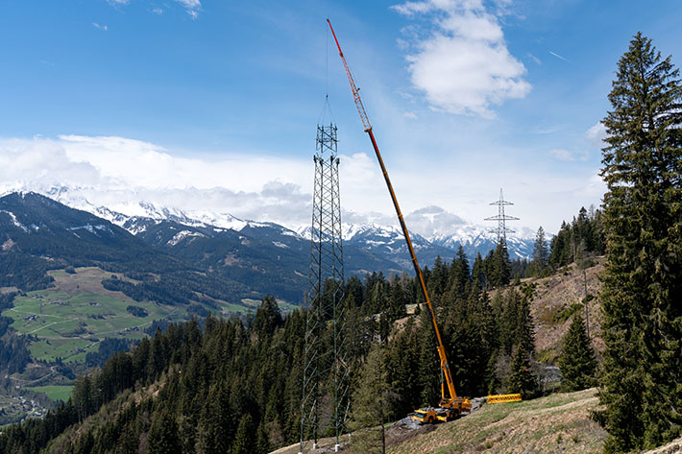

liebherr-ltm-1160-5-2-prangl-01.jpg  
Alpine scene – Prangl has been working full-time since February this year on building electricity pylons in the Austrian mountains using a Liebherr LTM 1160-5.2 mobile crane.

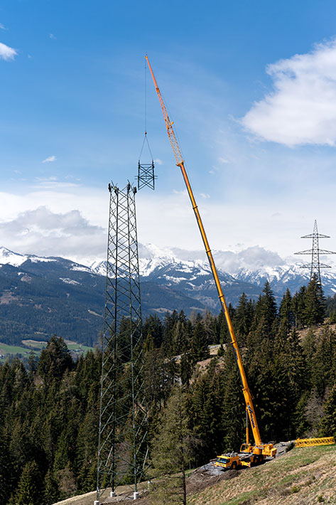

liebherr-ltm-1160-5-2-prangl-02.jpg  
Up, up and away – Prangl’s LTM 1160-5.2 is installing massive electricity pylons in the Austrian mountains using hook heights of up to 99 metres. Up to three extension sections each measuring seven metres in length can be attached to the crane’s telescopic boom.

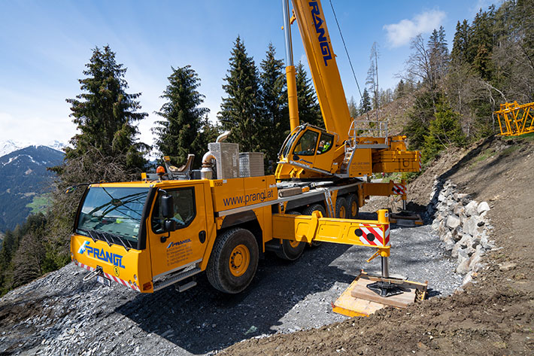

liebherr-ltm-1160-5-2-prangl-03.jpg   
Spacer-saver – the LTM 1160-5.2 generally has to operate with little set-up space on slopes. The flexible support system on Liebherr mobile cranes is a massive benefit in this case. Prangl only sends cranes with VarioBase® to these jobs in the mountains.

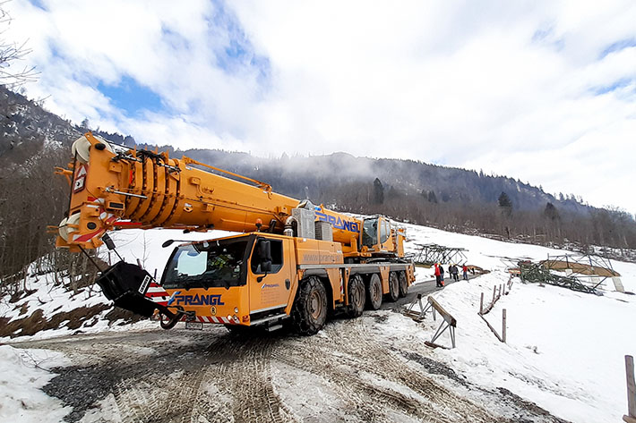

liebherr-ltm-1160-5-2-prangl-04.jpg   
Snow chains – on several occasions the powerful 5-axle crane required snow chains to ensure it could get to the site easily. “We always carry snow chains with us anyway”, says Oliver Thum from Prangl GmbH.

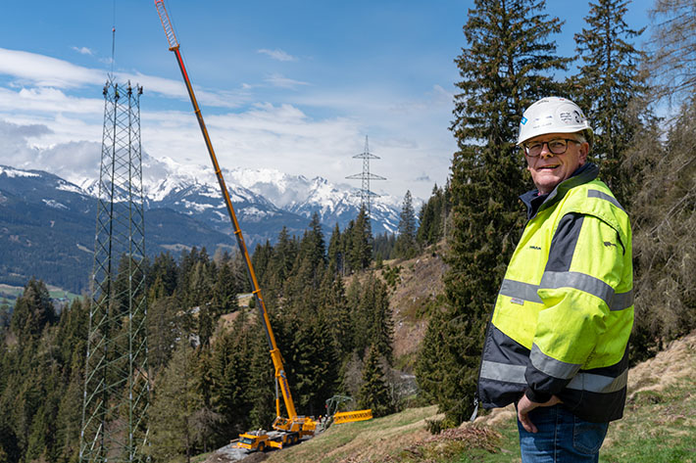

liebherr-ltm-1160-5-2-prangl-05.jpg   
Expert – Oliver Thum, Technical External Services Specialist at Austrian crane contractor Prangl GmbH, is planning and supervising the electricity pylon erection with his Liebherr cranes. He drops in at the sites in the mountains every week to make sure things are going smoothly.

Contacts

Wolfgang Beringer  
Marketing and Communication  
Phone: +49 7391/502-3663  
Email: wolfgang.beringer@liebherr.com

Published by

Liebherr-Werk Ehingen GmbH  
Ehingen (Donau) / Germany  
www.liebherr.com