Press Release

The new weightlifter:   
LR 1400 SX

⸺

“This is a big step for our location,” says Gerhard Frainer, Managing Director for Sales. “The request for a larger crane came from the market.” With the new LR 1400 SX, Liebherr-Werk Nenzing Gmbh extends its range of crawler cranes to include lifting capacities of up to 400 t. Especially satisfying: the first customers are already using the new model.

Nenzing (Austria), 9th November 2021 – The first LR 1400 SX have already left the Liebherr factory. With the compact transport weight of 46 t, the complete crane can be easily transported between jobsites. Platform and railings remain attached to the uppercarriage during transportation and only need to be folded down.

The self-assembly system enables quick assembly. “You can operate the whole crane with the remote control,” enthuses Paul Belcher, Owner and Managing Director of Mountain Crane Service, USA. This allows for a better overview and increases safety on site.

Despite its size, the LR 1400 SX has a wide range of applications and has already convinced the first German customer, Depenbrock, with its flexibility. “For barge operation, the available barge load charts for any configuration and any possible counterweight combination are crucial. The modular counterweight system is very good. If a smaller counterweight is sufficient, the unit can also be used on a correspondingly smaller barge. “This makes the use of the LR 1400 SX very flexible,” says Andreas Handel, Head of Mechanical Engineering Hydro Construction.

Just how flexible and mobile the crane is, can be seen when space is restricted. The four crawler drives make it easier to manoeuvre the LR 1400 SX on jobsites where space is tight. Thanks to the track width adjustment, access on narrow roads is enormously simplified.

Highest level of safety

The crane designers paid particular attention to the safety concept. The assistance system “Gradient Travel Aid” helps to negotiate slopes and inclines. It displays the crane’s centre of gravity and warns the operator before the crane leaves the safe area.

The Ground Pressure Visualization of the LR 1400 SX calculates the current ground pressure of the crane in real time and compares it with the specified safety limits of the relevant position. The ground pressure is displayed in the operator's cab and the operator is permanently aware of whether the machine is situated in, or is approaching, a critical area. “This is a super feature. We have to constantly observe and monitor the ground conditions,” says Paul Belcher.

The ground pressure of the crane can also be reduced using the ground pressure reduction plates. “Specifically, the wide crawlers and the ground pressure reduction plates convinced us,” says Ludger Holtmann, Technical Director at Depenbrock and adds, “the free-fall winches, which are required for some applications, were also decisive for the purchase.”

The animation shows the LR 1400 SX from transportation to the jobsite up to lifting operation:  
[Liebherr - Crawler Crane LR 1400 SX - YouTube](https://www.youtube.com/watch?v=6Jwj7af-m4c)

A complete interview with the customers Depenbrock and Mountain Crane Service can be found here:  
[www.liebherr.com/LR1400SX](http://www.liebherr.com/LR1400SX)

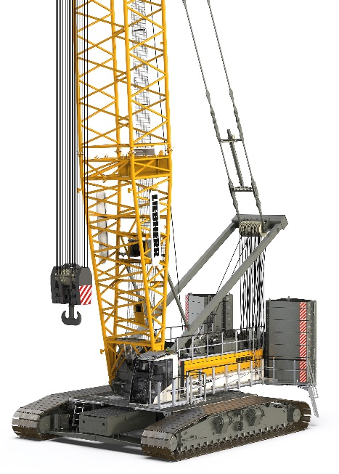Images

liebherr-lr1400sx-1.jpg  
The new weightlifter in the 400-tonne range.

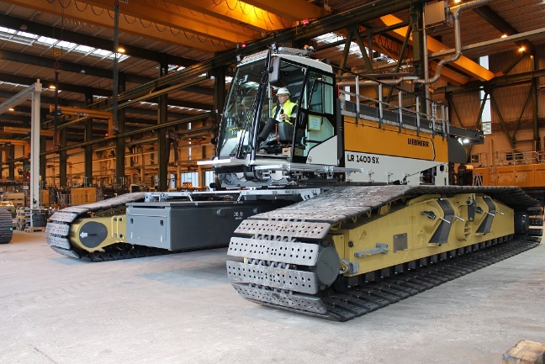

liebherr-lr1400sx-2.jpg  
A milestone for the LR 1400 SX. Managing Director, Gerhard Frainer, drives the new crane out of the production shop for the first time.

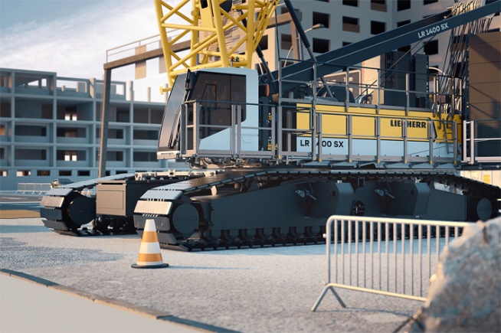

liebherr-lr1400sx-3.jpg  
The LR 1400 SX in elegant design.

Contact

Gregor Griesser  
Strategic Marketing and Communications  
Email: [gregor.griesser@liebherr.com](mailto:gregor.griesser@liebherr.com)

Wolfgang Pfister  
Head of Strategic Marketing & Communications  
Tel.: +43 50809 41444  
Email: [wolfgang.pfister@liebherr.com](mailto:wolfgang.pfister@liebherr.com)

Published by:

Liebherr-Werk Nenzing GmbH  
Nenzing / Austria  
[www.liebherr.com](http://www.liebherr.com)