

Press release

Premiere – first Liebherr compact cranes with rope pull technology delivered

⸺

Wasel and Felbermayr take delivery of the first compact cranes with rope pull technology

First unveiled at the end of 2020, the first cranes have now been delivered

Rope pull is the new alternative for crane contractors who chiefly use the compact crane inside buildings

Liebherr first unveiled the LTC 1050-3.1 compact crane with a second boom version in December 2020. Since then, customers have been able to choose between the TELEMATIK and rope pull mechanism versions for the compact 50 tonne model. The launch of this crane sees Liebherr round off its portfolio in the compact crane segment. The very first models of this new version were handed over to crane rental contractors Wasel in Germany and Felbermayr in Austria during October.

Ehingen (Donau) (Germany), 18 November 2021 – Crane rental contractors Felbermayr based in Wels, Austria, and Wasel based in Bergheim near Cologne have taken delivery of the first Liebherr LTC 1050-3.1 compact cranes featuring the rope pull mechanism boom. This new boom version for the 50 tonne crane was unveiled at the end of 2020 and rounds off Liebherr’s portfolio in the compact crane segment. Since then, customers have been able to choose between the powerful, long TELEMATIK version and the familiar, high speed rope pull mechanism.

Development started at the Bauma in 2019

The first talks between Matthias Wasel from Wasel, Mag. Peter Stöttinger, from Felbermayr and Dr Ulrich Hamme, Engineering and Development Director at Liebherr in Ehingen, took place at the Bauma in 2019. Both customers addressed similar requirements to Liebherr. “The LTC 1050-3.1 is a good compact crane, which particularly comes into its own when used inside buildings,” says Stöttinger. “However, TELEMATIK was not really a familiar technology for our crane operators in the compact crane segment. The rope pull mechanism has been in used for decades on small cranes and is very widespread. Our operators are very familiar with it and have come to appreciate it over many years.”

“It also takes slightly longer to extend and retract the boom using TELEMATIK. Particularly when we are working inside buildings, where production often has to be stopped, every minute counts. Fast telescoping with a high load is worth its weight in gold in these situations – which is why we directly approached Liebherr with our experience at the Bauma”, says Wasel.

Immediately after the Bauma, the design team at Ehingen started work on the development of the rope pull boom for the time-tested LTC 1050-3.1 compact crane. “We are always delighted when our customers come to us with valuable insights and requests, regardless of whether they refer to crane jibs, technologies or complete booms. This is yet another great example for our view that we should drive forward developments together in partnership. So it is a great pleasure for us to be able to hand over the first cranes featuring this boom technology”, says Dr Hamme.

Spoilt for choice

The new boom with rope pull mechanism is 31 metres long and consists of a pivot section and 4 telescoping sections – one less than the TELEMATIK boom. The telescoping sections are extended and retracted using a dual-action 2-stage hydraulic cylinder. Stage 1 extends telescoping section 1. Stage 2 extends telescoping sections 2 to 4 synchronously using a 2-way pulley block. The new boom also delivers high telescoping lifting capacities, an important feature for use inside buildings. This boom can telescope at high speed using familiar technology.

The TELEMATIK boom, which has been available since the market launch of the LTC 1050-3.1, delivers high lifting capacities with long booms and wide radii. But even with the booms not fully extended, TELEMATIK delivers higher lifting capacities as the individual telescoping sections can be extended in any sequence and independently of each other. “Today, customers can choose between the powerful, long TELEMATIK boom and the high speed, familiar rope pull mechanism. Depending on the applications for which the compact crane is needed, one or the other variant is better suited," says Dr Hamme.

About Liebherr-Werk Ehingen GmbH

Liebherr-Werk Ehingen GmbH is a leading manufacturer of mobile and crawler cranes. Its range of mobile cranes extends from 2-axle 35 tonne cranes to heavy duty cranes with a lifting capacity of 1200 tonnes and a 9-axle chassis. Its lattice boom cranes on mobile or crawler crane chassis deliver lifting capacities of up to 3000 tonnes. With universal boom systems and extensive additional equipment, they can be seen in action on construction sites throughout the world. The Ehingen site has a workforce of 3,500. Extensive, global service guarantees the high availability of Liebherr mobile and crawler cranes. In 2020, the Liebherr plant in Ehingen recorded a turnover of 2.03 billion euros.

About the Liebherr Group

The Liebherr Group is a family-run technology company with a widely diversified product range. The company is one of the largest manufacturers of construction machines in the world, but also supplies technically advanced, user-focused products and services in many other sectors. The group currently comprises more than 140 companies based in every continent of the world, has a workforce of around 48,000 and recorded a consolidated total turnover of more than 10.3 billion euros in 2020. Since it was founded in 1949 in Kirchdorf an der Iller in southern Germany, Liebherr’s aim has been to win customers by supplying high quality solutions and to contribute to technological progress.

Photographs

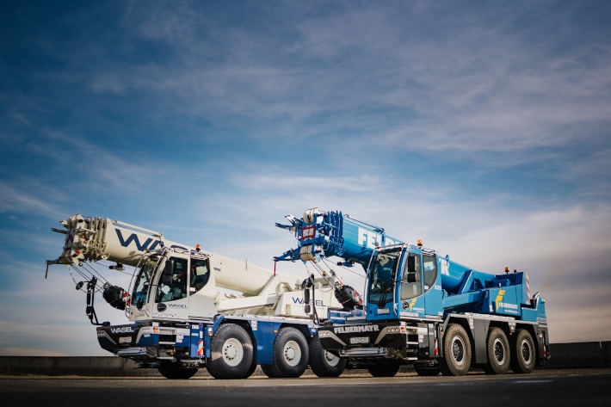

liebherr-ltc-rope-pull-wasel-felbermayr-1.jpg  
The first LTC compact cranes with rope pull technology are delivered.

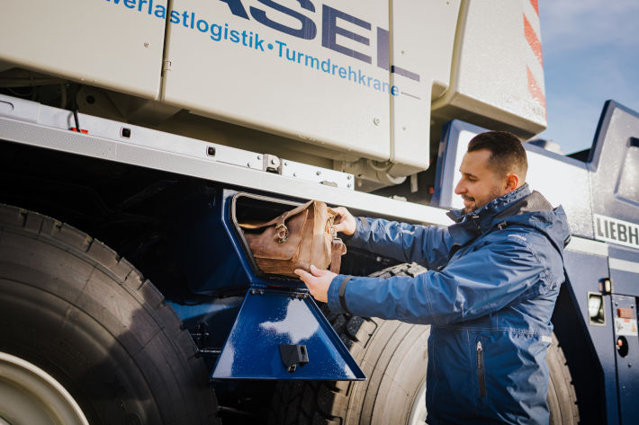

liebherr-ltc-rope-pull-wasel-felbermayr-2.jpg  
New with more space – the side compartment between axles 2 and 3 is new and now provides even more storage space.

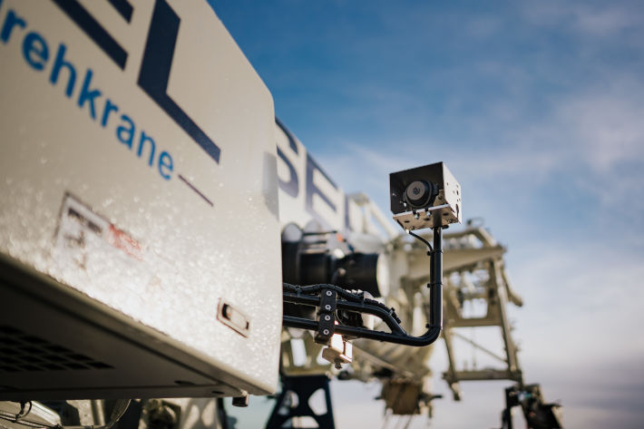

liebherr-ltc-rope-pull-wasel-felbermayr-3.jpg  
Also new – the side camera to monitor the right-hand side of the vehicle, particularly when the boom has been luffed down to achieve the lowest possible clearance height.

Contacts

Wolfgang Beringer  
Marketing and Communication  
Phone: +49 7391/502 - 3663  
Email: wolfgang.beringer@liebherr.com

Published by

Liebherr-Werk Ehingen GmbH  
Ehingen (Donau) / Germany  
www.liebherr.com