

Press release

Liebherr win contract to supply automated cranes to Port of Duqm, Oman

⸺

Four ship to shore container cranes (STS) and twelve rubber tyre gantry cranes (RTG) along with remote operator stations (ROS) to be supplied

Cabinless cranes will be operated via automation and remote control

High speed and near zero latency mesh network for remote control of diesel powered RTGs

Killarney (Ireland), November 2021 – Liebherr Container Cranes Ltd. are pleased to announce that they have secured the contract to supply STS and RTGs to the Port of Duqm. The order of four STS and twelve RTGs will be delivered to Oman in late 2022.

The Port of Duqm development is a greenfield project and is part of the ambitious SEZAD project (Special Economic Zone of Authority at Duqm). The facility is centrally located overlooking the Arabian Sea and the Indian Ocean beyond. This new port has been designed to be a world class, multipurpose commercial gateway and is destined to become one of the largest ports in the region. It is being developed into an integrated, multimodal logistics hub and is well connected via road, rail and air. The deep-water port and new cranes will allow the port to handle the world’s largest container vessels as it expands its existing cargo and bulk services with container handling.

Automation

The new ship to shore container cranes will be capable of handling the world’s largest container vessels and feature an outreach of 71 m, a back reach of 18 m and a lift height over rail of 50m. The cranes have a safe working load of 65 tonnes under twinlift spreader. Supplied without a cabin the cranes will be operated utilising a combination of remote control and automation. Automation will take care of the majority of the cycle with operator intervention only required when operating below a predefined safe height. Each Liebherr STS will be connected to its own dedicated ROS. The centrally located remote operation facility will also host the ROS for control of the automated RTGs. The cabinless RTGs feature automation over the stack with remote control only required for container pick or place from the truck trailers, or for exception handling. Four ROS operators will operate the twelve RTGs.

Mesh Technology

The diesel powered RTGs can stack eight containers and a truck lane wide and one over six containers high. Data communications in the container yard will be handed by a mesh network. This decentralised system sees multiple access points positioned throughout the yard providing a high speed and stable data network delivering the required latency and high-bandwidth communication necessary for remote control.

Prepared for the future

Gerry Bunyan, Managing Director - Sales for Liebherr Container Cranes Ltd. said “Liebherr is very happy to have been awarded this project in Oman. Liebherr has for many years supplied STS and RTG cranes throughout the Middle East, but these will be the first Liebherr container cranes in Oman. These are also our first cabinless and automated cranes in the region and we look forward to seeing the cranes being deployed, and playing the lead role in expanding the services offered by the Port. The new Liebherr cranes have been designed with the future in mind. Their size and the extensive automation features will ensure that the Port of Duqm will be able to efficiently, safely and predictably handle the world’s largest container vessels for many years to come.”

**About Liebherr Container Cranes**

Liebherr Container Cranes Ltd. Is one of the world’s leading manufacturers of ship to shore container cranes, rail-mounted gantry cranes and rubber tyre gantry cranes. From a base in Killarney, Ireland, Liebherr Container Cranes Ltd designs, builds and exports container cranes worldwide. Founded in 1958 as the first Liebherr factory outside of Germany, today, container cranes manufactured by Liebherr in Ireland are renowned for their quality, longevity and productivity..

About the Liebherr Group

The Liebherr Group is a family-run technology company with a highly diversified product portfolio. The company is one of the largest construction equipment manufacturers in the world. It also provides high-quality and user-oriented products and services in a wide range of other areas. The Liebherr Group includes over 140 companies across all continents. In 2020, it employed around 48,000 staff and achieved combined revenues of over 10.3 billion euros. Liebherr was founded in Kirchdorf an der Iller in Southern Germany in 1949. Since then, the employees have been pursuing the goal of achieving continuous technological innovation, and bringing industry-leading solutions to its customers.

Images

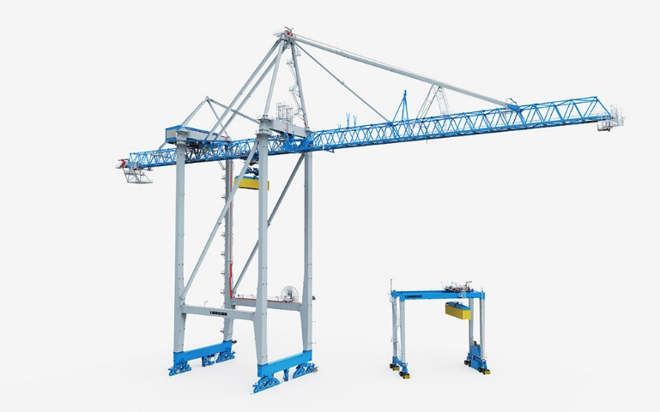

Liebherr_auto_sts_rtg.jpg  
Automated STS and RTG cranes for the Port of Duqm, Oman

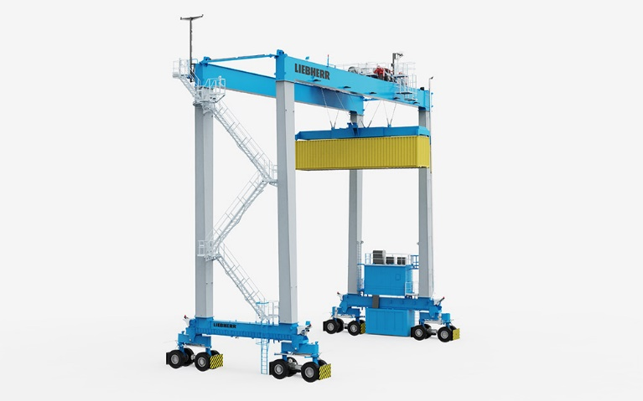

Liebherr_auto_rtg.jpg  
A cabinless, automated RTG crane

Contact person

Trevor O’Donoghue  
Marketing Manager  
Telephone: +353 (0)64 6680459  
E-Mail: trevor.odonoghue@liebherr.com

Published by

Liebherr Container Cranes Ltd.   
Killarney / Ireland  
www.liebherr.com