

Press release

Engineered for the future, built on experience – Liebherr LTM 1110-5.2 mobile crane

⸺

The LTM 1110-5.2 marks Liebherr’s launch of the 3rd generation of the LICCON crane control system

The new driver's cab has the very latest design, ergonomy and comfort features

Zero wear manoeuvring with the ZF TraXon DynamicPerform gearbox

1 becomes 2 because of 3 – the Liebherr LTM 1110-5.1 mobile crane has become the LTM 1110‑5.2 because it has three completely new features – the crane control system, the driver's cab and the gearbox. The Liebherr 110 tonne crane, which was first unveiled at Bauma 2019, features the new driver's cab also unveiled at the trade show in prototype form, Liebherr’s new LICCON3 crane control system and also the recently announced ZF TraXon DynamicPerform gearbox. The oil-cooled multi-disk clutch is also new. It has now undergone intensive testing and is now ready for series production. This means that the new LTM 1110-5.2 combines existing strengths with pioneering innovations to deliver greater safety and comfort. To go with these new features, Liebherr is launching a completely new standard crane design, which marks the future for its all-terrain series.

Ehingen (Donau) (Germany), 25 November 2021 – The 5-axle Liebherr 110 tonne crane is a best-seller with its powerful, 60 metre telescopic boom and variable axle loads for maximum mobility all over the world. But a good thing can become even better if it is made simpler, safer and more comfortable.

LICCON3 crane control system

This is now the third generation of the LICCON (Liebherr Computed Control) control system and features the time-tested control features, but has a completely new software package and programming language as well as a faster databus, significantly more storage space and more computing power. Nikolaus Münch, Head of the Control System Department at Liebherr in Ehingen, explains: “During the development of the new control system, it was important to us that crane operators, who are familiar with Liebherr cranes, would be able to get used to the new control system quickly and easily. At the same time, we must be future-proof as the progress currently being made in microelectronics is immense. Complex applications, such as VarioBase®, which require a great deal of performance data, can now be developed more frequently in the future. The current LICCON2 control system is reaching the limits of its capacity.”

The similarities with the current control system are wide-ranging. Time-tested hardware components, such as the BTT remote control terminal, have been included. The touchscreen function on the new large display in the superstructure cab means that it is now even easier and more comfortable to control. The way in which the information is shown has also been revised and simplified. In addition, LICCON3 cranes are also prepared for telemetry and fleet management systems as standard. In the future, crane contractors will be able to view and evaluate all the relevant data using the MyLiebherr customer portal.

Driver's cab with award-winning design

Liebherr has developed the modern design of the new driver's cab in collaboration with designer Jürgen R. Schmid, Design Tech, Ammerbuch (Germany). It was rewarded with the renowned American GOOD DESIGN® award 2020 in the “Transportation” category. The GOOD DESIGN® awards were started in 1950 by Eero Saarinen together with Charles and Ray Eames and are awarded to the most innovative and modern industry, product and graphic designs from all over the world. The Chicago Atheaeum Museum of Architecture and Design organises the programme to increase awareness of contemporary design and to honour leaders of both product and industry leaders in design and production.

Liebherr first unveiled its new driver's cab at the Bauma 2019 to obtain feedback from customers at an early stage of the development process. The company has managed to implement lots of ideas to mark the start of series production. Due to high synergy effects, Liebherr is introducing the new cab at the same time as the LICCON3 control system. The modern design features premium materials and timeless lines as well as delivering a whole host of improvements for the crane driver. These include the new multifunction steering wheel, side roller blind on the driver’s door, improved instruments and modules as well as new displays. Options, such as the central locking system with remote key, the cool box and tyre pressure monitoring system deliver additional comfort.

A completely new, modern automatic heating and climate control system in both the driver’s and operator’s cabs guarantees comfortable working conditions. A sun sensor detects strong sunshine and automatically adjusts the heating settings. In addition to the standard radio with hands-free facility, a double DIN radio with extended functions is available as an option.

Nikolaus Münch believes that the revised lighting system is another highlight: “LED technology is a real plus as a result of its long service life. It will last for many more hours of service and also provides better lighting.” The lighting packages for the crane cabs, the superstructure, the rear of the vehicle, the front headlights and the telescopic boom and lattice jibs have been improved and now feature LEDs.

ZF TraXon DynamicPerform gearbox

The innovative DynamicPerform clutch module delivers almost zero wear starting and manoeuvring for the modular ZF TraXon gearbox without overheating. The new clutch module transmits the engine power via an oil-cooled plate pack that runs in oil. The friction heat generated when starting is dissipated in the clutch oil and supplied to the vehicle’s cooling system via an oil/water heat exchanger. Due to the higher energy and power consumption, together with a calculation model, permanent and almost wear-free manoeuvring is made possible. An implemented clutch protection function also prevents overheating of the clutch and the associated increased wear or destruction of the clutch in extreme load cases. That prevents downtimes and helps to significantly extend the service life of the drivetrain. Crane owners therefore benefit from greater efficiency and falling maintenance costs while drivers will have their workload reduced by the highly controllable clutch.

Liebherr was ZF’s partner in the development of the TraXon DynamicPerform and its integration in the drivetrain of mobile cranes. Josef Schick, Head of the Testing Department at Liebherr, says: “As a result of the close collaboration with ZF and a very intensive phase of testing, the new gearbox version is now ready for widespread use. The cooling performance of the DynamicPerform clutch module has been significantly increased yet again by means of improvements to various hardware components. The model has also been refined for calculating the disc temperature. Vehicle tests in a refrigeration chamber at temperatures as low as minus 40 degrees have confirmed that DynamicPerform works very well even in extremely low temperatures. We have managed to solve all the initial problems. Overall we can safely say that there are worlds of differential between a dry clutch and the new wet starting clutch!”

Initially, Liebherr plans to install DynamicPerform in its 5-axle mobile cranes on a step by step basis. On mobile cranes with six or more axles, Liebherr intends to continue to use the ZF 12-speed TraXon Torque gearbox with starting converter, which in addition to zero wear manoeuvring, also delivers an increase in torque.

About Liebherr-Werk Ehingen GmbH

Liebherr-Werk Ehingen GmbH is a leading manufacturer of mobile and crawler cranes. Its range of mobile cranes extends from 2-axle 35 tonne cranes to heavy duty cranes with a lifting capacity of 1200 tonnes and a 9-axle chassis. Its lattice boom cranes on mobile or crawler crane chassis deliver lifting capacities of up to 3000 tonnes. With universal boom systems and extensive additional equipment, they can be seen in action on construction sites throughout the world. The Ehingen site has a workforce of 3,500. Extensive, global service guarantees the high availability of Liebherr mobile and crawler cranes. In 2020, the Liebherr plant in Ehingen recorded a turnover of 2.03 billion euros.

About the Liebherr Group

The Liebherr Group is a family-run technology company with a widely diversified product range. The company is one of the largest manufacturers of construction machines in the world, but also supplies technically advanced, user-focused products and services in many other sectors. The group currently comprises more than 140 companies based in every continent of the world, has a workforce of around 48,000 and recorded a consolidated total turnover of more than 10.3 billion euros in 2020. Since it was founded in 1949 in Kirchdorf an der Iller in southern Germany, Liebherr’s aim has been to win customers by supplying high quality solutions and to contribute to technological progress.

Photographs

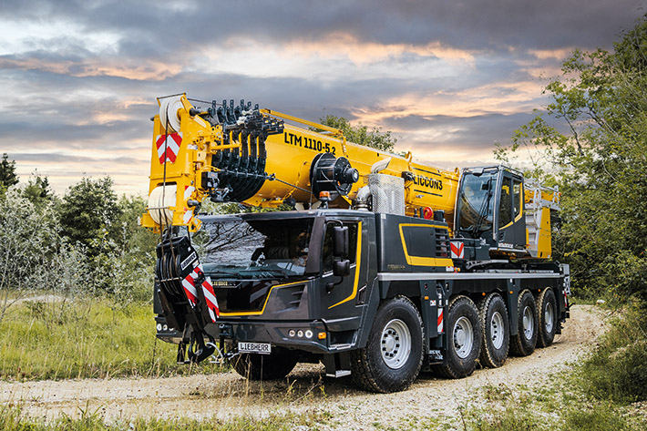

liebherr-ltm1110-5-2.jpg  
New design – the Liebherr LTM 1110-5.2 mobile crane features the very latest crane technology with a new look.

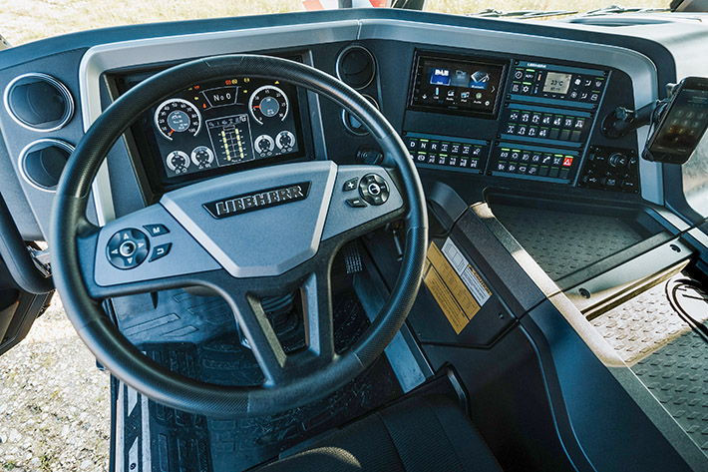

liebherr-ltm1110-5-2-driver-cab.jpg  
Designed for crane operators – new multifunction steering wheel, improved instruments and keypads as well as new displays.

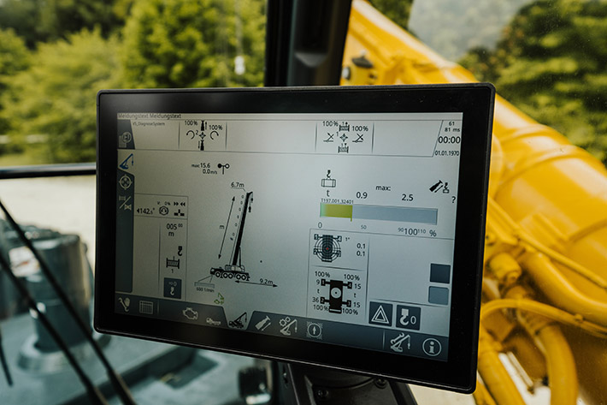

liebherr-ltm1110-5-2-touch-display.jpg  
Touchscreen function – Large display in the superstructure cab makes operation even easier and more comfortable.

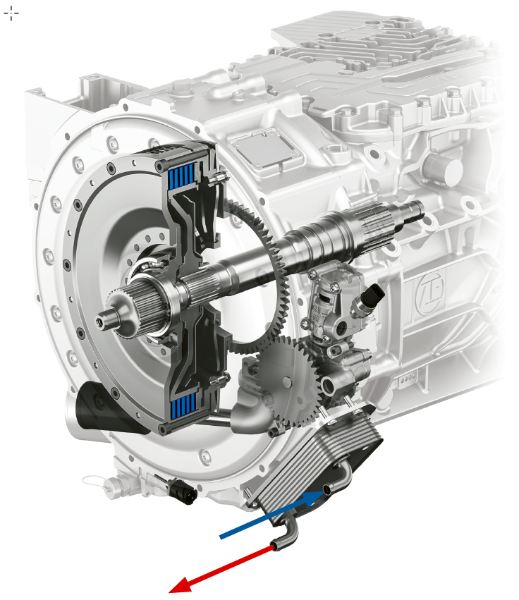

zf-traxon-dynamic-perform.jpg  
Manoeuvre like clockwork – the new DynamicPerform clutch module transfers the engine power using integral discs which are cooled by the oil system.

Contact

Wolfgang Beringer  
Marketing and Communication  
Phone: +49 7391/502 - 3663  
Email: wolfgang.beringer@liebherr.com

Published by

Liebherr-Werk Ehingen GmbH  
Ehingen (Donau) / Germany  
www.liebherr.com