Press release

Hautes-Alpes Département:

Liebherr crawler excavator R 926 G8 convinces SATP

⸺

“This machine is in no way inferior to a 30-tonne excavator”

Powerful and user-friendly excavator

Maximum comfort for the operator

Ten years of trusting cooperation between two family businesses

Earthmoving and canal work as well as the preparation of ski slopes will be the tasks of the new R 926 G8 crawler excavator at SATP. For almost ten years, the family-owned company has relied on the quality and user-friendliness of Liebherr machines. Last but not least, the high availability of spare parts and the responsiveness of Ets PIC - the local sales partner - makes all the difference.

Hautes-Alpes (France), 26 November 2021 – For almost 10 years now, SATP has relied on Liebherr to ensure the success of its own construction projects. The company was founded in 1992 by Jean-Claude Bonthoux and today has four Liebherr machines: two wheel loaders (an L 550 and an L 506 Compact) as well as an R 914 and an R 926 G8 crawler excavator. These two excavators are equipped with the LIKUFIX hydraulic coupling system to adapt very quickly to the tasks at hand.

The R 926 G8 is the latest addition to SATP's fleet and was purchased in 2020. David Martin from Liebherr's sales partner ETS Pic helped SATP to select the machine, taking into account the upcoming projects and goals.

Furthermore, SATP appreciates Liebherr's reliability and value-oriented corporate culture. After all, the company based in the French department of Hautes-Alpes and run by father and son Bonthoux is characterised by similar values.

MyLiebherr: intuitively and quickly select spare parts

Besides the mere distribution of machines, it is the availability of spare parts that matters most in the construction sector. Spare parts for the brand can be purchased via the MyLiebherr online portal. It is an intuitive and fast tool that secures the productivity of the customers on the construction site. “When we order something, it's there the next day. It's extremely fast,” reports Fabien Bonthoux, joint owner of the company with his father and driver of the R 926 G8.

The R 926 G8: Performance and user-friendliness

One year after delivery of the Liebherr R 926 G8 crawler excavator and after more than 1,500 hours of operation, Fabien Bonthoux is convinced of the machine's performance and user-friendliness: “This machine is in no way inferior to a 30-tonne excavator.”

With an output of 150 kW / 204 hp and an operating weight of 28 tonnes, the Generation 8 model combines comfort and uncompromising ergonomics with optimum performance. The electric joysticks that characterise the entire Generation 8 also are an excellent development as, unlike a hydraulic system housed in the cab, they don’t generate any heat.

About the SATP

The Société Alpine de Travaux Publics (SATP) was founded in 1992 by Jean-Claude Bonthoux and today employs 15 people. His son Fabien joined the company and runs it together with his father. It is responsible in particular for the acquisition of equipment. The company is primarily active on construction sites in the areas of civil engineering, utility infrastructure and earthworks in the vicinity of Gap in the French Alps. The preparation of ski slopes in the period from the beginning of autumn to December is another important business area of the dynamic family business.

About the Liebherr Group

The Liebherr Group is a family-run technology company with a highly diversified product portfolio. The company is one of the largest construction equipment manufacturers in the world. It also provides high-quality and user-oriented products and services in a wide range of other areas. The Liebherr Group includes over 140 companies across all continents. In 2020, it employed around 48,000 staff and achieved combined revenues of over 10.3 billion euros. Liebherr was founded in Kirchdorf an der Iller in Southern Germany in 1949. Since then, the employees have been pursuing the goal of achieving continuous technological innovation, and bringing industry-leading solutions to its customers.

Images

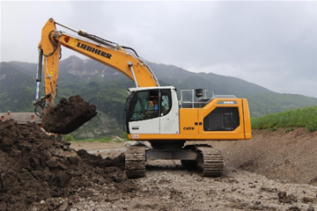

liebherr-crawler-excavator-r-926-SATP-1.jpg

The machine combines comfort and ergonomics with optimum performance.

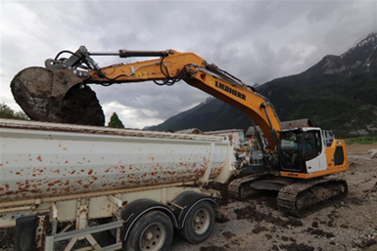

liebherr-crawler-excavator-r-926-SATP-2.jpg

SATP appreciates the performance and user-friendliness of the machine.

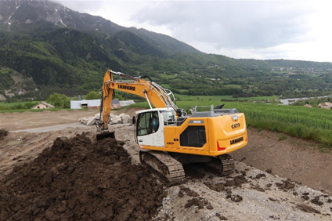

liebherr-crawler-excavator-r-926-SATP-3.jpg

SATP is primarily active in civil engineering, utility infrastructure and earthworks in the French Alps.

Contact

Alban Villaumé  
Marketing Manager   
Telefon: +33 3 89 21 36 09   
E-Mail: alban.villaume@liebherr.com

Published by

Liebherr-France SAS   
Colmar / France  
www.liebherr.com