

Press release

Liebherr-Australia opens new branch in Kalgoorlie

⸺

Liebherr-Australia will open a new mining branch in Kalgoorlie, Western Australia in January 2022

The branch will house spare parts, tooling, and customer support personnel

The branch will support the growing fleet of Liebherr mining equipment in the region

Liebherr-Australia is set to return to Kalgoorlie, the heart of the Goldfields-Esperance, with a new branch to open in the city in 2022. The Kalgoorlie branch will provide support in the form of fast access to spare parts and customer service for the growing number of Liebherr mining equipment in the region and will be one of three mining branches in Western Australia.

Adelaide (Australia), 30 November 2021 – Liebherr-Australia will open a new mining branch in Kalgoorlie, its third mining branch in Western Australia, to support its growing fleet of equipment and customer base in the Goldfields region. The branch is set to be located in the city on a 10,000m2 block, incorporating a 1,000m2 warehouse and 180m2 office space, with necessary parts and Liebherr tooling held in the facility. The branch will be supported by full time parts personnel, with customer support and service teams using the branch as a hub when travelling between sites.

Kalgoorlie is located in the Goldfields-Esperance region in Western Australia. The city is centrally located, ideal to support Liebherr’s growing fleet of equipment in the region. In recent years, Liebherr’s footprint of mining equipment has grown, now supporting more than 30 excavators and trucks, over 15 mine sites and nine customers, with more scheduled into 2022.

“Returning to Kalgoorlie marks the success we’ve had in recent years in growing our equipment fleet in the region,” comments Trent Wehr, Liebherr-Australia Managing Director, on the significance of this investment for the company. The new opening marks a return to the region for Liebherr-Australia who were present in the region through an agent between 1986 and 1990, before taking over the official OEM dealership in the region from 1990 to 2006. He adds, “We have always been committed to providing the best support to our customers and establishing the Kalgoorlie branch will only further enable us to provide these services.”

Liebherr-Australia’s mining customer support network includes branches in Mackay QLD, Mt Thorley NSW, Perth WA, Newman WA, soon-to-be Kalgoorlie WA, along with the head office, national distribution centre and production facility in Adelaide SA.

The Kalgoorlie branch is scheduled to be operational in January 2022, with Liebherr-Australia to hold an official opening ceremony with key customers and partners in the first quarter of 2022 to celebrate the milestone.

**About Liebherr-Australia**

Liebherr-Australia Pty Ltd was first incorporated as a company in 1981 and soon after, the new head office complex in Adelaide (South Australia) was built. Today, the company sells and supports a range of Liebherr products from seventeen branches across Australia and New Zealand, including mobile and crawler cranes, offshore cranes, tower cranes, deep foundation machines, earthmoving, and mining equipment.

About the Liebherr Group

The Liebherr Group is a family-run technology company with a highly diversified product portfolio. The company is one of the largest construction equipment manufacturers in the world. It also provides high-quality and user-oriented products and services in a wide range of other areas. The Liebherr Group includes over 140 companies across all continents. In 2020, it employed around 48,000 staff and achieved combined revenues of over 10.3 billion euros. Liebherr was founded in Kirchdorf an der Iller in Southern Germany in 1949. Since then, the employees have been pursuing the goal of achieving continuous technological innovation, and bringing industry-leading solutions to its customers.

Images

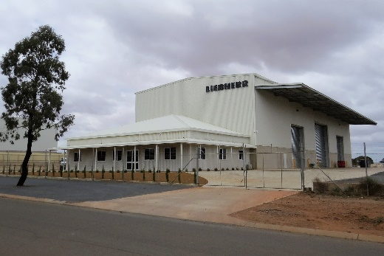

Liebherr-australia-kalgoorlie-branch.jpg  
Liebherr-Australia’s new facility in Kalgoorlie, ready to service the region from 2022.

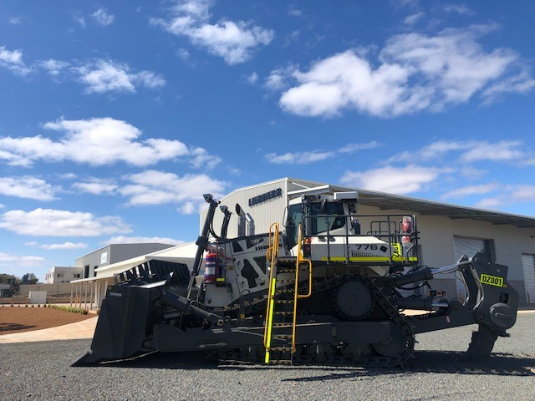

Liebherr-australia-kalgoorlie-pr776.jpg  
A PR 776 mining dozer arrives at the Kalgoorlie branch.

Contact

Breanna Bennett  
Marketing Associate - Mining  
Telephone: +61 7 3038 8803  
E-Mail: Breanna.Bennett@liebherr.com

Published by

Liebherr-Australia Pty Ltd  
Adelaide / Australia  
www.liebherr.com.au