Press release

Blade replacement at a wind farm – tandem hoist by Liebherr mobile cranes

Grúas Ibarrondo uses LTM 1750-9.1 and LTM 1650-8.1 in tandem

Three rotor blades were replaced by new ones with a longer span at Experimental Cener-Alaiz wind farm in Navarra, Spain

LTM 1750-9.1 and LTM 1650-8.1 impress with high lifting capacities, variable boom systems and versatility

**Crane and transport contractor Grúas Ibarrondo took two Liebherr mobile cranes, an LTM 1750-9.1 and an LTM 1650-8.1, the first in Spain, to the Experimental Cener-Alaiz wind farm in Navarra, Spain, to replace three rotor blades on a wind turbine. The 650 tonne crane has been added to the Grúas Ibarrondo fleet and will strengthen the company’s position on the market.**

Ehingen (Donau) (Germany), 6 December 2021 – In September, Grúas Ibarrondo replaced three rotor blades on an SG 4.X wind turbine, each measuring 64.5 metres in length and weighing in at 24 tonnes, with new rotor blades with a larger span, a length of 71.5 metres and weighing 22.5 tonnes each. The job at the Experimental Cener-Alaiz wind farm in Navarra was carried out using two Liebherr mobile cranes, the 9-axle LTM 1750-9.1 and the first 8-axle LTM 1650-8.1 in Spain. The project was “part of maintenance work which was carried out under the preventative service contract with our customer”, explains Mikel Ibarrondo, General Manager of Grúas Ibarrondo.

The Liebherr mobile cranes worked in tandem using a hook height of 130 metres. “Liebherr mobile cranes are ideal for wind energy projects of this type as they are manoeuvrable and easy to position. They also deliver the required height and lifting capacity”, continues Mikel Ibarrondo. One of the major challenges for this job was to reach the specified height whilst also ensuring that the required lifting capacity could be delivered at that height. Furthermore, the cranes had to be controlled very sensitively as they had to install the turbine blades in tandem.

Grúas Ibarrondo has always pursued a policy of the continuous modernisation of its fleet with the aim of providing its customers with excellent service quality using its technically up to date and well-maintained fleet. The company has worked with Liebherr cranes for many years for this reason and to date has certainly recorded a great deal of positive experience. “The products developed and manufactured with the Liebherr brand deliver premium technology and quality and guarantee us having a reliable partner at our side in the long term”, says Ibarrondo finally. One of the key factors behind its trust in Liebherr is the outstanding customer service, which is provided in Spain by Liebherr Ibérica and gives the company the facility to obtain support at any time and in any place, which is particularly helpful as the cranes often have to work in challenging environments. The company’s fleet consists of 66 cranes, 41 of which are Liebherr cranes, including almost every model in the LTM mobile crane series as well as a 750 tonne LG 1750 lattice boom crane.

About Grúas Ibarrondo

Grúas Ibarrondo was founded in 1956 as a family-run transport business. To meet the needs and demands of the market led, the company bought its first 18 tonne crane in 1970, which opened up whole new areas of work and business sectors. This was also the point at which the company changed its name to Grúas y Transportes Ibarrondo S.A. The company has now developed into a reference for the sector thanks to its reliability and the quality of its services. With a 140-strong workforce, the company now supplies its solutions to a very wide range of sectors – industrial businesses, refineries, steelworks, shipbuilding yards, wind farms and ports, to name just a few. A successful business based on the values of solidity, experience, competence and corporate responsibility.

About Liebherr Ibérica, S.L.

Liebherr Ibérica is the Liebherr Group’s Spanish sales and service company and was founded in 1988. Today, Liebherr Ibérica is responsible for the sales and customer service of the Mobile Cranes, Earthmoving, Mining, Maritime Cranes and Concrete Technology Business Units.

About Liebherr-Werk Ehingen GmbH

Liebherr-Werk Ehingen GmbH is a leading manufacturer of mobile and crawler cranes. Its range of mobile cranes extends from 2-axle 35 tonne cranes to heavy duty cranes with a lifting capacity of 1200 tonnes and a 9-axle chassis. Its lattice boom cranes on mobile or crawler crane chassis deliver lifting capacities of up to 3000 tonnes. With universal boom systems and extensive additional equipment, they can be seen in action on construction sites throughout the world. The Ehingen site has a workforce of 3,500. Extensive, global service guarantees the high availability of Liebherr mobile and crawler cranes. In 2020, the Liebherr plant in Ehingen recorded a turnover of 2.03 billion euros.

About the Liebherr Group

The Liebherr Group is a family-run technology company with a widely diversified product range. The company is one of the largest manufacturers of construction machines in the world. However, it also supplies high quality, user-focused products and services in many other sectors. The group currently comprises more than 140 companies based in every continent of the world. In 2020, it had a workforce of around 48,000 and recorded a consolidated total turnover of more than 10.3 billion euros. The company was founded in 1949 in Kirchdorf an der Iller in southern Germany. Since then, its,aim has been to win customers by supplying high quality solutions and to contribute to technological progress.

**Photograph**

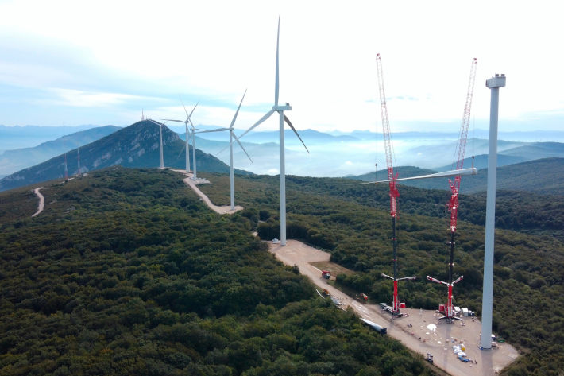

liebherr-gruas-iarrondo.jpg  
Two Liebherr mobile cranes, an LTM 1750-9.1 and an LTM 1650.8.1 from Grúas Ibarrondo replacing three rotor blades on a wind turbine at the Cener-Alaiz experimental offshore wind farm.

Contacts

Wolfgang Beringer  
Marketing and Communication  
Phone: +49 7391/502 - 3663  
Email: wolfgang.beringer@liebherr.com

Published by

Liebherr-Werk Ehingen GmbH  
Ehingen (Donau) / Germany  
www.liebherr.com