Press release

100 percent Liebherr: Hess extends fleet with LTM 1150‑5.3

⸺

LTM 1150-5.3 purchased due to its high performance, compact dimensions and versatility

Good experience with Liebherr machines and reliable service the main factors

Hess is one of the leading providers of a complete range of plant and machine relocation services

Düsseldorf-based company Hess GmbH has strengthened its crane fleet with a Liebherr LTM 1150-5.3 mobile crane. This specialist contractor for company relocations, machine installation and machine transport services has its own crane department. This is responsible both for the rental and for the use of the cranes for its own machine installation work. Hess relies 100 percent on Liebherr mobile cranes.

Ehingen (Donau) (Germany), 13 December 2021 – Company proprietor Joachim Hess explains: “The LTM 1150-5.3 is a modern, powerful crane which we can use flexibly due to the fact that its road-going state can be varied. It is also compact and manoeuvrable – a major benefit for many of our jobs.” Oliver Kuldtzun, Manager of the Crane Department, continues: “We ordered the crane with the VarioBase® variable supporting base because it delivers additional safety, particularly on restricted sites. And it also gives us additional lifting capacity directly above the outriggers.”

Flexible all-rounder

Hess is planning to use the new 150 tonne crane for heavy installation work and also for various everyday crane rental jobs, for example, in the construction and infrastructure sectors. All the mobile cranes in the Hess fleet were delivered by Liebherr. “We have had very good experience with Liebherr machines. They feature the very latest crane technology. We also like the fact that the crane controls are standard in small and large cranes alike. That enables us to use our operators flexibly on the machines,” Hess adds.

Kuldtzun also mentions the fact that the renowned good service from Liebherr was a major factor behind the decision to buy the crane: “We receive excellent support from the Liebherr service outlet in Oberhausen, both for inspection and regular maintenance work as well as repairs.”

The LTM 1150-5.3 has the longest telescopic boom in its crane class at 66 metres and is on a par with crane types in the 200-tonne capacity class. It delivers outstanding lifting capacities when fully raised and at large radii. And it is immediately ready for use once it reaches the site. This is because the new 150 tonne crane carries nine tonnes of a ballast with a gross weight of 60 tonnes. That means it can complete lots of jobs without requiring additional ballast transport vehicles. That saves time and money.

Hess GmbH was founded in 1977 as an industrial installation contractor and now has a workforce of over 60. The fleet also contains special electrically powered mobile cranes and mini cranes. Today the company is one of the leading providers of a complete range of plant and machine relocation services.

About Liebherr-Werk Ehingen GmbH

Liebherr-Werk Ehingen GmbH is a leading manufacturer of mobile and crawler cranes. Its range of mobile cranes extends from 2-axle 35 tonne cranes to heavy duty cranes with a lifting capacity of 1200 tonnes and a 9-axle chassis. Its lattice boom cranes on mobile or crawler crane chassis deliver lifting capacities of up to 3000 tonnes. With universal boom systems and extensive additional equipment, they can be seen in action on construction sites throughout the world. The Ehingen site has a workforce of 3,500. Extensive, global service guarantees the high availability of Liebherr mobile and crawler cranes. In 2020, the Liebherr plant in Ehingen recorded a turnover of 2.03 billion euros.

About the Liebherr Group

The Liebherr Group is a family-run technology company with a widely diversified product range. The company is one of the largest manufacturers of construction machines in the world, but also supplies technically advanced, user-focused products and services in many other sectors. The group currently comprises more than 140 companies based in every continent of the world, has a workforce of around 48,000 and recorded a consolidated total turnover of more than 10.3 billion euros in 2020. Since it was founded in 1949 in Kirchdorf an der Iller in southern Germany, Liebherr’s aim has been to win customers by supplying high quality solutions and to contribute to technological progress.

Photograph:

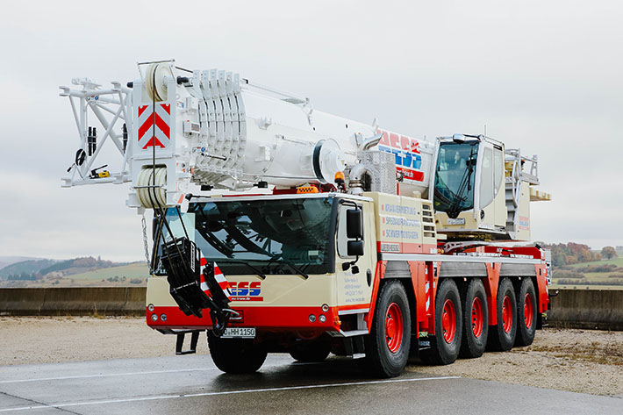

liebherr-ltm1150-5-3-hess.jpg  
Hess extends fleet with LTM 1150 5.3.

Contact

Wolfgang Beringer  
Marketing and Communication  
Phone: +49 7391/502 - 3663  
Email: wolfgang.beringer@liebherr.com

Published by

Liebherr-Werk Ehingen GmbH  
Ehingen (Donau) / Germany  
www.liebherr.com