Press release

Liebherr crawler excavator R 960 SME conquers the world market

⸺

Excavator is now available worldwide

Leading in Europe since 2012

R 960 SME is the most powerful 60-tonne excavator

The R 960 SME is more than a 50-tonne powerhouse - it is a true 60-tonne crawler excavator. With its 70 tonne excavator undercarriage, it sets the benchmark in its market segment. The further development of the R 960 SME, which has already been available in Europe since 2012, was recently also launched in Africa, Asia and South America. As of now, the SME crawler excavator is also setting its sights on the Brazilian and Russian markets.

Colmar (France), 16 December 2021 - With its stability and the highest breakout forces on the market, the R 960 SME excels with particularly high productivity compared to its predecessor version. With its large bucket volume of 3.7 m³, it is easily suitable for loading dumper trucks in the 30 to 45 tonne weight range.

This excavator, developed and produced at Liebherr-France SAS in Colmar, France, has been setting the global benchmark in the 60-tonne excavator segment since 2012. The R 960 SME has been in use in quarries and mining operations around the world for almost ten years. The R 960 SME also impresses with its low fuel consumption, which can be accessed online via [the fuel calculator](https://www.liebherr.com/en/int/specials/fuel-savings-calculator/tool/calculator.html).

The SME series: Crawler excavators for demanding applications

Liebherr's SME crawler excavators are designed for quarry applications. Four models ranging from 44 to 102 tonnes have been developed for the world market. These variants are equipped with reinforced undercarriages into which components from the larger models of the standard series have been integrated. On the R 960 SME, these are components of the 70-tonne standard model R 966. The same principle applies for the counterweights.

This allows the use of larger buckets without compromising the stability of the machine. Thanks to its special kinematics of the working equipment and specifics cylinders, the machine offers exceptional digging and breakout forces that are unparalleled in this machine category. Overall, all these factors increase the performance and profitability of the machine. As with all Liebherr crawler excavators from 14 to 100 tonnes operating weight, machine operators can choose between four different working modes. The hydraulic and engine power can be adapted to the operating conditions to achieve either maximum performance and productivity during difficult applications or a highly economical mode of operation.

Working environment based on the latest standards

The R 960 SME has a spacious driver's cab equipped with a host of features to guarantee operator comfort and safety. These include continuous automatic air conditioning and heating and a large 9” display as standard. The machines is available with bullet-proof windscreen and roof window.

About the Liebherr Group

The Liebherr Group is a family-run technology company with a highly diversified product portfolio. The company is one of the largest construction equipment manufacturers in the world. It also provides high-quality and user-oriented products and services in a wide range of other areas. The Liebherr Group includes over 140 companies across all continents. In 2020, it employed around 48,000 staff and achieved combined revenues of over 10.3 billion euros. Liebherr was founded in Kirchdorf an der Iller in Southern Germany in 1949. Since then, the employees have been pursuing the goal of achieving continuous technological innovation, and bringing industry-leading solutions to its customers.

Images

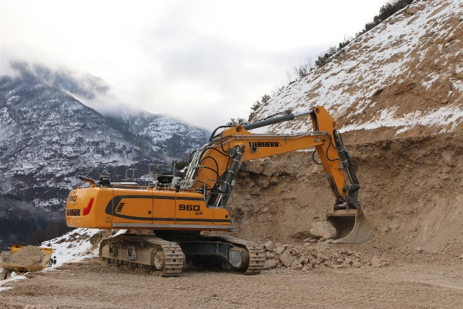

liebherr-crawler-excavator-r-960-sme-1.jpg  
The R 960 SME crawler excavator has proven itself in quarries and mining operations around the world since 2012.

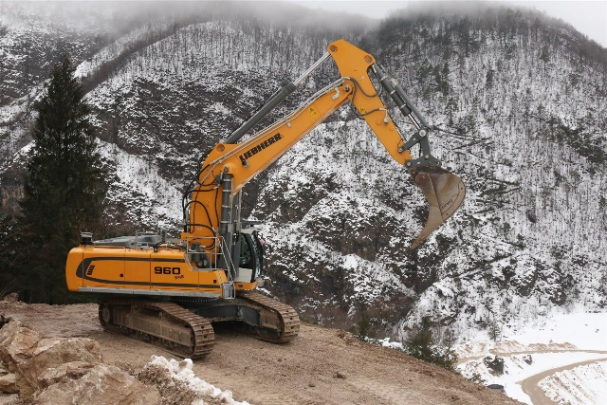

liebherr-crawler-excavator-r-960-sme-2.jpg  
The R 960 SME crawler excavator achieves the highest breakout forces on the market.

Contact

Alban Villaumé  
Marketing Manager   
Phone: +33 (0)3 89 21 36 09  
E-Mail: alban.villaume@liebherr.com

Published by

Liebherr-France SAS   
Colmar / France  
www.liebherr.com