Press release

A first in Brazil – Guindastes Tatuapé takes delivery of Liebherr LTM 1120-4.1 mobile crane

⸺

Liebherr delivers the first LTM 1120-4.1 to Brazil

Liebherr’s VarioBallast® and VarioBase® deliver greater capacity, flexibility and safety on constricted sites

Second already on the way: Next LTM 1120-4.1 arrives at Tatuapé in mid-2022

High lifting capacity and versatility were the main criteria behind the purchase by Guindastes Tatuapé

The LTM 1120-4.1, unveiled at the CONEXPO-CON/AGG 2020 in Las Vegas (USA), is the most powerful four-axle mobile crane on the market. Its 66-metre telescopic boom is the longest ever realised in this crane class. In December, the first unit of the Liebherr 120-tonne crane arrived in Brazil and was taken over by the crane and heavy transport company Guindastes Tatuapé.

Ehingen (Donau) (Germany), 9 February 2022 – The LTM 1120-4.1 embodies great performance and the very latest crane technology. Its 66 metre telescopic boom means that it encroaches into the class of 5-axle mobile cranes. Its lattice jib enables it to reach a maximum hoist height of 91 metres. This was an important factor in the purchase decision for Guindastes Tatuapé. Denys Garzon Rodrigues, Commercial Director at Guindastes Tatuapé, reasons: “The LTM 1120-4.1 is the new benchmark in the 4-axle class. It has the longest boom and delivers extremely high lifting capacities which increase its flexibility for jobs and improve transport costs as the crane can be used to complete jobs which would otherwise require a 5-axle crane, for which a great deal more logistical work is required.”

Rodrigues also highlights the compact design and manoeuvrability of the Liebherr 4-axle crane: “As all four axles can be steered, it is ideal for use on very restricted sites. The VarioBase® variable supporting base and VarioBallast® adjustable ballast radius are features that make jobs in extreme conditions safer and more flexible.” To extend its range of cranes even further, Tatuapé actually placed an order for two LTM 1120-4.1 machines. The second one is due to arrive in Brazil in mid-2022.

Guindastes Tatuapé has been active in the Brazilian market for more than 60 years, providing crane rental and special haulage services. From the very beginning, the company showed its preference for innovative technologies and has kept its fleet up to date by repeatedly purchasing new crane models. The company has had a good business relationship with Liebherr for more than 30 years.

**About Guindastes Tatuapé**

With a total area of 120,000 m² at its headquarters in São Paulo/SP, a branch in the State of Espírito Santo/ES and around 400 personnel, Guindastes Tatuapé has been active in the market for 60 years. Currently the company has a fleet totalling 400 machines, including mobile and crawler cranes, forklift trucks, lifting platforms, knuckle boom cranes, conveyor systems and manipulators. Guindastes Tatuapé delivers solutions to the market using progressive technology and technical training by providing machinery and equipment for all hoisting work as well as the required logistics. The main sectors served by Tatuapé include oil and gas, wind turbines, prefabricated concrete components, mining, petrochemicals, sugar mills and cellulose.

**About Liebherr-Werk Ehingen GmbH**

Liebherr-Werk Ehingen GmbH is a leading manufacturer of mobile and crawler cranes. Its range of mobile cranes extends from 2-axle 35 tonne cranes to heavy duty cranes with a lifting capacity of 1200 tonnes and a 9-axle chassis. Its lattice boom cranes on mobile or crawler crane chassis deliver lifting capacities of up to 3000 tonnes. With universal boom systems and extensive additional equipment, they can be seen in action on construction sites throughout the world. The Ehingen site has a workforce of 3,500. Extensive, global service guarantees the high availability of Liebherr mobile and crawler cranes. In 2020, the Liebherr plant in Ehingen recorded a turnover of 2.03 billion euros.

About the Liebherr Group

The Liebherr Group is a family-run technology company with a highly diversified product portfolio. The company is one of the largest construction equipment manufacturers in the world. It also provides high-quality and user-oriented products and services in a wide range of other areas. The Liebherr Group includes over 140 companies across all continents. In 2020, it employed around 48,000 staff and achieved combined revenues of over 10.3 billion euros. Liebherr was founded in Kirchdorf an der Iller in Southern Germany in 1949. Since then, the employees have been pursuing the goal of achieving continuous technological innovation, and bringing industry-leading solutions to its customers.

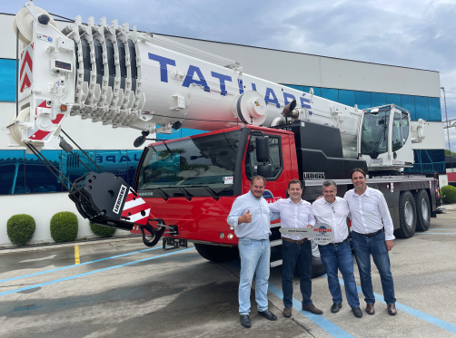Photograph

liebherr-ltm1120-4-1-guindastes-tatuape.jpg  
Handover of LTM 1120-4.1 to Guindastes Tatuapé.  
Left to right: Daniel Garzon Rodrigues (Guindastes Tatuapé), René Porto (Liebherr-Brasil), Denys Garzon Rodrigues (Guindastes Tatuapé), Fabio Azevedo (Liebherr-Brasil).

**Contacts**

Wolfgang Beringer  
Marketing and Communication  
Phone: +49 7391/502 - 3663  
E-Mail: wolfgang.beringer@liebherr.com

**Published by**

Liebherr-Werk Ehingen GmbH  
Ehingen (Donau) / Germany  
www.liebherr.com