Press release

Digital clearance monitoring for slewing bearings

⸺

Liebherr enables high-precision wear measurement from a distance

The new technology ensures greater safety in the danger zone

Condition monitoring is also available for lubrication and temperature measurement

**Nussbaumen (Switzerland), February 23, 2022 – With the condition monitoring system for slewing bearings, Liebherr has created a digital monitoring system. The integrated wear measurement system, bearing clearance monitoring (BCM), ensures optimum remote monitoring of the slewing bearings in various applications, such as mining, material handling or maritime equipment. The BCM system can be used to measure bearing wear in axial and radial directions, as well as tilting clearance. Such a remote diagnostics does not only ensure flexibility in measurement, but also reduced downtime, lower costs in maintenance and, above all, higher personal protection.**

More safety: No service personnel needed in the danger zone

The focus of digital remote clearance maintenance lies on personnel safety. "A distinct disadvantage of all common wear measurement methods is the necessity for service technicians to mount dial gauges or other measuring devices directly on the slewing bearing in the danger zone under the excavator or other machines," explains Wolfram Halder, product manager of the slewing bearings business unit. "The Liebherr BCM system makes this unnecessary, as the measuring devices are already permanently installed on the bearing." Another advantage is flexibility in terms of time. Currently, machine operators commission external service providers to measure the bearing clearance. This makes them dependent on the experience and schedule of third-party companies. "With digital maintenance for slewing bearings by Liebherr, measurements can be carried out at any time outside the danger zone, independently of external service providers," explains Wolfram Halder.

Measurement within a few minutes: This is how the BCM by Liebherr works

How does it work? The right technology and the right connection make it happen. The sensor connection box receives the data from the sensors attached to the slewing bearing and supplies the entire BCM system with power. The gateway stores the sensor data and updates for the BCM. This allows using the system autonomously even in regions without data connection. This is the case in mines, for example, as these often do not have the necessary mobile reception. A direct connection via Bluetooth makes the measurement process possible from a safe distance and without a network connection. Smart, integrated and remote, the BCM system is a small helper with great effects.

About Liebherr-Components AG

In this segment, the Liebherr Group specialises in the development, design, manufacturing of high-performance components in the field of mechanical, hydraulic and electric drive and control technology. Liebherr-Component Technologies AG, based in Bulle (Switzerland), coordinates all activities in the Components product segment.

The extensive product range includes diesel and gas engines, injection systems, engine control units, axial piston pumps and motors, hydraulic cylinders, slewing bearings, gearboxes and winches, switchgear, electronic and power electronics components, and software. The high-quality components are used in cranes and earthmoving machinery, in the mining industry, maritime applications, wind turbines, automotive engineering or in aviation and transport technology. Synergy effects in s other product segments of the Liebherr Group are used to drive continuous technological development.

About the Liebherr Group

The Liebherr Group is a family-run technology company with a highly diversified product portfolio. The company is one of the largest construction equipment manufacturers in the world. It also provides high-quality and user-oriented products and services in a wide range of other areas. The Liebherr Group includes over 140 companies across all continents. In 2020, it employed around 48,000 staff and achieved combined revenues of over 10.3 billion euros. Liebherr was founded in Kirchdorf an der Iller in Southern Germany in 1949. Since then, the employees have been pursuing the goal of achieving continuous technological innovation, and bringing industry-leading solutions to its customers.

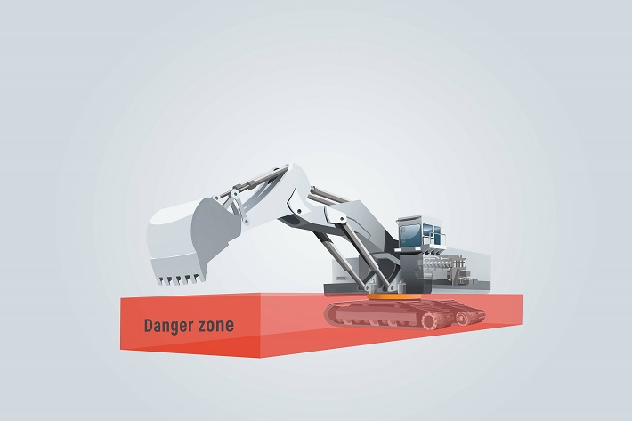Images

liebherr-bcm-for-more-safety.jpg

The danger zone of the excavator is located directly at the point, where the service personnel attach the measuring device during a manual measurement.

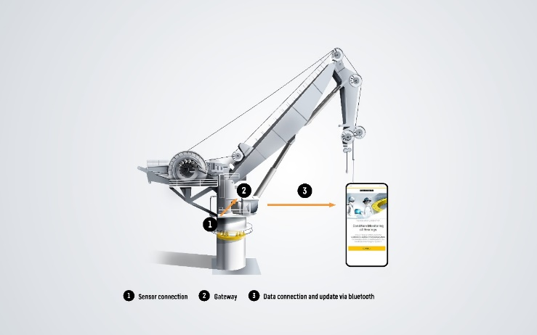

liebherr-bcm-solution.jpg  
This is how Liebherr's bearing clearance monitoring system works.

Contact

Alexandra Nolde  
Senior Communication & Media Specialist  
Telefon: +41 56 296 4326  
E-Mail: alexandra.nolde@liebherr.com

Published by

Liebherr-Components AG  
Nussbaumen / Switzerland  
[www.liebherr.com](http://www.liebherr.com)/components