Press release

Three at one blow – Herrmann & Wittrock modernises fleet with Liebherr mobile cranes

⸺

LTM 1040-2.1, LTM 1055-3.2 and LTM 1150-5.3 for new outlet in Bayreuth

Herrmann & Wittrock continuously modernises its fleet

The quality of its products and services are big points in favour of Liebherr

**Crane and work platform rental contractor Herrmann & Wittrock took delivery of three new Liebherr mobile cranes on one day at the beginning of February. The LTM 1040-2.1, LTM 1055-3.2 and LTM 1150-5.3 machines will expand the company’s crane fleet and are also part of the process to continuously modernise the fleet, which is very important to Herrmann & Wittrock. Liebherr supplied ten new mobile cranes to the company last year and more cranes are already on order for this year.**

Ehingen (Donau) (Germany), 2 March 2022 – “None of our cranes is more than five years old”, says Managing Director Oliver Herrmann. “We will be receiving more cranes during 2022, which we have ordered to keep our fleet up to date and to expand our crane fleet at our various outlets. We continue to place our trust in the excellent quality and reliability of Liebherr cranes. What is more, its after-sales service is unbeatable.”

The new LTM 1040-2.1, LTM 1055-3.2 and LTM 1150-5.3 cranes were delivered to the Hof outlet, where they were fitted with various accessories. They are then destined for the new outlet in Bayreuth, which was opened recently.

Herrmann & Wittrock is growing and now operates more than 50 mobile cranes. “Over the past few years we have bought all our new cranes from Liebherr”, says Managing Director Johannes von Sobbe. The LTM 1150-5.3 which has just been delivered will be joined by another before the end of the year. Herrmann explains: “The 150 tonne model features the latest crane technology on the market. It is the successor to the LTM 1130-5.1, which is a crane we are very satisfied with.”

Herrmann & Wittrock is part of the Wittrock Group, which operates throughout Germany. It was founded in 2005 and initially only rented work platforms. Mobile crane rental was added to its services in 2007. Based in Hof, the company now has ten outlets in Bavaria, Saxony and Brandenburg.

About Liebherr-Werk Ehingen GmbH

Liebherr-Werk Ehingen GmbH is a leading manufacturer of mobile and crawler cranes. Its range of mobile cranes extends from 2-axle 35 tonne cranes to heavy duty cranes with a lifting capacity of 1200 tonnes and a 9-axle chassis. Its lattice boom cranes on mobile or crawler crane chassis deliver lifting capacities of up to 3000 tonnes. With universal boom systems and extensive additional equipment, they can be seen in action on construction sites throughout the world. The Ehingen site has a workforce of 3,500. Extensive, global service guarantees the high availability of Liebherr mobile and crawler cranes. In 2020, the Liebherr plant in Ehingen recorded a turnover of 2.03 billion euros.

About the Liebherr Group

The Liebherr Group is a family-run technology company with a highly diversified product portfolio. The company is one of the largest construction equipment manufacturers in the world. It also provides high-quality and user-oriented products and services in a wide range of other areas. The Liebherr Group includes over 140 companies across all continents. In 2020, it employed around 48,000 staff and achieved combined revenues of over 10.3 billion euros. Liebherr was founded in Kirchdorf an der Iller in Southern Germany in 1949. Since then, the employees have been pursuing the goal of achieving continuous technological innovation, and bringing industry-leading solutions to its customers.

Photograph  
  
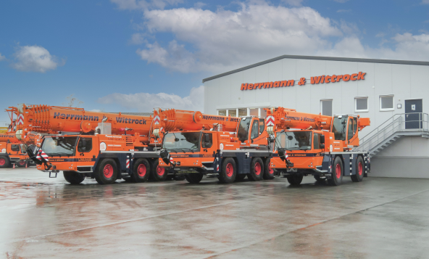  
  
liebherr-herrmann&wittrock.jpg  
Herrmann & Wittrock takes delivery of three new Liebherr mobile cranes at its outlet in Hof.

**Contacts**

Wolfgang Beringer  
Marketing and Communication  
Phone: +49 7391/502 - 3663  
Email: wolfgang.beringer@liebherr.com

**Published by**

Liebherr-Werk Ehingen GmbH  
Ehingen (Donau) / Germany  
www.liebherr.com