Press release

Liebherr continues successful cooperation with start-ups

⸺

Move a step closer to the Factory of the Future – Liebherr and Continuum-Innovation have achieved this objective together. The cooperative venture between these two companies arose from the Bosch Startup Harbour, an incubation programme for startups in the early phase.

Kirchdorf an der Iller (Germany), 14 March 2022 – The Bosch Startup Harbour supports talented start-ups like Continuum-Innovation, which is based in Berlin, with the development of its product innovation. During a six-month programme funded by the state of Berlin and the ESF (European Social Fund), in addition to financial support the participants also receive comprehensive training and coaching, as well as direct networking opportunities with the business sector. The latter is possible as industrial companies like Liebherr are included in the programme. As co-innovator Liebherr made available the slewing ring screw connection of wheeled excavators. With the aid of this production step the product innovation of the start-up, a collaborative robot arm, called “Cobot” for short, was tested and optimised in initial simulations.

Exchange of expertise on all levels

Liebherr, Continuum-Innovation and Bosch all agree: The objective to develop a functioning robot together was successfully achieved. At the same time, there was a valuable exchange of expertise. “In cooperation with the founders of Continuum-Innovation we built expertise in the areas of collaborative robotics and artificial intelligence. At the same time the Bosch Startup Harbour opened up new and inspiring formats for us,” reports Kim Dörries, who coordinates the project at Liebherr. This new form of collaboration accelerates, e.g., the innovation process in production.

The Berlin-based start-up also benefited from the cooperation: “In the last six months we obtained insights into the production environment of wheeled excavators. Liebherr expert teams supported us with the conceptual planning of our product innovation. This allowed us to better adapt the Cobot to automated, digital production”, says Kilian Reiß from Continuum-Innovation. “Liebherr demonstrated great commitment in the Bosch Startup Harbour and was extremely interested in and open to new technologies”, adds Veronika Brandt, Head of the Bosch Startup Harbour.

After the completion of the official programme, Liebherr and Continuum-Innovation will also maintain the partnership and stay in contact. Liebherr will accompany the start-up with the development of the product innovation. The company also continues to be strongly committed to the Bosch Startup Harbour and will assume the mentoring for other start-ups in the early phase.

About the Liebherr Group

The Liebherr Group is a family-run technology company with a highly diversified product portfolio. The company is one of the largest construction equipment manufacturers in the world. It also provides high-quality and user-oriented products and services in a wide range of other areas. The Liebherr Group includes over 140 companies across all continents. In 2020, it employed around 48,000 staff and achieved combined revenues of over 10.3 billion euros. Liebherr was founded in Kirchdorf an der Iller in Southern Germany in 1949. Since then, the employees have been pursuing the goal of achieving continuous technological innovation, and bringing industry-leading solutions to its customers.

Images

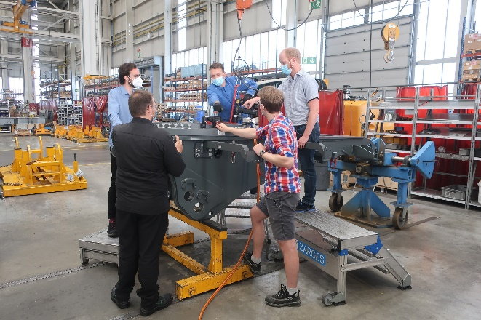

liebherr-continuum-innovation-1.jpg  
Within the framework of a technical workshop experts from Liebherr-Hydraulikbagger GmbH in Kirchdorf a. d. Iller described the application in production to the young entrepreneurs from the Berlin-based startup Continuum-Innovation.

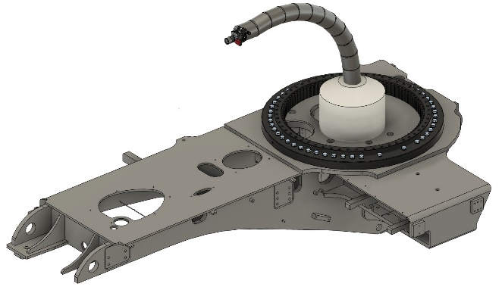

liebherr-continuum-innovation-2.jpg  
As co-innovator Liebherr provided the application: Using the slewing ring screw connection of a Liebherr wheeled excavator the collaborative robot arm was tested and optimised in initial simulations.

Contact

Nadine Willburger  
Marketing  
Phone: +49 7354 / 80 - 7332  
E-mail: nadine.willburger@liebherr.com

Published by

Liebherr-Hydraulikbagger GmbH   
Kirchdorf a.d. Iller / Deutschland  
[www.liebherr.com](http://www.liebherr.com)