Press Release

Workout with 100 tonnes:

LR 1100.1

⸺

The quick availability of crawler cranes is a decisive factor in the 100-tonne class. A requirement that the new LR 1100.1 fulfils perfectly making it the ideal multi-purpose crane on any construction site.

Nenzing (Austria), 22 March 2022 - The new crawler crane LR 1100.1 is optimised for all typical lifting applications in the 100-tonne category. It can be configured either with a main boom up to 62 m, or with a main boom up to 44 m in combination with a fixed jib up to 20 m.

The LR 1100.1 is fitted with the most powerful engine in its class - 230 kW provide the necessary performance for the lifting operations. Thanks to the Eco-Silent Mode, the engine speed can be reduced to a predefined level. This means that diesel consumption and noise emission are reduced; nevertheless the performance remains the same. The Automatic Engine Stop Control offers a further economic and environmentally friendly solution. After checking certain system functions, the engine is switched off during longer work interruptions.

Everything in view

The crawler crane is optimised for quick transfer between construction sites. The transport width is 2,983 mm or 3,500 mm, depending on whether the crane is transported with or without crawlers. At the construction site, the assembly of the LR 1100.1 is simplified through the self-assembly system and radio remote control.

Radio remote control allows the crane operator a high degree of flexibility and additional safety even during operation. The crane can be operated from outside the cabin and so allow for a better overview of the construction site. So-called blind spots can thus be better avoided. Depending on the application, a second person is no longer required to assist with hand signals during lifting operations. The cabin of the new crawler crane can be elevated by 2.8 m thus allowing for a good all-round view.

Safety on the slopes

For the safe negotiation of slopes and inclines, the new crane is fitted with Gradient Travel Aid. The control system automatically calculates the centre of gravity and warns the operator before the crane leaves the safe area. While travelling, the operator receives information about the permissible and actual gradient and the crane's overall centre of gravity at all times. If necessary, the boom angle can be altered so that the machine remains in the safe area.

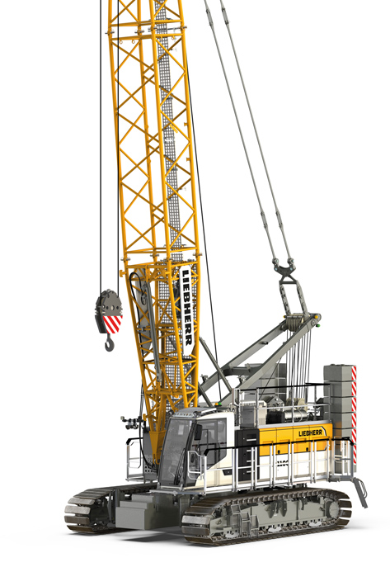Images

liebherr-lr-1100.1.jpg  
A multi-purpose crane for any construction site: the LR 1100.1.

Contact

Gregor Griesser  
Strategic Marketing and Communications  
Email: [gregor.griesser@liebherr.com](mailto:gregor.griesser@liebherr.com)

Wolfgang Pfister  
Head of Strategic Marketing & Communications  
Tel.: +43 50809 41444  
Email: [wolfgang.pfister@liebherr.com](mailto:wolfgang.pfister@liebherr.com)

Published by

Liebherr-Werk Nenzing GmbH  
Nenzing / Austria  
[www.liebherr.com](http://www.liebherr.com)