Press release

Zero emission, full power – Liebherr LTC 1050-3.1 mobile crane with electric power unit

⸺

Liebherr 50 tonne compact crane with additional electric power unit

Crane functions can be powered either by combustion engine or electric motor

Full performance even in electric mode

The accelerating climate revolution demands drive concepts to be used in the construction industry which reduce emissions of greenhouse gases. To meet the needs of customers and the demand for greener equipment as well as possible, Liebherr is working on alternative drive units, which are perfectly tailored to the application and location of the machine, without focusing on a single technology. The new LTC 1050-3.1 compact crane from the Liebherr Plant in Ehingen features an electric motor in addition to its conventional internal combustion engine. This enables crane movements to be powered electrically as an option. The new version of the compact 50 tonne crane therefore helps to reduce CO2 emissions and meets the requirements for operating on “zero emission” sites.

Ehingen (Donau) (Germany), 6 April 2022 – Liebherr developed the electric power unit for the LTC 1050-3.1 using the slogan “Zero emission, full power”. Dr Ulrich Hamme, Technical Director at Liebherr-Werk Ehingen GmbH, says: “We want to be able to offer our customers full crane performance even with the alternative electric power unit. The LTC 1050-3.1 still has a conventional internal combustion engine, powered by diesel or HVO, for driving on roads and for crane operations. However, as an alternative it also has an electric power unit for crane operations so that it generates “Zero emission”. That means that all the familiar usage properties of the crane will be retained, regardless of whether the crane operations are powered by its zero emission electric motor or its internal combustion engine.”

Maximum flexibility for full green credentials and customer benefits

The new alternative LTC 1050-3.1 delivers the best possible combination of green credentials, customer benefits and efficiency. On the road and off-road, it has a conventional, low emissions internal combustion engine which complies with emissions stage 5 and develops 243 kW (326 bhp). The engine can be fuelled with hydrogenated vegetable oil (HVO) with absolutely no restrictions, enabling it to reduce its CO2 emissions by up to 90 % compared to fuelling it with diesel.

Either the engine or the electric motor can be selected in crane mode depending on the conditions for the job. The latter reduces both air and noise emissions to a minimum. This also means that the machine is suitable for use in noise-sensitive areas and in “zero emission areas”.

Simple, clever electric motor concept – flexible electric power unit

The newly developed power unit featuring an electric motor develops 72 kW and therefore enables the crane to be operated without restriction, in other words with almost the same performance as using the 6-cylinder engine. The electric motor uses the existing hydraulic pump, which is mounted direct on the powershift transmission on the conventional LTC 1050-3.1, to transfer the power to the consumers in the crane superstructure.

Only the electric motor and a distributor gear as well as the required control equipment must be added to the conventional LTC 1050-3.1 model to transform it into an electric version. The distributer gear is located directly between the crane pump and the powershift transmission. This clever yet simple solution enables the operator to switch flexibly between diesel-hydraulic power and electro-hydraulic power. Site current at 125 A is required to achieve full performance, but the crane also operates very well with a 63 A supply. Alternatively, the crane can operate using an external conventional battery pack if the site does not have the appropriate electrical infrastructure.

Liebherr supplies the electric model of the LTC 1050-3.1 for the version with the 36 metre TELEMATIK telescopic boom. The RemoteDrive option for remote-controlled driving and height-adjustable elevating cab are also available for the new crane. The prototype with the electric power unit is currently undergoing intensive testing and Liebherr is planning to deliver the first models in 2023.

About Liebherr-Werk Ehingen GmbH

Liebherr-Werk Ehingen GmbH is a leading manufacturer of mobile and crawler cranes. Its range of mobile cranes extends from 2-axle 35 tonne cranes to heavy duty cranes with a lifting capacity of 1200 tonnes and a 9-axle chassis. Its lattice boom cranes on mobile or crawler crane chassis deliver lifting capacities of up to 3000 tonnes. With universal boom systems and extensive additional equipment, they can be seen in action on construction sites throughout the world. The Ehingen site has a workforce of 3,800. Extensive, global service guarantees the high availability of Liebherr mobile and crawler cranes. In 2021, the Liebherr plant in Ehingen recorded a turnover of 2.33 billion euros.

About the Liebherr Group

The Liebherr Group is a family-run technology company with a highly diversified product portfolio. The company is one of the largest construction equipment manufacturers in the world. It also provides high-quality and user-oriented products and services in a wide range of other areas. The Liebherr Group includes over 140 companies across all continents. In 2021, it employed more than 49,000 staff and achieved combined revenues of over 11.6 billion euros. Liebherr was founded in Kirchdorf an der Iller in Southern Germany in 1949. Since then, the employees have been pursuing the goal of achieving continuous technological innovation, and bringing industry-leading solutions to its customers.

Photographs

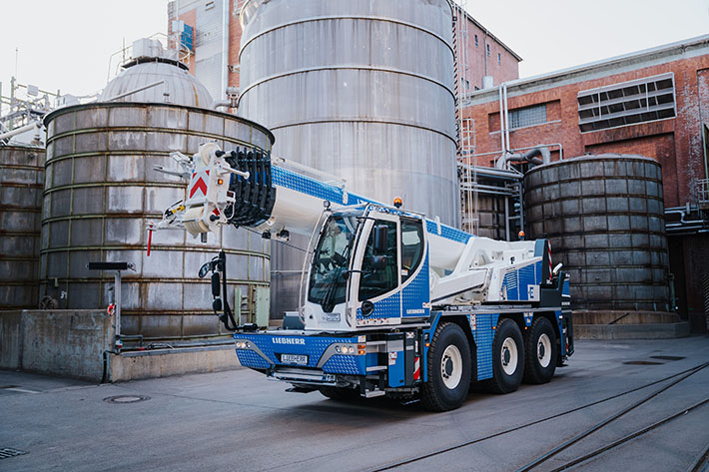

liebherr-ltc1050-electric.jpg  
The new version of the LTC 1050-3.1 features and an additional electric motor to power the crane functions.

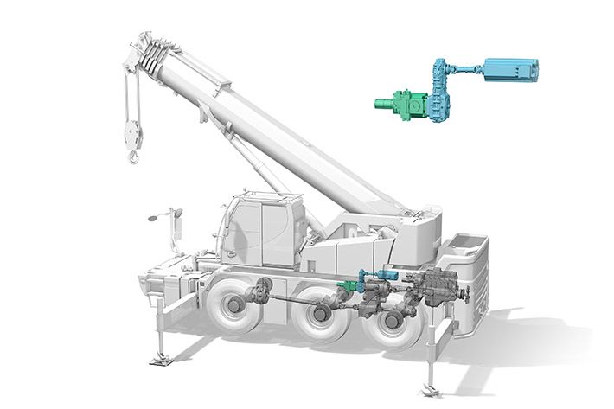

liebherr-ltc1050-electric-concept.jpg  
The electric motor drives the crane pump through a distributor gear.

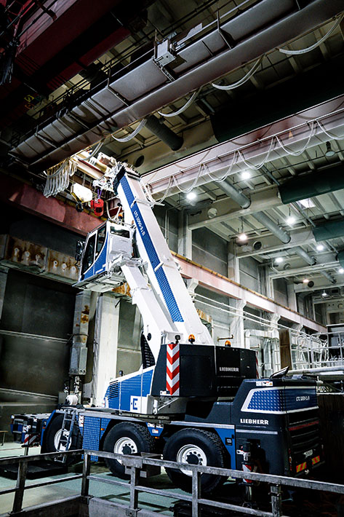

liebherr-ltc1050-electric-indoor.jpg   
The LTC 1050-3.1 with electric drive and lift cabin in use in a factory workshop

Contacts

Wolfgang Beringer  
Marketing and Communication  
Phone: +49 7391/502 - 3663  
Email: wolfgang.beringer@liebherr.com

Published by

Liebherr-Werk Ehingen GmbH  
Ehingen (Donau) / Germany  
www.liebherr.com