Press release

A first for Serbia – Beokran takes delivery of Liebherr LTM 1150-5.3 mobile crane

⸺

Beokran takes delivery of the very first LTM 1150-5.3 in Serbia

66 metre telescopic boom was a major factor behind the purchase decision

Beokran convinced by Liebherr’s quality and service

Crane and special haulage contractor Beokran d.o.o. has taken delivery of the firs Liebherr LTM 1150-5.3 mobile crane in Serbia. The new 150 tonne crane will supplement the Belgrade-based company’s crane fleet between machines with lifting capacities of 130 and 200 tonnes. The 66 metre telescopic boom was an important criterion behind the decision.

Ehingen (Donau) (Germany), 9 May 2022 – “The new LTM 1150-5.3 fits into our crane fleet perfectly between our LTM 1200-5.1 and the LTM 1130-5.1. The 150 tonne machine is now the second most powerful crane in our fleet”, says Goran Karanovic, founder and owner of the company based in the Serbian capital. “The 66 metre telescopic boom is perfect for erecting tower cranes. That was a very important criterion for us when we decided to buy the new crane.”

Long, powerful telescopic boom

The telescopic boom on the new LTM 1150-5.3 is six metres longer than the one on its predecessor, the LTM 1130-5.1. At the same length of 60 metres, the new 5-axle crane can hoist 12 tonnes when fully raised – 1.5 tonnes more than its predecessor. When fully extended to 66 metres, the new crane has a lifting capacity of over 9 tonnes. That makes it perfect for erecting tower cranes and radio masts. Lattice extensions enable the Liebherr 150 tonne crane to achieve hook heights of up to 92 metres and radii of up to 72 metres. A 7 metre lattice section is used as a boom extension for this purpose along with a 10.8 to 19 metre double folding jib. The latter can be adjusted hydraulically between 0° and 40°.

The LTM 1150-5.3 is immediately ready for use when it reaches the site. This is because it carries nine tonnes of ballast whilst travelling at a gross weight of 60 tonnes and with an axle load of 12 tonnes. That means it can complete lots of jobs without requiring additional ballast transport vehicles. That saves time and money.

**Beokran has always chosen Liebherr**

Goran Karanovic founded Beokran in 2007 with two small mobile cranes with lifting capacities of 8 and 20 tonnes. He continues: “As my budget was not enough for a new crane, I bought a used Liebherr LTM 1040/1. We renovated it, were successful and after a year we bought another LTM 1040/1 and an LTM 1060/2.” Today, Beokran employs 25 people and has eleven Liebherr mobile cranes with lifting capacities ranging from 40 to 200 tonnes as well as several special transport vehicles and loading cranes.

“Liebherr provides excellent service along with its Serbian partner, DS Inženjering. The high level of quality and service has minimised the downtimes of our cranes. Beokran builds on the Liebherr brand”, adds Karanovic.

About Liebherr-Werk Ehingen GmbH

Liebherr-Werk Ehingen GmbH is a leading manufacturer of mobile and crawler cranes. Its range of mobile cranes extends from 2-axle 35 tonne cranes to heavy duty cranes with a lifting capacity of 1200 tonnes and a 9-axle chassis. Its lattice boom cranes on mobile or crawler crane chassis deliver lifting capacities of up to 3000 tonnes. With universal boom systems and extensive additional equipment, they can be seen in action on construction sites throughout the world. The Ehingen site has a workforce of 3,800. Extensive, global service guarantees the high availability of Liebherr mobile and crawler cranes. In 2021, the Liebherr plant in Ehingen recorded a turnover of 2.33 billion euros.

About the Liebherr Group

The Liebherr Group is a family-run technology company with a highly diversified product portfolio. The company is one of the largest construction equipment manufacturers in the world. It also provides high-quality and user-oriented products and services in a wide range of other areas. The Liebherr Group includes over 140 companies across all continents. In 2021, it employed more than 49,000 staff and achieved combined revenues of over 11.6 billion euros. Liebherr was founded in Kirchdorf an der Iller in Southern Germany in 1949. Since then, the employees have been pursuing the goal of achieving continuous technological innovation, and bringing industry-leading solutions to its customers.

Images

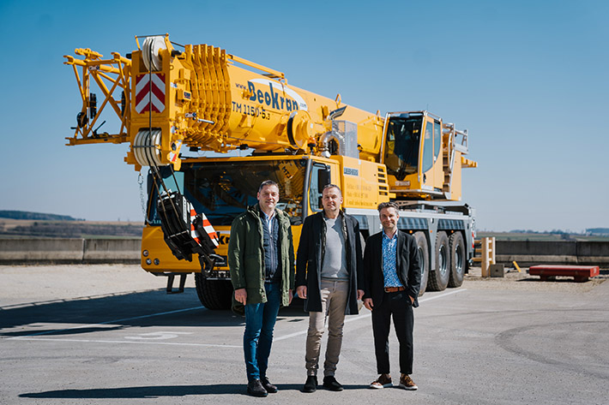  
  
liebherr-ltm1150-5-3-beokran-handover.jpg  
Crane handover at the manufacturing plant in Ehingen (from left to right): Nikola Savkovic (DS Inženjering(, Goran Karanovic (Beokran d.o.o.), Thomas Fiesel (Liebherr-Werk Ehingen GmbH).

**Contacts**

Wolfgang Beringer  
Marketing and Communication  
Phone: +49 7391/502 - 3663  
Email: wolfgang.beringer@liebherr.com

**Published by**

Liebherr-Werk Ehingen GmbH  
Ehingen (Donau) / Germany  
www.liebherr.com