Press release

The new Liebherr mobile harbour crane

⸺
Liebherr presents its new mobile harbour crane product line
New control and sensor technology forms the basic framework for future solutions in the field of crane automation
The new LHM crane series is characterised by a new design, an advanced Pactronic hybrid system and an ergonomically improved operator's cab

The Liebherr mobile harbour crane series gets ready for the future. The new LHM is more digital, more efficient and impresses with a modern exterior design. A new crane control system, advanced sensor integration and digital information transmission enable future assistance and partial automation systems. In addition, the Liebherr Pactronic hybrid system and the operator's cab have been improved to meet customer needs.

Rostock, June 2022 - With its new mobile harbour crane, Liebherr presents groundbreaking technical developments and updates that make the LHM product series fit for the future. The decisive innovation is the implementation of the "Master V" crane control system. Together with an even more efficient software architecture, this forms the basis for integrating future assistance and partial automation systems into the crane in the long term. Overall, the crane will become much more digital, networked, and smarter.
The position of the outrigger system is now monitored by sensors and thus part of the internal data processing. The use of a new outrigger base in the field only requires a software update by Liebherr and thus offers more flexibility. Another practical advantage is the variable use of digital IP cameras for better monitoring of the crane interior as well as the external crane environment. The new crane control is supplied by an independent power circuit. This means that the crane can be continuously monitored by cameras and efficiently protected without the crane ignition being activated.
New hybrid system - Pactronic 2.0
The Liebherr Pactronic 2.0 hybrid system represents the second generation of a hydraulic drive system using hybrid technology. An accumulator serves as an energy storage and provides support when needed by supplying additional, temporarily stored power. The second generation of the Pactronic offers the operator a choice of two operating modes, depending on the current work situation:

Boost mode
In this mode, the Pactronic 2.0 acts as a significant power amplifier. Lifting speeds are significantly increased - without the aid of a larger or even additional engine for more power. This massively increases the efficiency of the crane. The LHM together with a Pactronic 2.0 hybrid system provides a reduced cargo-handling time and achieves the same performance parameters as a comparable device with two main units.
Green mode
This mode is designed to save fuel or power consumption and to reduce CO₂ emissions. During the lifting process, the Pactronic supports the main unit to such an extent that less power is required by the main drive, despite the lifting speeds remaining the same. As a result, absolute fuel or power consumption and emissions are reduced.
The second-generation Pactronic is thus even more closely aligned to the actual needs of the user. By setting the individual lifting height, the power output of the Pactronic is adjusted accordingly. The additional energy of the Pactronic is distributed over the entire lifting process. It is also important to note that the new Pactronic reacts to changes in the outside temperature and the accompanying change in pressure in the reservoir, thus further increasing the efficiency of the system.
New maritime cabin
The redesign of the LHM operator's cab focuses on the crane operator. Thanks to the new coupling of control lever and armrest, not only does the driver's comfort increase, but the control of the crane also becomes even more precise and safe. With the new integrated touch panel, all crane functions can be selected clearly and intuitively, which greatly simplifies the operation of the crane. An integrated bottle cooler provides cool drinks - even on warm days. A revised air-conditioning concept significantly increases the well-being of the operator, whether air-conditioning or heating. It also ensures that fogged windows are quickly dehumidified, thus providing a clear view and more safety.
Innovation has never looked so good
The colour compositions of the latest LHM generation combine the classic Liebherr yellow with new accents in black, grey, and white. The agile-looking design reflects how long-standing tradition and corporate values combine with advanced technologies. The modern colour scheme gives the machines a distinctive look and instant recognition. The blue accent in the colour composition and also the blue
E-symbol next to the crane type, give all alternatively powered machines a distinctive look. This allows all future LHM customers to directly communicate advanced and environmentally friendly crane technology to their stakeholders.

About Liebherr-MCCtec Rostock GmbH
Liebherr-MCCtec Rostock GmbH is one of the leading European manufacturers of maritime handling solutions. The product range includes ship, mobile harbour and offshore cranes. Reach stackers and components for container cranes are also included in the product portfolio.
About the Liebherr Group
The Liebherr Group is a family-run technology company with a broadly diversified product range. The company is one of the world's largest manufacturers of construction machinery, but also offers high-quality, user-oriented products and services in many other areas. Today, the group comprises more than 140 companies on all continents, employs around 48,000 people and generated a consolidated total turnover of more than 10.3 billion euros in 2020. Since its foundation in 1949 in Kirchdorf an der Iller in southern Germany, Liebherr has pursued the goal of convincing its customers with sophisticated solutions and contributing to technological progress.

Images
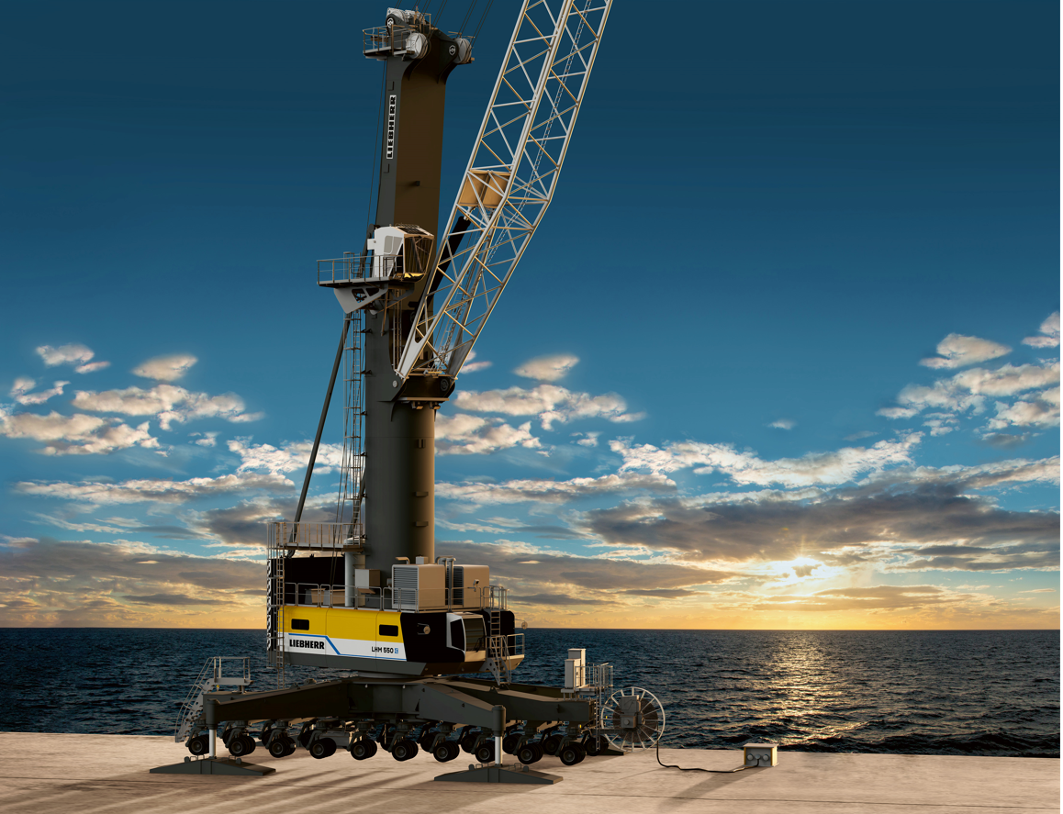
liebherr-the-new-lhm-1.jpg
The new LHM crane series is further characterised by a new control and sensor technology, new design, an advanced Pactronic hybrid system and an ergonomically improved operator's cab.

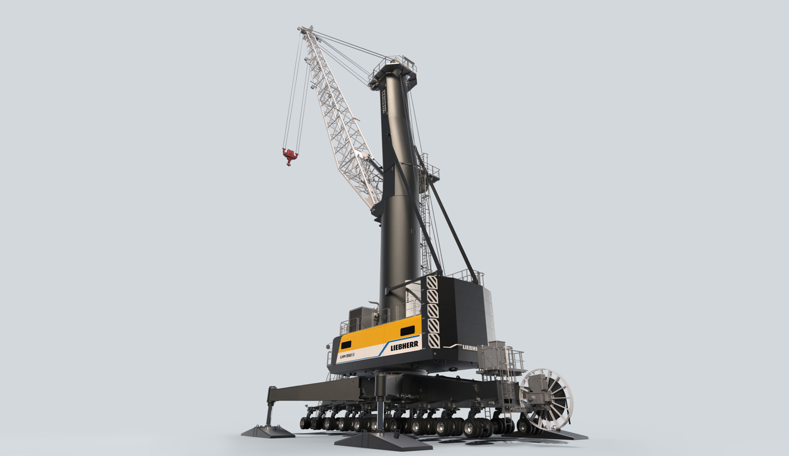
liebherr-the-new-lhm-2.jpg
The new LHM is much more digital, networked and smarter.
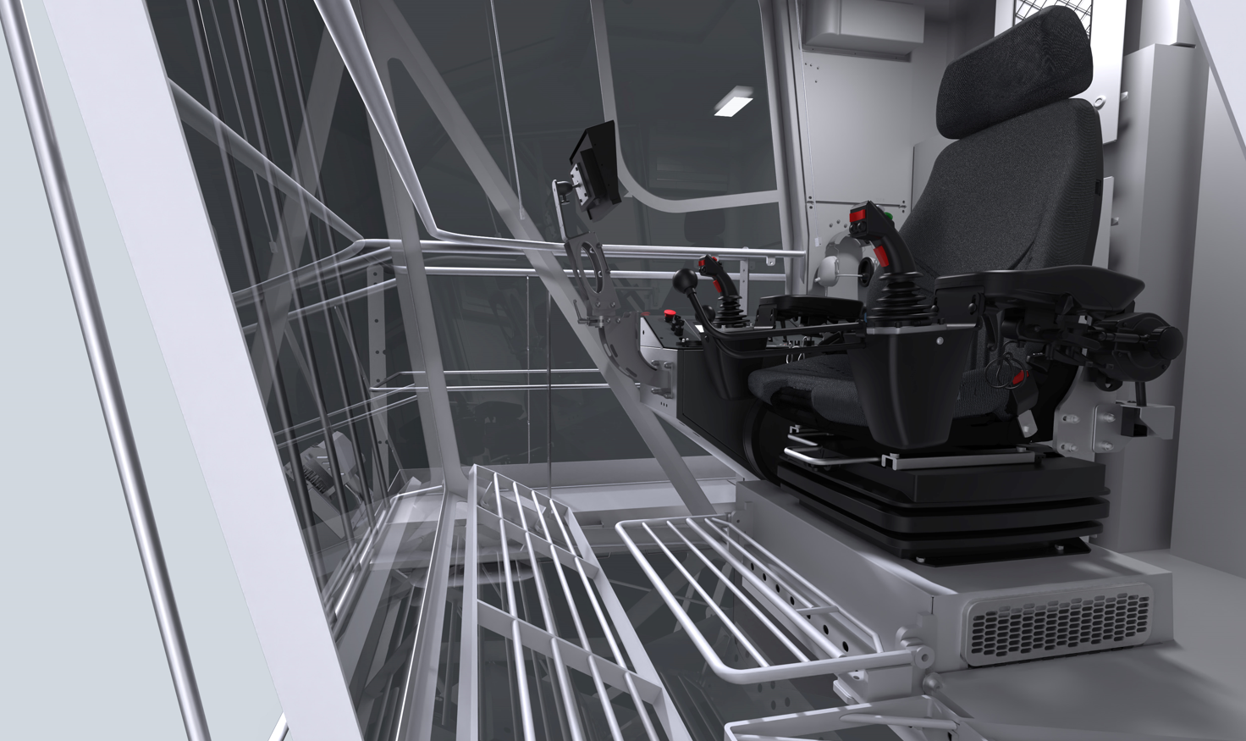
liebherr-lhm-maritime-cabine.jpg
Thanks to the new coupling of control lever and armrest, not only does the driver's comfort increase, but the control of the crane also becomes even more precise and safe.

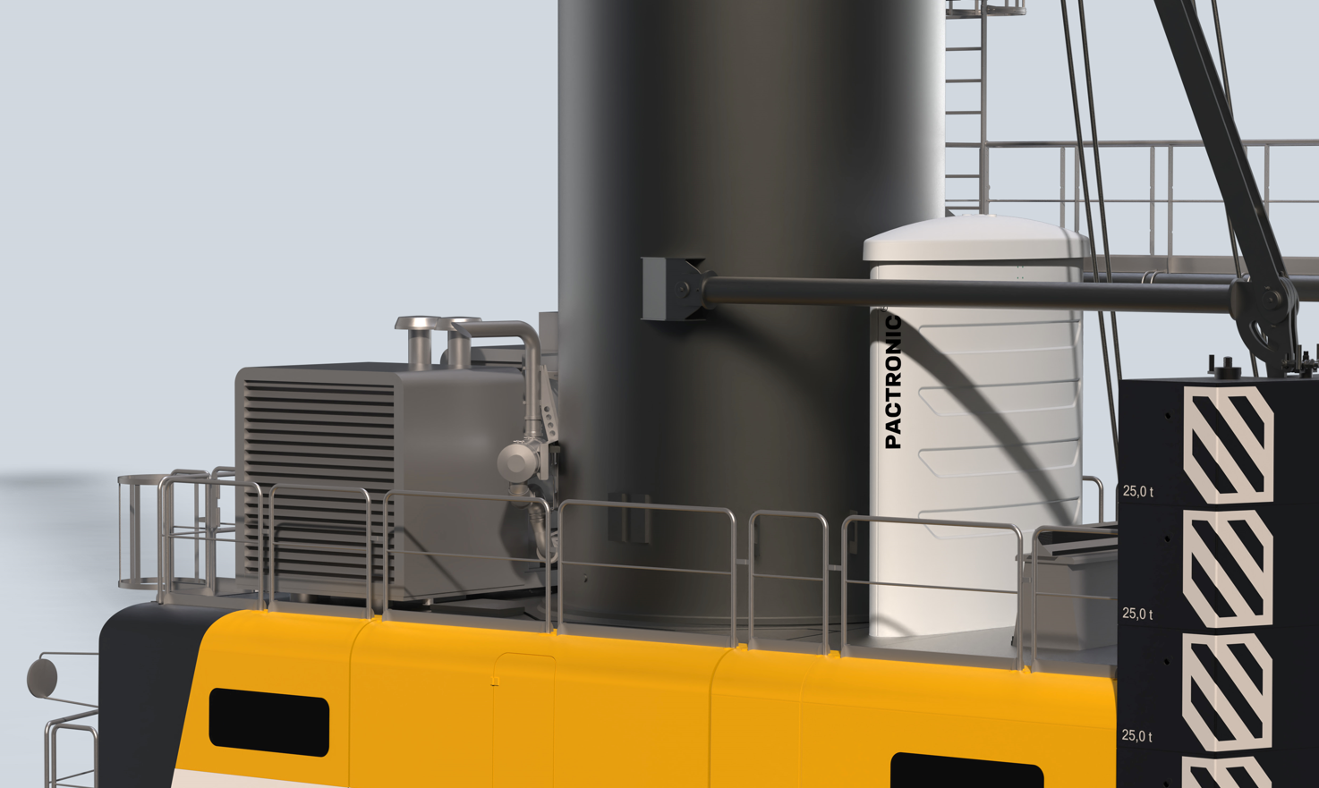
liebherr-pactronic-2.0-hybrid-system.jpg
The second generation of the Pactronic offers the operator a choice of two operating modes, depending on the current work situation.

Contact
Philipp Helberg
Phone: +49 381 6006 5024
Email: philipp.helberg@liebherr.com

Published by
Liebherr-MCCtec Rostock GmbH
Rostock / Germany
www.liebherr.com

