Press release

"On your site":

Liebherr at Bauma 2022

⸺

* Innovative Liebherr construction machines on the outdoor grounds at booth 809-810 / 812-813
* Liebherr components in Hall A4, Stand 326
* Liebherr tool attachments/implements and quick coupler systems in Hall B5, booth 439
* Additional booth of Liebherr concrete technology in Hall C1, No. 425 with a focus on mixing technology for precast plants
* Efficiency, digitalisation and service, as well as product responsibility: Liebherr showcases over 70 exhibits and various solutions from its high-quality portfolio, which meets individual customer needs on every construction site

At Bauma 2022 from 24 to 30 October 2022, Liebherr offers visitors unique opportunities to discover first hand the latest developments from the areas construction machines, cranes, material handling technology, mining and components. In line with the motto "On your site", the Liebherr Group shows that Liebherr can always be found at its customers' side – whether it is directly on the construction site with high-quality machines or through individual advice, global services and comprehensive solutions.

Biberach an der Riss (Germany), 13 June 2022 – The Liebherr booths at Bauma 2022 offers space for more than 70 exhibits on the outdoor grounds with an area over 14,000 m² (Booths 809-810 / 812-813). Numerous new products and developments from the areas construction machines, cranes, material handling technology, mining and components are on show. In addition, Liebherr presents the latest component developments in Hall A4 (Booth 326). In Hall B5 (Booth 439) interested parties can find out more about new products from the comprehensive programme of Liebherr tool attachments/implements and quick coupler systems. Products from Liebherr Concrete technology are exhibited at the main booth in the outdoor area as well as at an additional booth (425) in Hall C1, where the focus is on mixing technology for precast plants.

Visitors also have the opportunity to obtain information about the training and entry opportunities in the Liebherr Group at the Career Point of the Liebherr booth on the outdoor grounds, as well as in the ICM Foyer (Booth 105).

Digitalisation and drive technology: Liebherr's contribution to the construction site of the future

The product segment mobile and crawler cranes will present several digital products at Bauma, including numerous applications in the new MyLiebherr customer portal such as the Crane Finder, the Crane Planner 2.0, the digital mobile crane licence, fleet management, as well as a new telemetrics application.

The T 274, a class-leading 305-tonnes mining truck, will be on display featuring an impressive demonstration of the Trolley Assist System.

In the technology pavilion visitors can also familiarise themselves with the latest products and services from the Technology Product portfolio of Liebherr Mining, including the product segment's modular approach to emissions reduction.

In addition to a static machine exhibition, practical applications of current and future alternative drive concepts for earthmoving and material handling technology are presented to the specialist audience within the framework of live shows taking place several times a day. At the main trade fair booth Liebherr also gives further insights into and outlooks of future-oriented services and solutions for its earthmoving machines and material handlers.

The new compact crane LTC 1050-3.1 from the Liebherr in Ehingen is equipped with an electric motor in addition to the conventional drive. This means the crane movements can also be executed using electricity. The new version of the compact 50-tonne machine helps reduce CO2 emissions and satisfies the requirements for operation on "Zero Emission" construction sites.

Liebherr also presents a new generation of stationary mixing plants at Bauma. The new stationary mixing plant series Betomix and Mobilmix can be flexibly combined from prefabricated modules, meaning that several predecessor series could be replaced. For customers this means greater freedom in the configuration of the machines, shorter delivery times, faster assembly and a high level of availability of parts. Moreover, optimisation of the drives reduces power consumption by up to 30 percent and increases the weighing accuracy so that up to 7.5 kg of cement can be saved per cubic metre of concrete.

In the area of digital assist systems the components product segment also presents the IoT complete solutions for increased data security in addition to the LiXplore camera monitor and panoramic systems. This includes the integrated, digital wear measurement system for optimal monitoring of large diameter bearings, the force sensor for hydraulic cylinders, as well as the digital condition monitoring for combustion engines.

In the area of alternative drive concepts Liebherr Components presents the first hydrogen engine, the H964, with high efficiency and very low NOx emissions with the same service life and maintenance intervals as diesel engines. The various injection solutions for hydrogen for medium and heavy-duty engines, as well as large engines with 7 to 100 litre capacity, are also presented. The new developments also include the mobile energy storage system, which in future will ensure local zero-emission operation of electric or hybrid construction sites with maximum power density, efficiency and quality.

Product highlights at Bauma 2022

At Bauma 2022 the two product segments earthmoving and material handling technology present numerous new products, highlights and innovations at the main trade fair booth.

The comprehensive portfolio of Liebherr tool attachments/implements and quick coupler systems is presented on a separate area in Hall B5 Stand 439.

Liebherr extends its line of Fibre tower cranes with extremely powerful machines – and for the first time beyond the EC-B series. The luffing jib crane 258 HC-L 10/18 Fibre, the high-top crane 1188 EC-H 40 Fibre, as well as the flat-top cranes 520 EC-B 20 Fibre and 370 EC-B 16 Fibre, are new. Cranes with high-strength Fibre ropes offer even greater performance, which is particularly noticeable in large cranes. With the 195 HC-LH 6/12 Liebherr showcases its first hydraulic luffing jib crane in combination with a slim and climbing tower system. Liebherr is also working on future-oriented solutions in order to make crane driving even safer and more efficient. An excellent example is the tele-operation for tower cranes, which allows the machine to be controlled outside the crane cab.

With the slogan "Game changer for tomorrow's energy", Liebherr presents a new crawler crane: The LR 12500-1.0 with 2,500-tonne load-bearing capacity supplements the portfolio below the LR 13000. The designs of the rotating platforms and the main boom set new standards because the unrivalled wide main boom gives the crane the stability of a power boom. Liebherr describes the new boom design as a high-performance boom. Despite the enormous capacity of the new crawler crane and the size of the individual components, Liebherr has managed to create a unique, practical concept for efficient transport.

The new LTM 1110-5.2 combines old strengths with future-oriented innovations for greater safety and comfort. In addition to these new features, Liebherr produces a completely new crane design in series, which is future-oriented for the all-terrain series.

Liebherr Mining will showcase its existing and proven mining solutions at Bauma 2022 and will also unveil a brand-new mid-size class hydraulic mining excavator - the second Generation 8 machine within the Liebherr Mining portfolio.

Other highlights of LiebherrComponents include the extension of the axial piston pump range with new rated sizes, the hybrid cylinder as part of the Fibre composite portfolio, the online configurator for hydraulic cylinders, the combustion engine for off-road applications, the D976, which is compatible for operation with HVO, and lots more.

From the Unplugged series Liebherr brings six new products from the areas piling, drilling and lifting to Bauma 2022: The piling rigs LRH 100.1 unplugged and LRH 200 unplugged can work four to five hours in battery mode with a 200 kWh battery package, the charging is done using conventional construction site power. The battery package can be upgraded to 400 kWh for an operating time of eight to ten hours. The drilling rigs LB 25 and LB 30 have proven themselves as a conventional version over the years. The new battery-powered Unplugged versions are identical in terms of possible applications, weight and transport, but have the added advantage of "Zero Emissions". They can be used for all standard applications in the area of special civil engineering. The two crawler cranes LR 1130.1 unplugged and LR 1160.1 unplugged from Liebherr in Nenzing have the same performance data as the conventional version. Both are operated in a similar manner, which is very practical if the crane operators frequently change between different machines in a fleet.

About the Liebherr Group

The Liebherr Group is a family-run technology company with a highly diversified product portfolio. The company is one of the largest construction equipment manufacturers in the world. It also provides high-quality and user-oriented products and services in a wide range of other areas. The Liebherr Group includes over 140 companies across all continents. In 2021, it employed more than 49,000 staff and achieved combined revenues of over 11.6 billion euros. Liebherr was founded in Kirchdorf an der Iller in Southern Germany in 1949. Since then, the employees have been pursuing the goal of achieving continuous technological innovation, and bringing industry-leading solutions to its customers.

Images

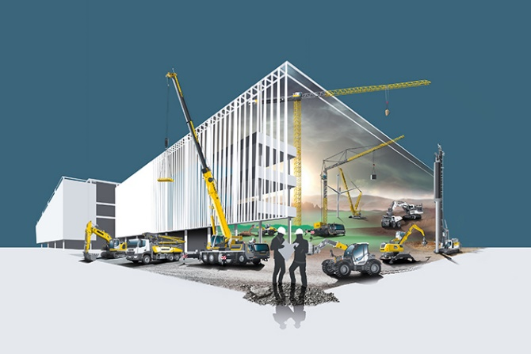

liebherr-bauma-2022.jpg  
Under the motto "On your site", Liebherr presents customized solutions for the construction site of the future to its customers at Bauma.

Contact

Philipp Hirth  
Head of Public & Media Relations  
Phone: +49 7351 4144-45  
Email: philipp.hirth@liebherr.com

Published by

Liebherr-International Deutschland GmbH  
Hans-Liebherr-Strasse 45  
88400 Biberach an der Riss / Germany  
[www.liebherr.com](http://www.liebherr.com)