Press release

Fortescue and Liebherr establish partnership for zero emission mining equipment

⸺

Fortescue and Liebherr have announced a partnership for the development and supply of green mining haul trucks

Liebherr will integrate the zero emission power system technologies being developed by Fortescue Future Industries and Williams Advanced Engineering into its T 264 haul truck

The phased supply of haul trucks is anticipated to commence following a two-year joint development period

Fortescue Metals Group Ltd (Fortescue) and Liebherr Australia Pty Ltdhave signed an agreement for the development and supply of mining haul trucks integrating zero emission power system technologies being developed by Fortescue Future Industries (FFI) and Williams Advanced Engineering (WAE).

Colmar (France), 15th June 2022 - The partnership between Fortescue and Liebherr tackles the challenge of decarbonising heavy mobile equipment in the mining industry. It will support global initiatives to reduce emissions and it will enable both Fortescue and Liebherr’s Mining product segment to achieve their respective commitments to address global emissions. The partnership will draw from Liebherr’s industry-leading equipment and technology and FFI’s expertise in green technologies to deliver zero emission mining equipment.

The phased supply of haul trucks is anticipated to commence following a two-year joint development period enabling the development and integration of Fortescue’s proprietary-owned battery electric and fuel cell electric power system, into Liebherr’s proprietary-owned base truck. To achieve the target Liebherr will use its vast OEM expertise in the design and manufacturing of machinery and machinery core technology, such as electric drive systems, engines, hydraulics and electronics to engineer, manufacture and supply the new mining haul trucks, in accordance with Fortescue’s requirements.

Partners for success

Liebherr is implementing their defined “Mining Zero Emission Program”. Where the first step was to build the electrified mining product range and the second step is to offer complete fossil fuel free mining equipment for haulage, digging, and dozing by 2030. On this pathway, focus is on modularisation to allow the integration of energy type agnostic power trains including alternative fuel combustion engines, battery and fuel cells. Liebherr’s partnership with Fortescue is a key component of this program.

“This project provides an excellent opportunity for us to accelerate the integration of clean energy battery and fuel cell power systems into our mining equipment, which supports our vision and defined strategy to offer future zero emission equipment with the best suitable power train technologies,” said Oliver Weiss, CTO of Liebherr Mining. “As a leader in green technologies for the international heavy industry and a world class mining owner-operator, Fortescue is an ideal partner for decarbonized mining equipment and technology initiatives, sharing the same vision as us.”

The partnership will also assist the future evolution of the Liebherr business. “A mining product that will be developed through a close partnership of two tier one companies, including access to the latest zero emission technology, will create an immense industry opportunity and demand,” said Dr. Jörg Lukowski, Executive Vice President for Sales and Marketing of Liebherr Mining. “It also supports our future investment as we expand Liebherr’s already extensive manufacturing capability including at our truck facility in Newport News Virginia USA, and of course into our service and support network in Australia.”

Fortescue Chief Executive Officer, Elizabeth Gaines said, “The signing of this contract with Liebherr marks a significant step in the delivery of our industry leading decarbonisation target to achieve net zero Scope 1 and 2 emissions by 2030.

“We look forward to working with Liebherr and WAE to develop and deploy some of the world’s first zero emission large mining haul trucks in our operations, while also establishing an important new business growth opportunity for Fortescue as we diversify to become an integrated green energy and resources company.”

Fortescue Chairman and Founder Dr Andrew Forrest said, “We are on a march to achieve net zero by 2030, strengthening the economics of our business and making our products acceptable to a zero pollution future. Every day our Fortescue and FFI family take forward the technology, hard work, and willpower of going green, the world mining industry takes one step closer to being the first globally leading industry to go fully green.”

About the Liebherr Group

The Liebherr Group is a family-run technology company with a highly diversified product portfolio. The company is one of the largest construction equipment manufacturers in the world. It also provides high-quality and user-oriented products and services in a wide range of other areas. The Liebherr Group includes over 140 companies across all continents. In 2021, it employed more than 49,000 staff and achieved combined revenues of over 11.6 billion euros. Liebherr was founded in Kirchdorf an der Iller in Southern Germany in 1949. Since then, the employees have been pursuing the goal of achieving continuous technological innovation, and bringing industry-leading solutions to its customers.

About Fortescue

Established in 2003, Fortescue Metals Group Ltd (Fortescue) is a global leader in the resources and renewable energy industry. A proud West Australian company, we are recognised for our culture, innovation and industry-leading development of infrastructure and mining assets.

Underpinned by operational excellence and balance sheet strength, we are committed to our strategic goals of building thriving communities, optimising returns from our operations through disciplined capital management, diversifying to commodities that support decarbonisation and pursuing green energy opportunities through our green energy company, Fortescue Future Industries (FFI).

Together with FFI, we are diversifying into a global green renewables and resources company, driven by our industry leading targets to achieve carbon neutrality for Scope 1 and 2 emissions by 2030, and net zero Scope 3 emissions by 2040.

About Fortescue Future Industries

Fortescue Future Industries (FFI) is a global green energy company committed to producing zero-carbon green hydrogen from 100 per cent renewable sources.

[Green hydrogen](https://fortescuefutureindustries.createsend1.com/t/y-i-bjkllik-l-t/) is a zero-emission fuel, that when used produces nothing but water. It is the practical and implementable solution that will help revolutionise the way we power our planet: decarbonising heavy industry and creating jobs globally.

FFI is leading the green industrial revolution, developing technology solutions for hard-to-decarbonise industries, while building a global portfolio of renewable green hydrogen and [green ammonia](https://fortescuefutureindustries.createsend1.com/t/y-i-bjkllik-l-i/) projects to produce 15 million tonnes per year of renewable green hydrogen by 2030, rising to 50 million tonnes per year in the decade thereafter.

FFI is also leading the world effort to decarbonise hard-to-abate sectors and is responsible for the decarbonisation of one of the biggest resources companies in the world by 2030 – our parent company Fortescue Metals Group.

**About Williams Advanced Engineering**

WAE is a world-leading technology and engineering services business delivering pioneering innovation to improve performance, efficiency and sustainability to a global customer base.

Combining cutting-edge technological advances and the industry’s best engineers with precision and speed to market derived from the ultra-competitive environment of motorsport, WAE’s capabilities cover a wide range of disciplines.

The company provides ground-breaking innovation covering advanced battery and electrification technologies and product development; aided by advanced simulation, testing, rapid prototyping and volume manufacturing. Working in close collaboration with our customers, WAE remains committed to meeting the continued sustainability challenges of the 21st Century.

WAE can trace its foundations back to 2010 when Williams Grand Prix Engineering Limited began diversifying its operations; a division which later became WAE. In December 2019, Williams Grand Prix Engineering (which is owned by private investment firm Dorilton Capital) sold a majority equity stake in WAE to EMK Capital.

WAE has grown from an embryonic business in 2010 to a company which employs approximately 400 people engaged in leading-edge and transformative technologies for a growing list of Tier 1 clients.

Following the acquisition by Fortescue in March 2022, WAE will continue to service its existing customers and commercialise new technology opportunities, in addition to playing a key role in supporting Fortescue’s decarbonisation strategy.

Images

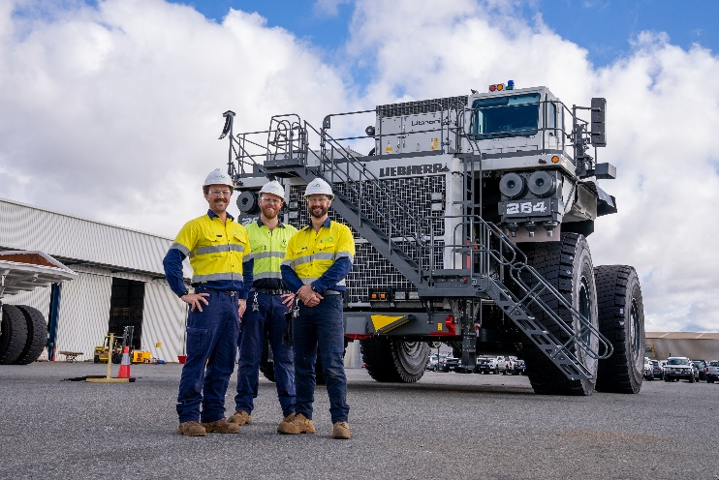

ffi-team-working-on-the-t264-in-australia.jpg  
FFI team working on the T 264 in Australia.

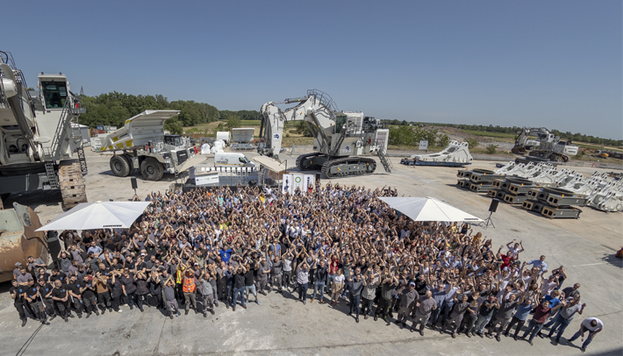

partnership-signing-ceremony-in-colmar-france.jpg  
Partnership signing ceremony in Colmar, France.

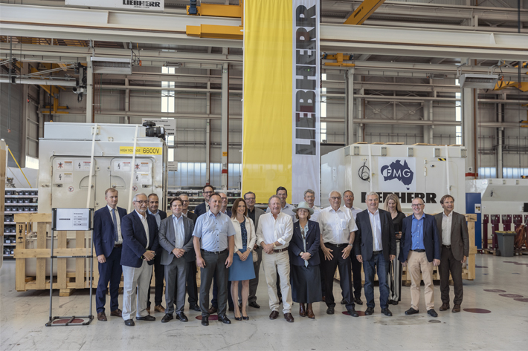

fortescue-metals-chairmen-williams-advanced-engineering-co-chairmen-meeting-with-liebherr-in-colmar-france.jpg  
Fortescue Metals chairmen, Williams Advanced Engineering co-chairmen meeting with Liebherr in Colmar, France.

Contact

Swann Blaise  
Divisional General Manager – Marketing & Business Intelligence   
Telephone: +1 757 928 2239  
E-Mail: [swann.blaise@liebherr.com](mailto:swann.blaise@liebherr.com)

Published by

Liebherr-Mining Equipment SAS   
Colmar / France  
www.liebherr.com