Press release

The Liebherr-Components world at Bauma 2022

⸺

With digital assistance systems, Liebherr demonstrates digitalization progress

Alternative drive concepts by Liebherr provide the most suitable drive form for specific applications and locations to reach the greatest possible machine efficiency

Innovative product technologies by Liebherr offer a complete package for the entire life cycle of the machines

At Bauma 2022, Liebherr will offer the visitors a unique opportunity to gain an insight into the world of components alongside the latest developments in construction machinery, cranes, material handling and mining from 24 to 30 October 2022. In line with the Group's motto “On your site”, the Components product segment also demonstrates that the Liebherr team is always at the side of its customers, wherever they may be - whether directly on the construction site with innovative product technologies or through individual consulting, worldwide services and fully comprehensive solution concepts.

Biberach an der Riss (Germany), 21 June 2022 - Liebherr's Components product segment will be showcasing its innovative product technologies at a booth measuring around 450 m² (hall A4, booth 326). It's all there - from digital solutions to alternative drive concepts for a functional future that trade fair visitors can already expect from Liebherr today.

Vision through digitalization

Digitalization in making huge progress in all areas. In order to optimally master the associated challenges, Liebherr offers comprehensive digital solutions. The top priority thereby is to increase the performance, reliability and security of customer applications.

Our camera-monitor systems and surround vision solutions in the LiXplore product family are based on digital camera technology. The assistance systems feature higher resolution and, therefore, a more detailed view of the working environment outside the cab. For drivers of a mobile machine this is of real benefit in terms of efficiency and work safety. Our overall IoT solutions also ensure greater data security.

The integrated digital wear measurement system for optimum monitoring of slewing bearings, Bearing Clearance Monitoring (BCM), the force measurement sensor for hydraulic cylinders and digital condition monitoring for combustion engines also play a role in ensuring improved safety, higher performance and longer machine service life.

Alternative drive concepts

The optimum drive has a decisive influence on the efficiency of the work operation in question. The heterogeneous fields of application typical of construction machinery require the most suitable form of drive for the specific application and site, in order to ensure the greatest possible machine efficiency.

With this in mind, Liebherr offers customers engines with high efficiency and very low NOx emissions with the same service life and maintenance intervals as diesel engines. The first hydrogen engine ever built at Liebherr, the H964, ensures high performance and efficiency at competitive costs and high availability thanks to the large proportion of common parts.

In response to the trend of decarbonisation, Liebherr enhances the internal combustion engine and offers various hydrogen injection solutions. The system approaches for port fuel injection (PFI) and direct injection (LPDI) are based on a common, scalable injector platform. A wide range of applications is possible for medium and heavy-duty engines, as well as large engines in the 7 - 100 litre displacement range.

To optimise the operating performance of hydrogen-powered commercial and construction vehicles, Liebherr is also developing electric turbochargers. Air compression provides a higher oxygen partial pressure and thus a higher power density. Our system approach with the integration of a compressor and power electronics enables weight and cost savings, as well as reliable technology that is easy to integrate into the vehicle.

In the future, Liebherr's mobile energy storage systems will ensure locally emission-free operation of electrified or hybrid-powered construction sites. The challenge on fully electrified or hybrid-powered construction sites is operating machines at maximum power, charging all machines during break periods, or smoothing power peaks on sites with limited grid supply. We meet these challenges by developing energy storage systems with the highest power density, efficiency and quality.

Innovative, efficient and open to technology into the future

We take our product responsibility very seriously. Our goal is to provide customers with safe, efficient and environmentally compatible products in the long run. We wish to create solutions that meet both work and environmental requirements at all times.

Available at any time and any place - this is one of the approaches we are pursuing with our new online configurator for hydraulic cylinders. In future, all products in the standard series can be conveniently configured via the Liebherr website and downloaded as 3D models, for example. All cylinder variants can be requested directly and easily via the configurator - Liebherr ensures a response within one working day.

Hybrid cylinders as part of the fibre composite portfolio ensure greater effectiveness and efficiency of mobile and stationary applications. Thanks to the use of the lightweight components and the inherent weight savings, performance can be increased or fuel consumption reduced.

Our axial piston hydraulics also offers flexibility in application. Thus, the LH30VO family with the nominal sizes of 28, 45 and 85 will be extended by the nominal size of 100. It is characterised in particular by a modular system of controllers and a high degree of flexibility for the drive-through concept. In addition, the rated size of 550 (also available as a double pump of 1,100 cm3) complements the selection of open circuit pumps. In the development of this rated size, the focus lied on robustness. This results in high availability and longevity in various applications.

The newly developed combustion engine for off-road applications, the D976, is also suitable for individual customisation options. Its high power density, robust design and wide range of options make it perfect for the harshest environments and provide an ideal solution for a variety of industries and applications. Because the engine is compatible with hydrogenated vegetable oil (HVO), operators can reduce their emissions by up to 90% when filling up with the alternative fuel instead of diesel.

Thanks to the Liebherr-Reman programme, customers benefit from cost-efficient procurement prices, fast and long-term spare parts availability and original manufacturer’s quality. The remanufacturing of used components into as-new parts also has an ecological impact: Up to 78% raw material can be saved and the CO2 footprint reduced by over 50%.

Liebherr’s most powerful slewing drives, DAT 1000, are another exhibit highlight. These have been specially designed for heavy-duty applications in the highest quality with design and process expertise. With their immense power, they are nevertheless relatively compact in design and can be customised. They are indispensable, for example, when it comes to implementing the rotary movements for a heavy-duty crane that can lift several thousand tons.

About Liebherr-Components

In this segment, the Liebherr Group specialises in the development, design, manufacturing of high-performance components in the field of mechanical, hydraulic and electric drive and control technology. Liebherr-Component Technologies AG, based in Bulle (Switzerland), coordinates all activities in the Components product segment.

The extensive product range includes combustion engines, injection systems, engine control units, axial piston pumps and motors, hydraulic cylinders, slewing bearings, gearboxes and winches, switchgear, electronic and power electronics components, and software The high-quality components are used in cranes and earthmoving machinery, in the mining industry, maritime applications, wind turbines, automotive engineering or in aviation and transport technology. Synergy effects in s other product segments of the Liebherr Group are used to drive continuous technological development.

About the Liebherr Group

The Liebherr Group is a family-run technology company with a highly diversified product portfolio. The company is one of the largest construction equipment manufacturers in the world. It also provides high-quality and user-oriented products and services in a wide range of other areas. The Liebherr Group includes over 140 companies across all continents. In 2021, it employed more than 49,000 staff and achieved combined revenues of over 11.6 billion euros. Liebherr was founded in Kirchdorf an der Iller in Southern Germany in 1949. Since then, the employees have been pursuing the goal of achieving continuous technological innovation, and bringing industry-leading solutions to its customers.

Image

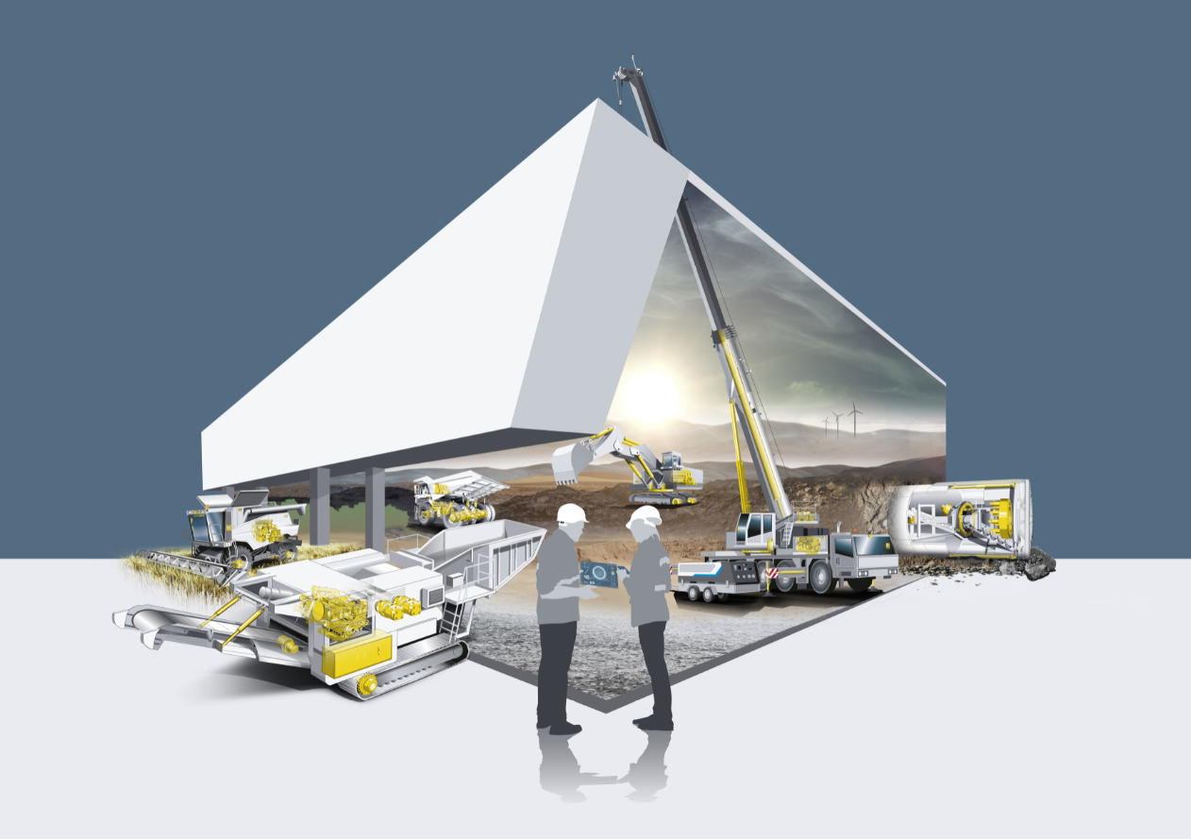

liebherr-key-visual-components-bauma2022.jpg  
The Liebherr-Components world at Bauma 2022

Contact

Alexandra Nolde

Senior Communication & Media Specialist

Phone: +41 79 538 53 46

E-mail: alexandra.nolde@liebherr.com

Published by

Liebherr-Components AG

Nussbaumen/ Switzerland

[www.liebherr.com/components](http://www.liebherr.com/components)